`

ISU Property Control Surplus Catalog

This surplus catalog is for reference only. To claim an item, you must come to the Warehouse Road complex. This catalog will be updated each Monday.
Table of Contents
Cabinets & Shelving Units 3
Desks & Tables 21
Chairs 28
Office Equipment & Miscellaneous Equipment 39

Cabinets & Shelving Units

100- 20260320 Black Cabinet
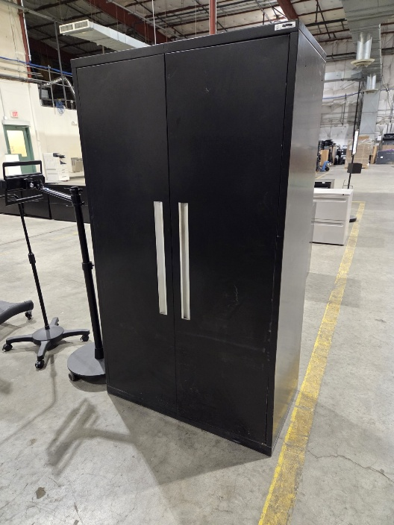
101- 20260605 Small Cabinet w/ Wheels (QTY 2)
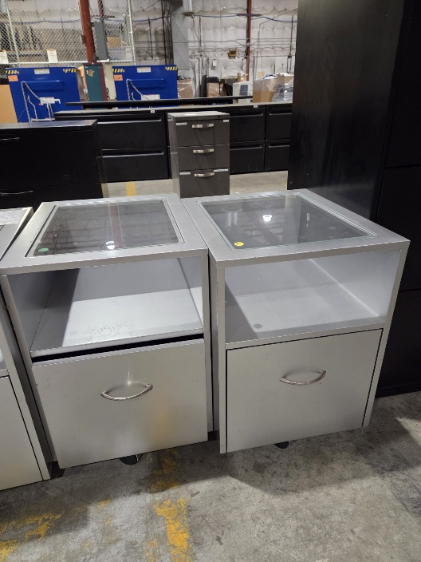

103- 20260403 Wooden Filing Cabinet (QTY 3)
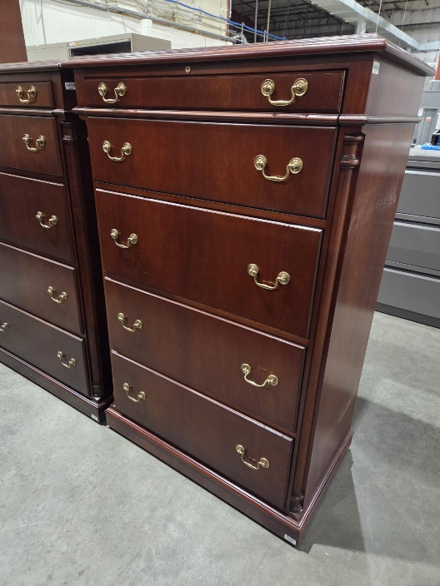

106- 20260706 Wooden Credenza
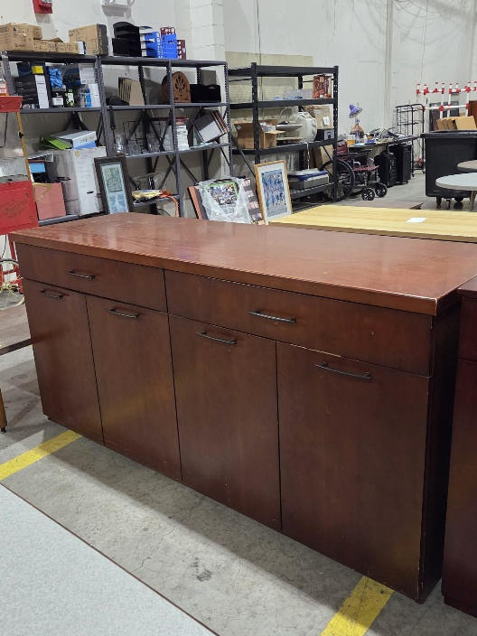

108- 20260526 Tan Bookshelf
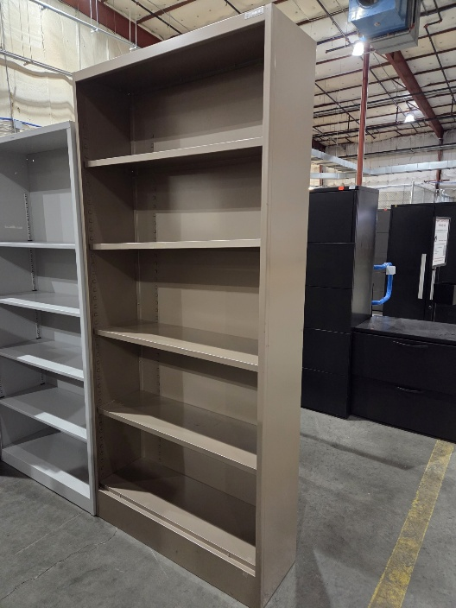
109- 20260629 Wooden Credenza
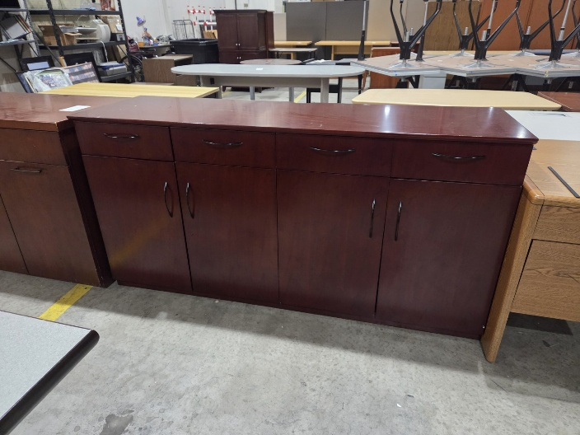

111- 20260605 Small Black Bookshelf
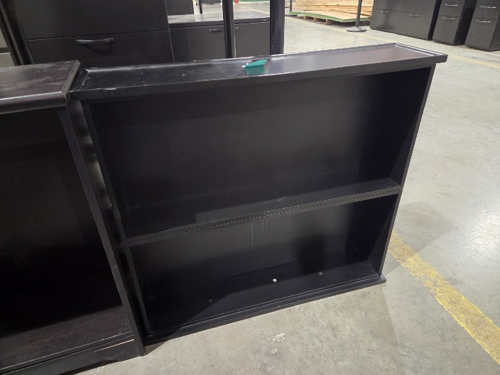

113- 20260612 Black Cabinet
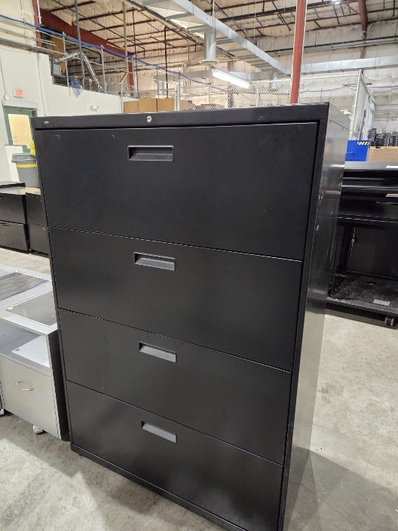

117 – 20250317 Brown Filing Cabinet
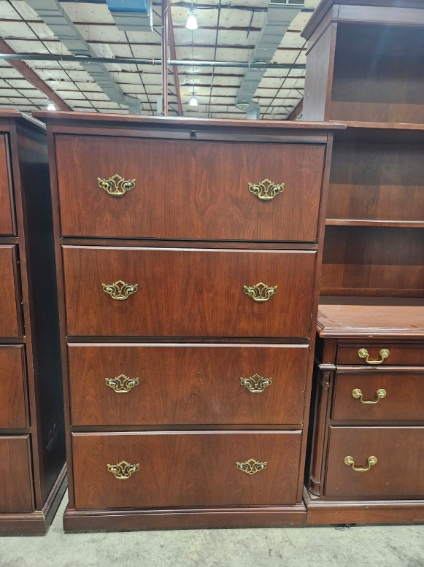
120 – 20250317 Dark Brown Cabinet
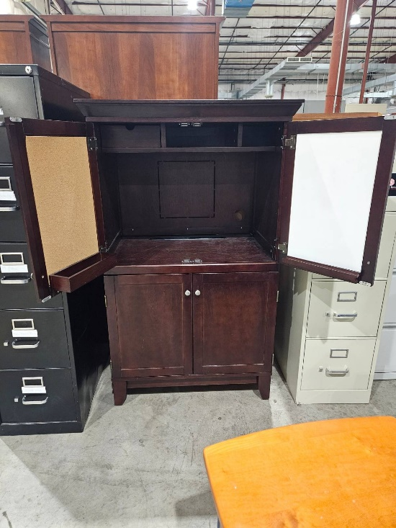
123- 20260720 Wooden Bookshelf
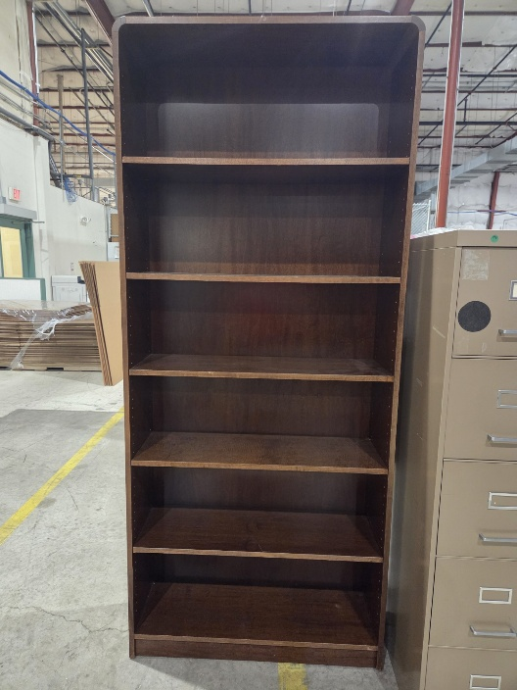

124- 20260629 Wooden Bookshelf
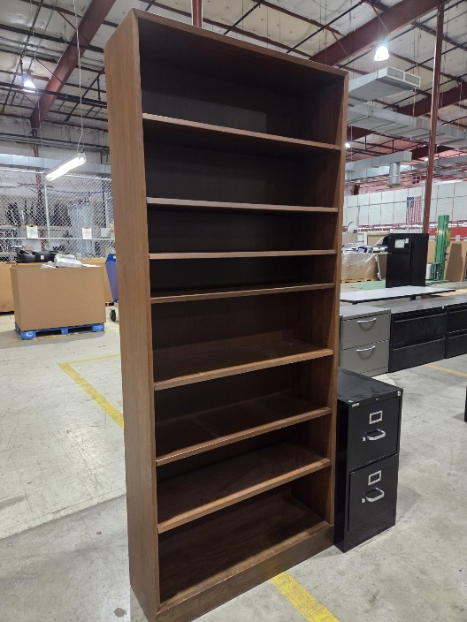

125- 20260313 Short Black Filing Cabinet
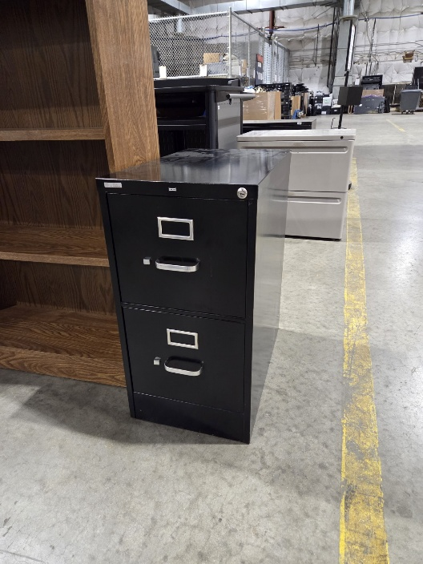

127- 20260313 Gray Filing Cabinet
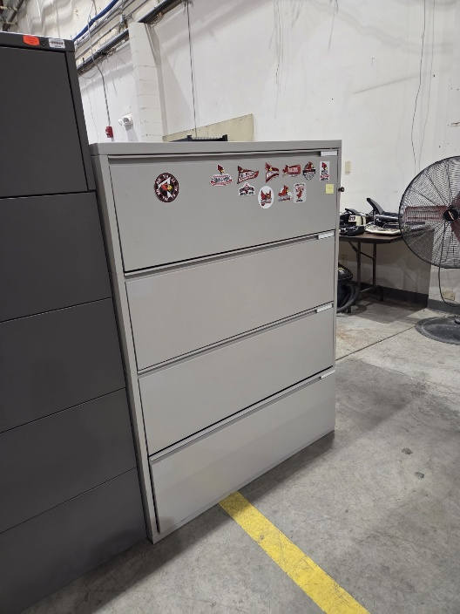

129- 20260720 White Metal Bookshelf
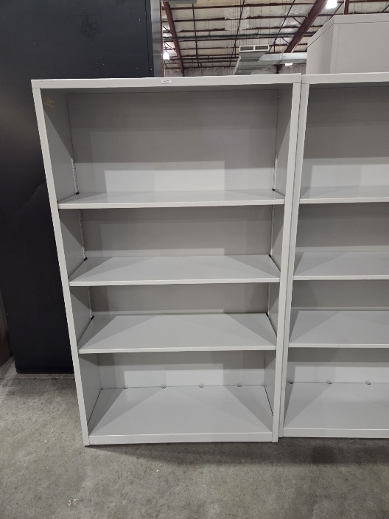
130- 20260720 Tan Filing Cabinet
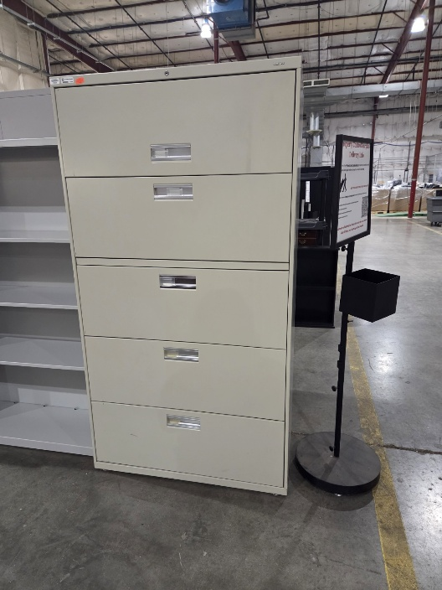

143- 20251121 Black Filing Cabinet
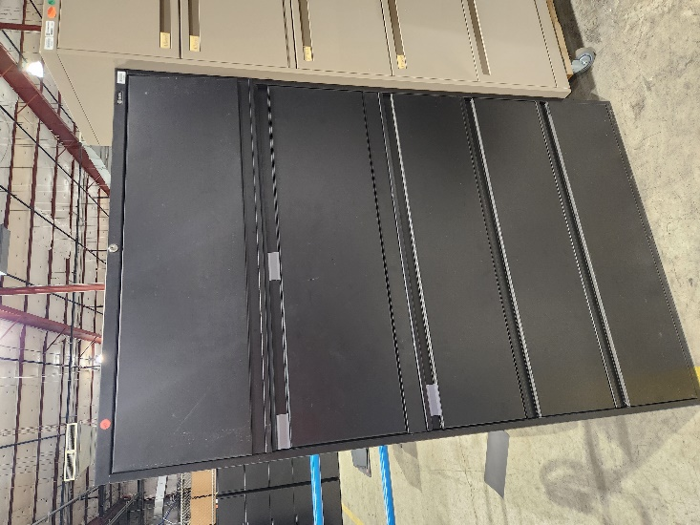

168- 20250822 Tall Gray Filing Cabinet
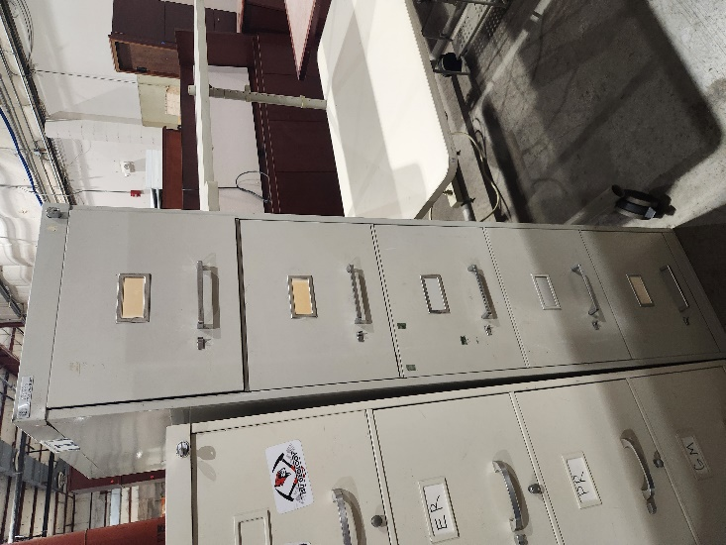

169- 20260424 Black Filing Cabinet
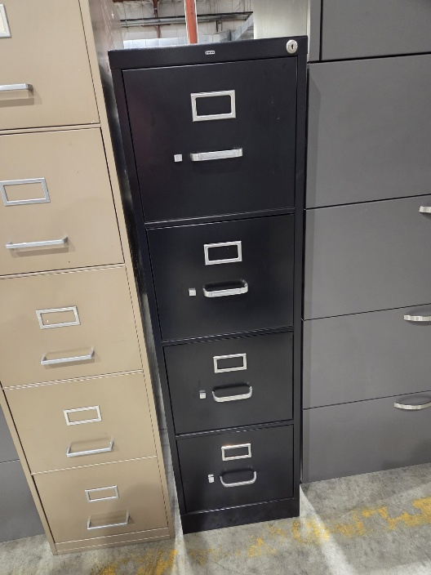

179- 20260622 White Cabinet w/ Shelf
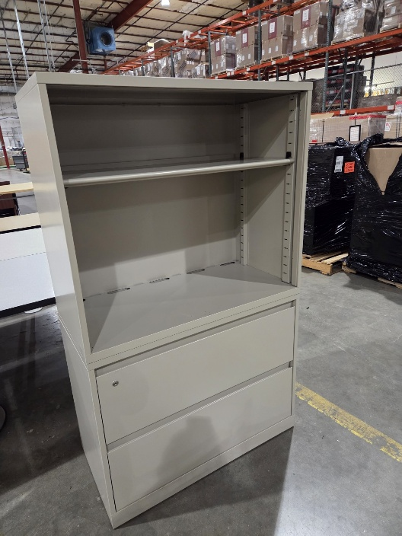

182- 20251010 Gray Filing Cabinet
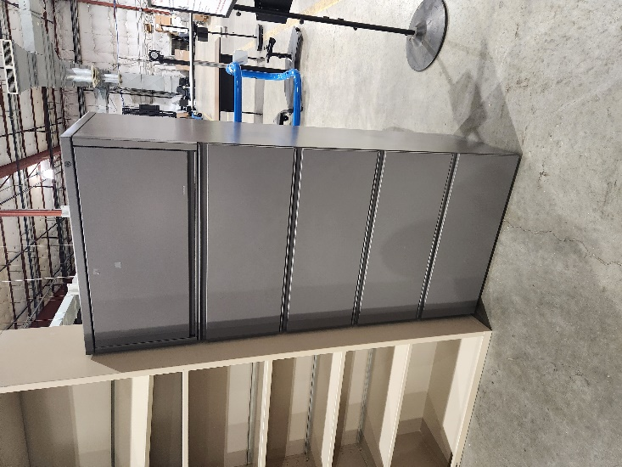

183- 20260227 Short Wooden Cabinet
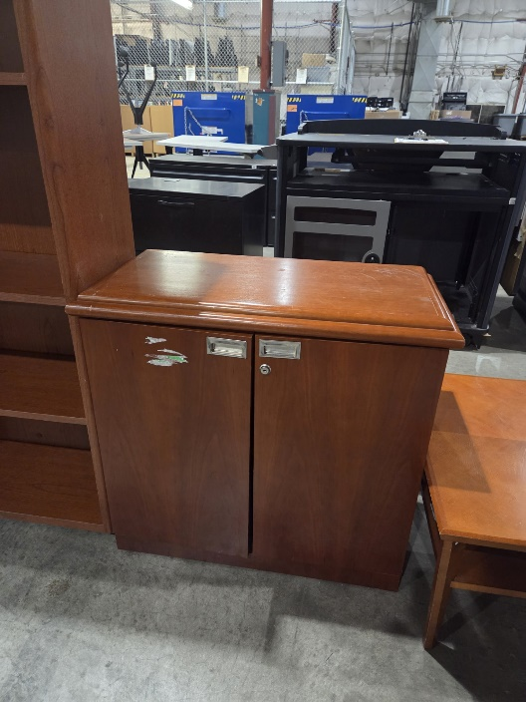

184- 20260622 Black Filing Cabinet
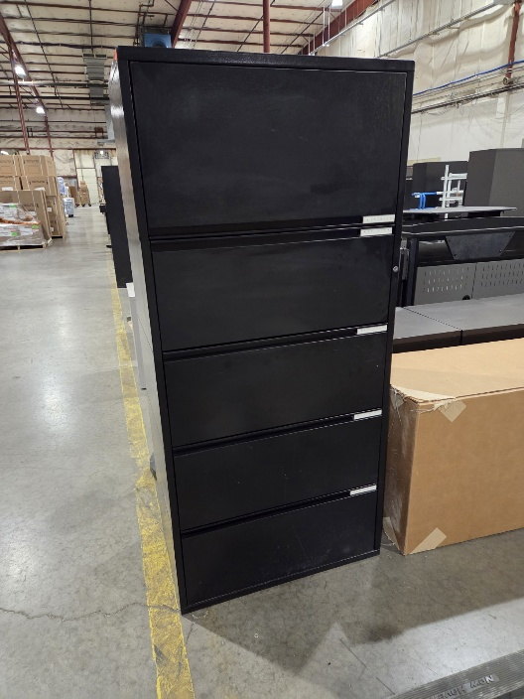

186- 20251107 White Filing Cabinet
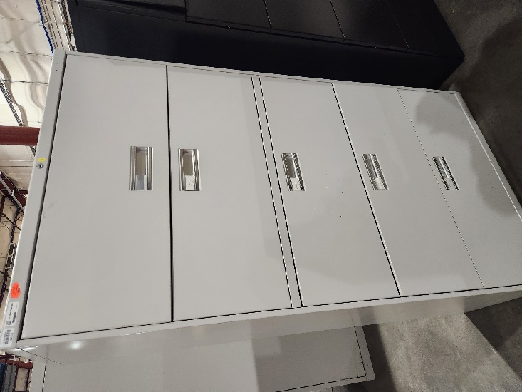

188- 20260327 Wooden Bookshelf
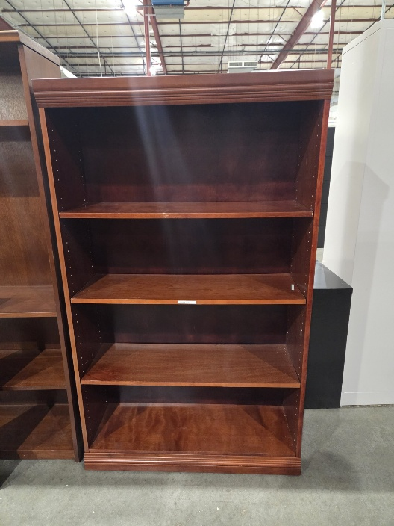
189- 20260807 Blue Shelves w/ Bottom Cabinet
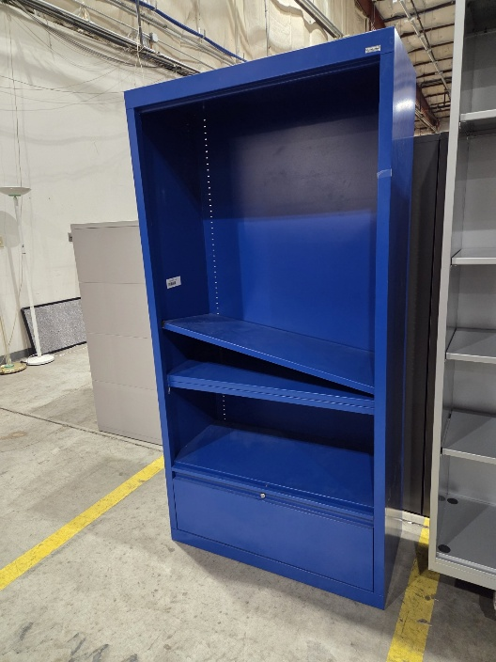

191- 20251114 Short Black Filing Cabinet (QTY 4)
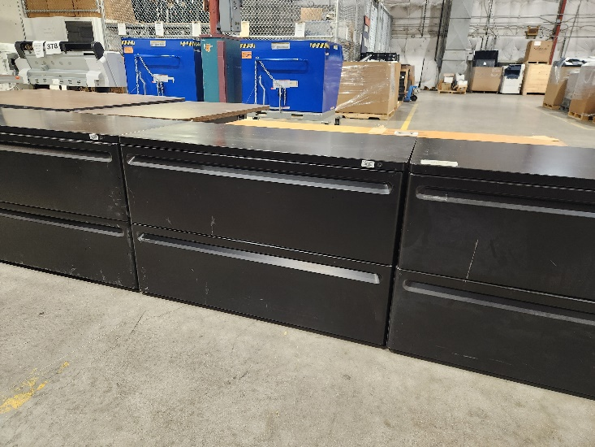

192- 20260807 Wooden Cabinet
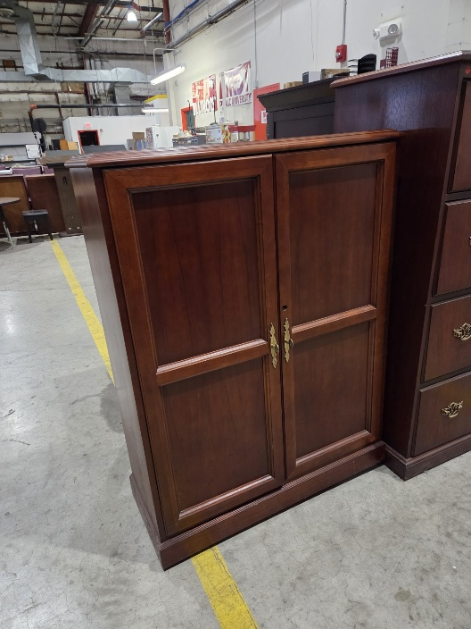

193- 20260807 Gray Bookshelf
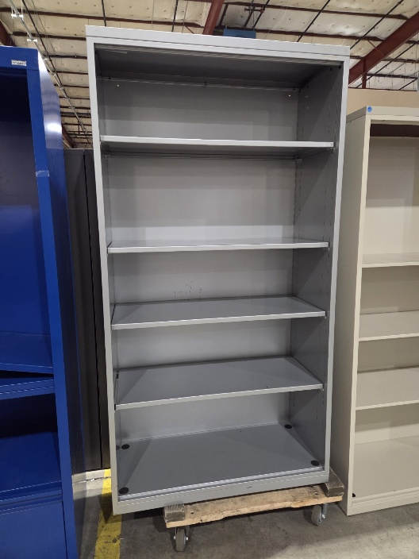

194- 20260105 Gray Filing Cabinet
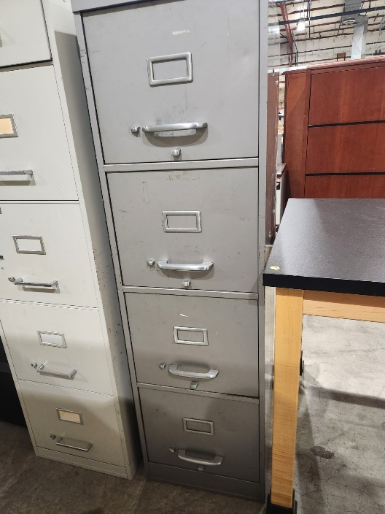

195- 20251114 Short Black Filing Cabinet
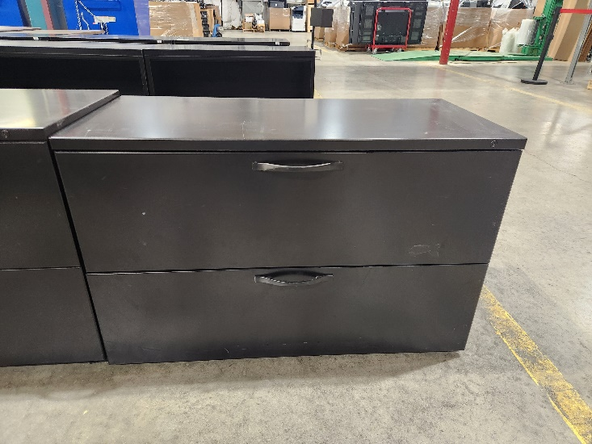

196- 20251114 Large Overhead Cabinet W/ 2 Drawers (2 Pictures)
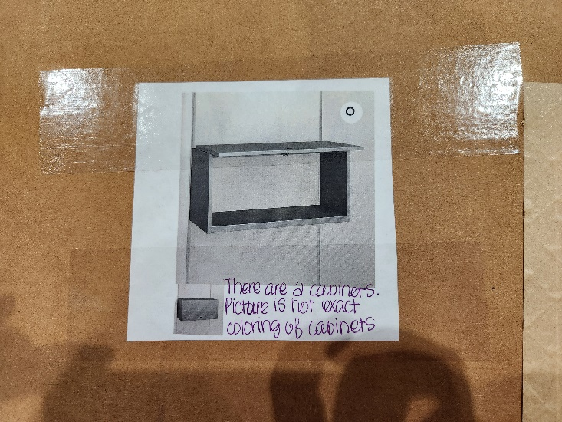
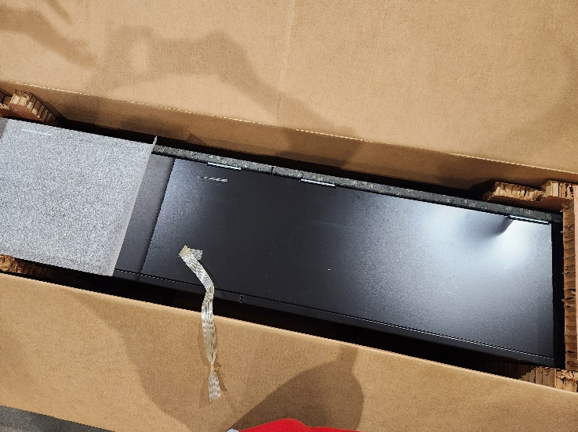

197- 20260807 Short Gray Filing Cabinet
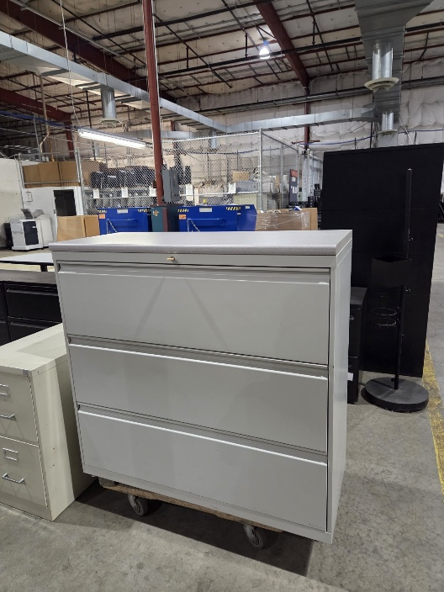

198- 20260720 White BookShelf (QTY 3)
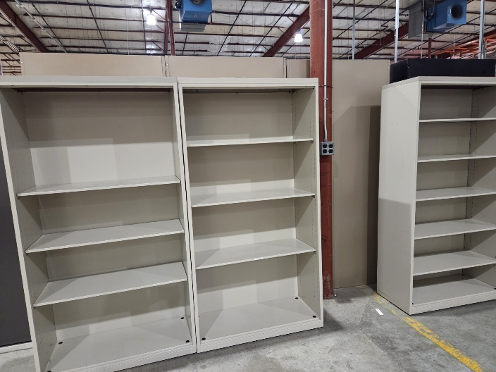

199-20260420 Tan Filing Cabinet
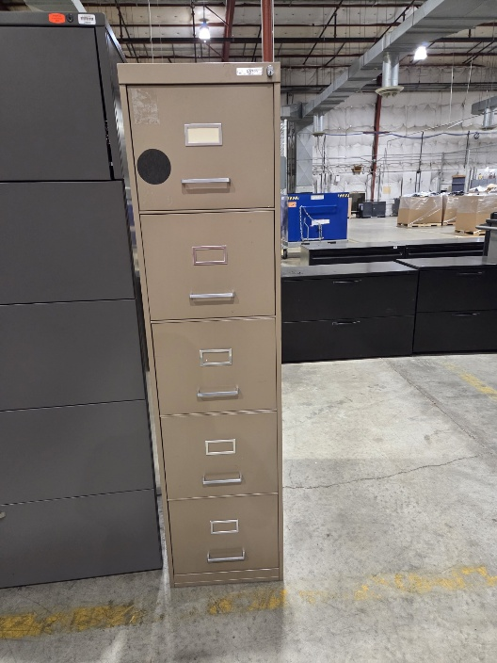

Desks & Tables

204- 20260605 Black Desk w/ Wooden Top
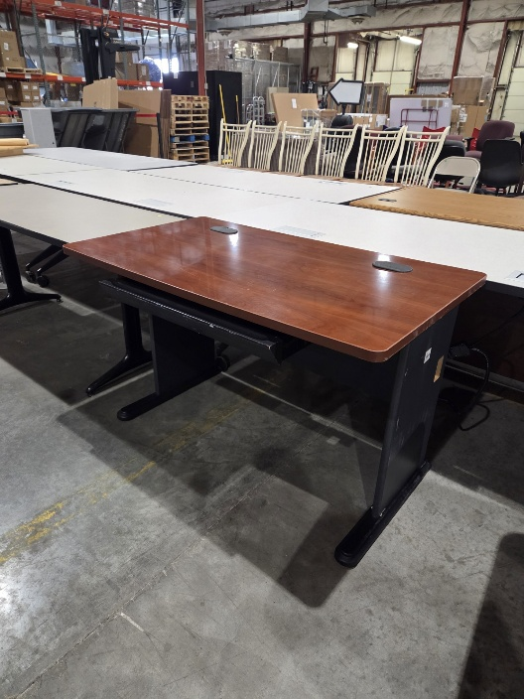

211- 20260612 Round Wooden Table
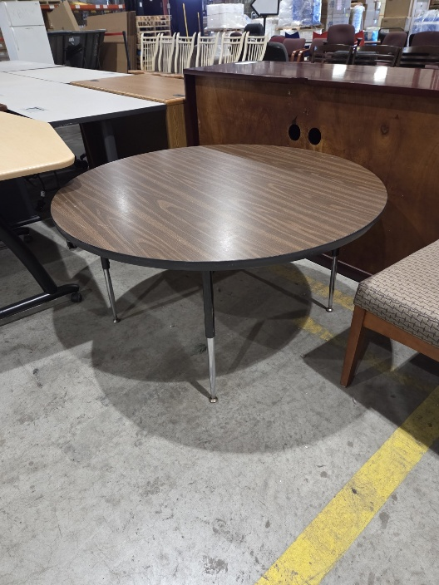

212- 20260526 Small Black Bench
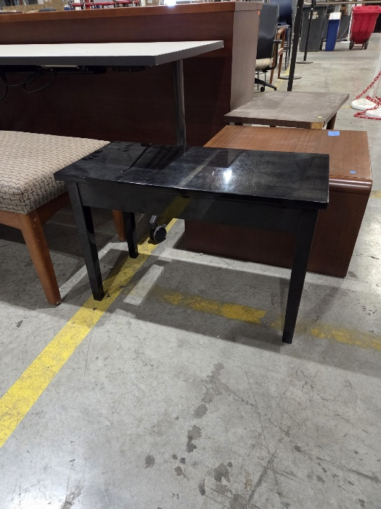

217- 20260720 Rolling Workstation (QTY 3)
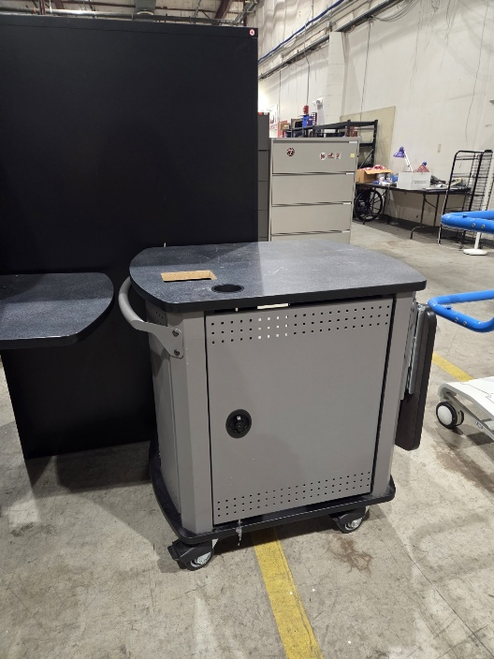

219- 20260706 Small Black Table/Bench
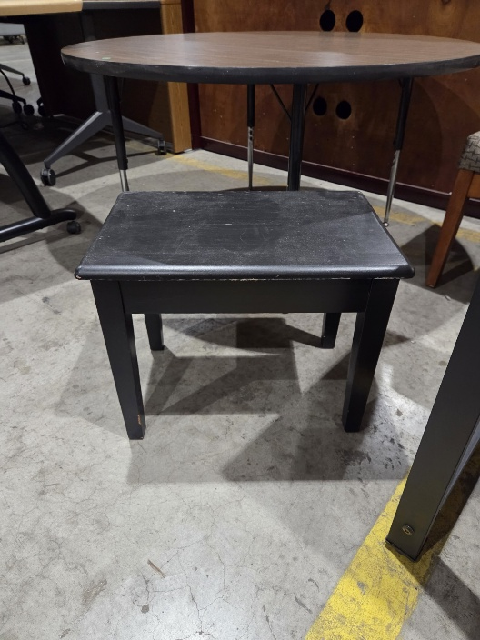

253- 20250829 Wooden Coffee Table (QTY 2)
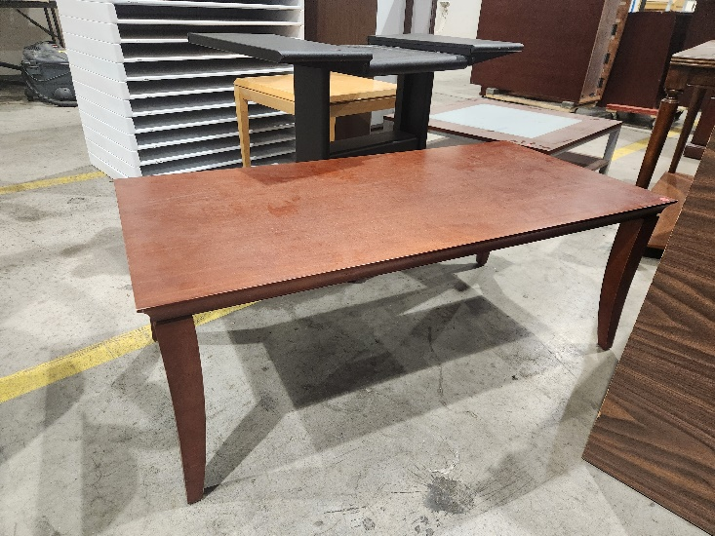

274- 20250815 Wooden Desk
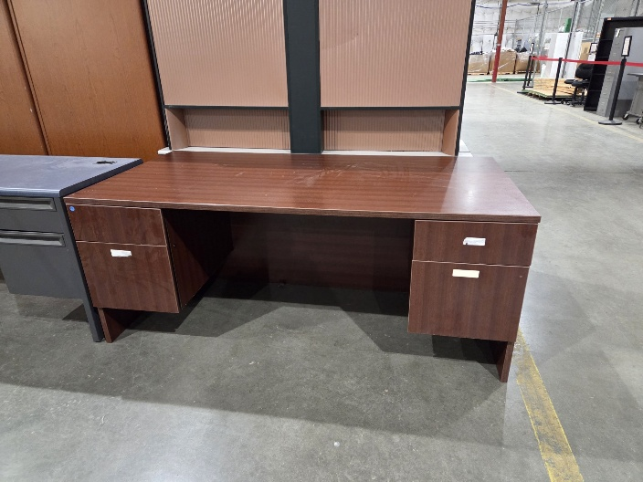

287- 20250908 Tan Table w/ Wheels
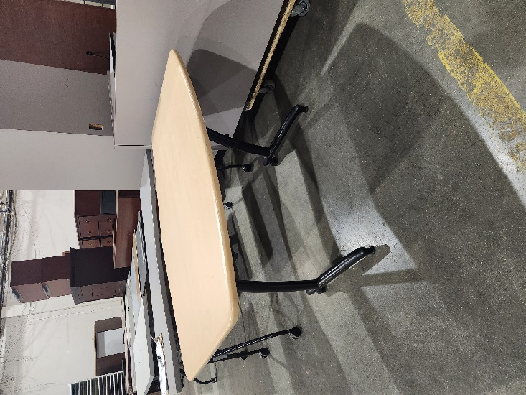
288- 20260327 Large White Table
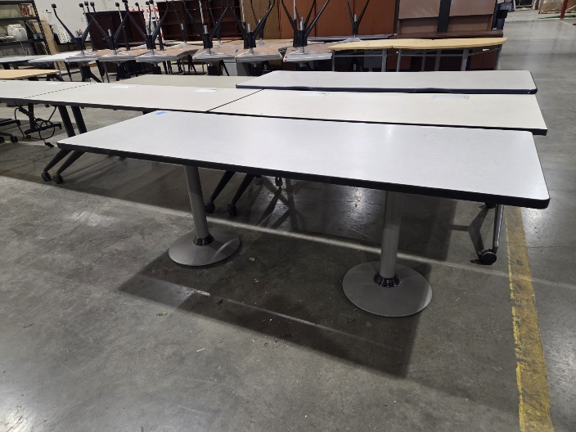
289- 20260807 Tall Wooden Table w/ Wheels
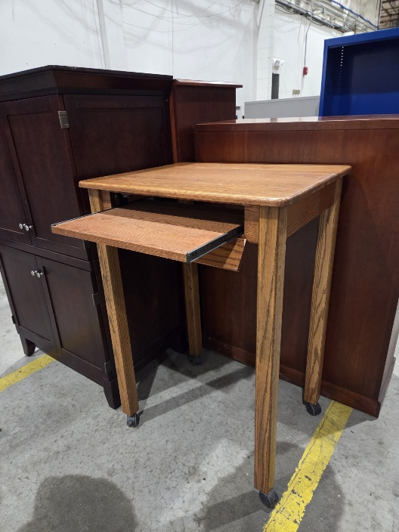

290- 20260807 Metal Desk w/ Wooden Top
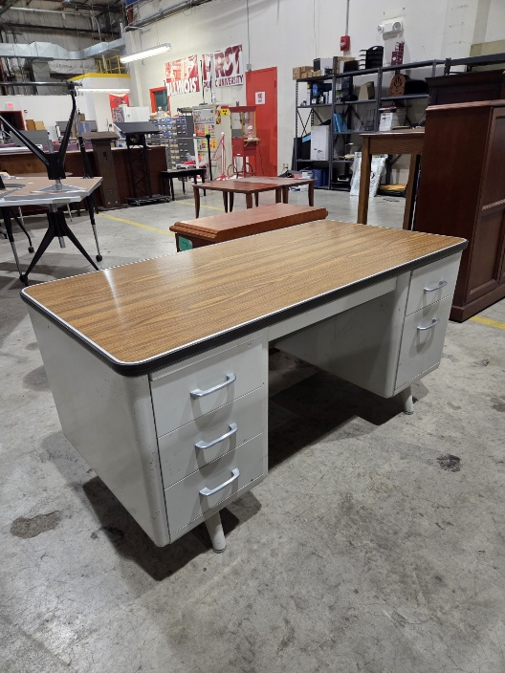
291- 20260807 Round Table
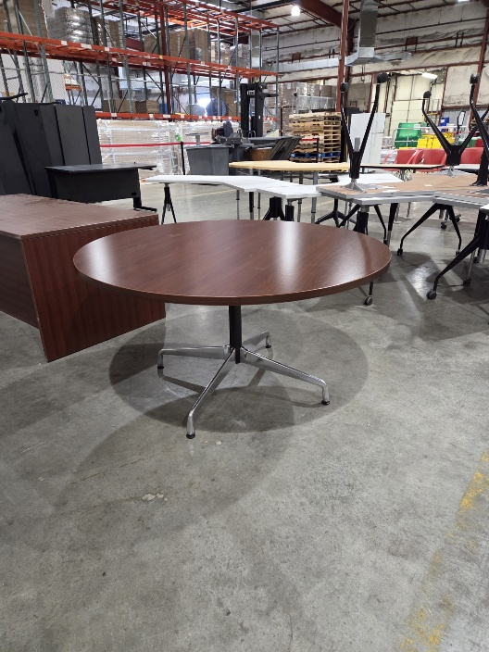

299- 20260420 Small Wooden Table
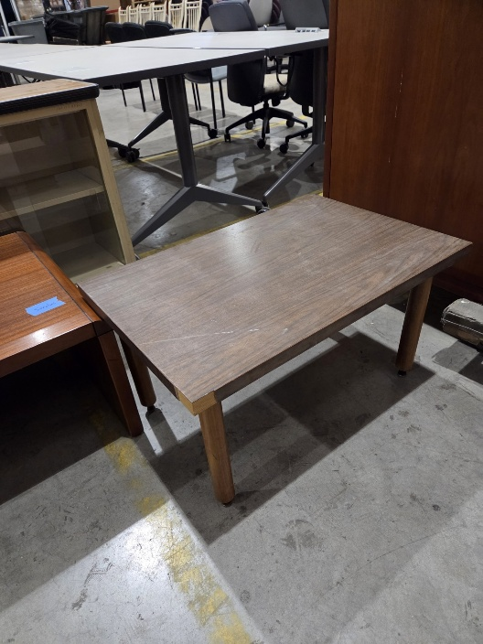

Chairs

303- 20260105 Black Chair
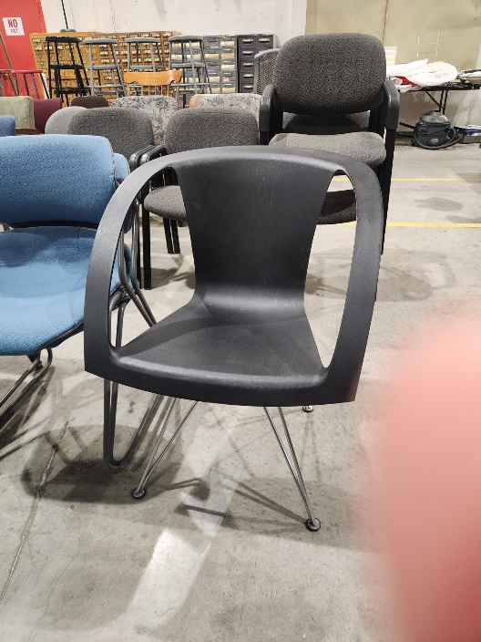

307- 20260130 Red Chair
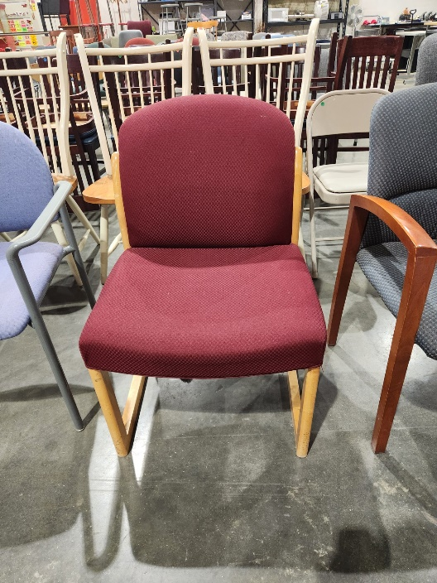

309- 20260529 Gray Chair
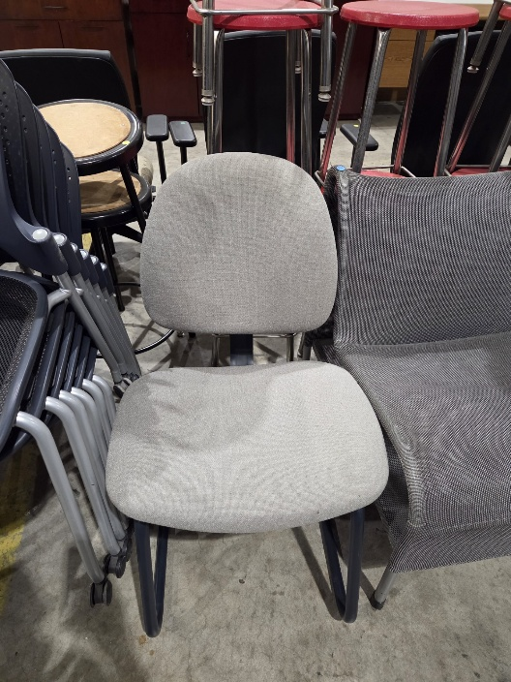

311- 20260720 Blue Chair
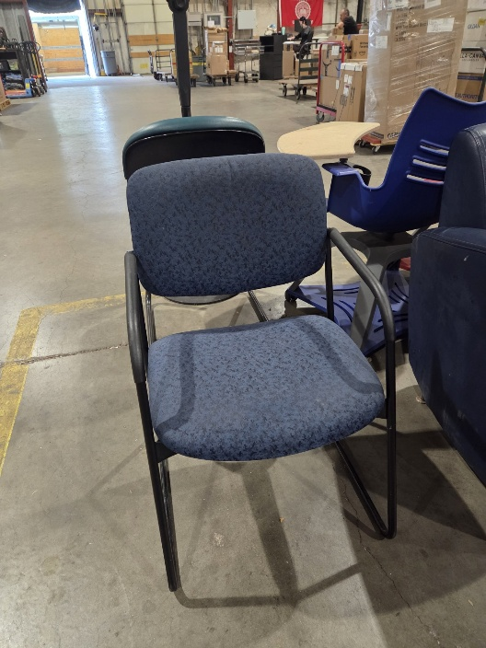

312- 20260720 Blue Chair w/ Desk
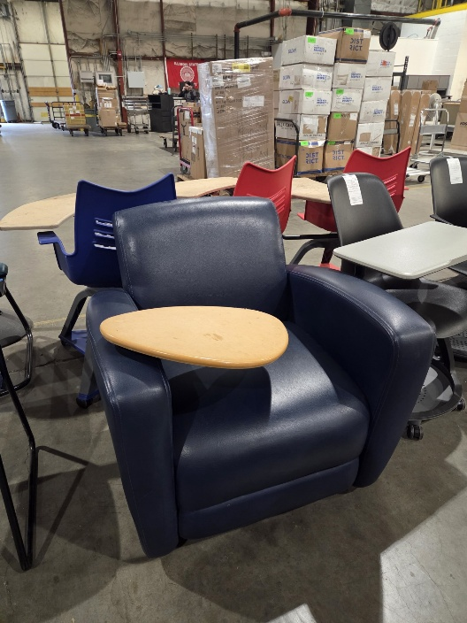

314- 20250829 Cream Colored Chair
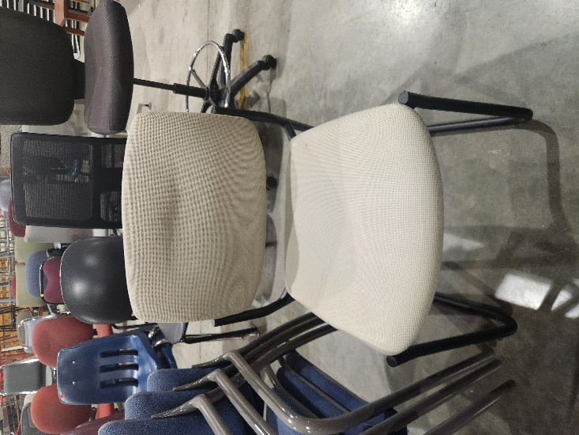

318- 20260313 Maroon Chair
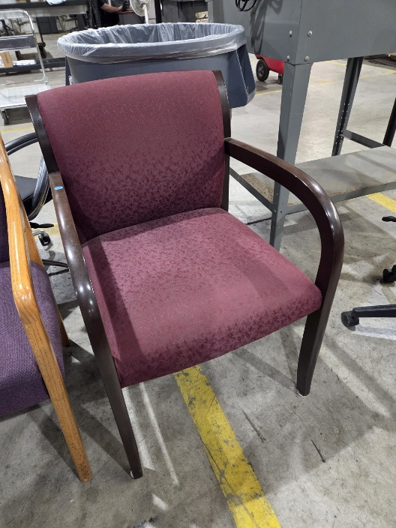

323- 20260410 Green Chair
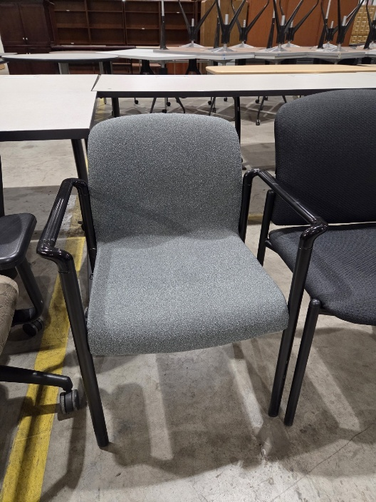

326- 20260515 Blue Chair w/ Wheels
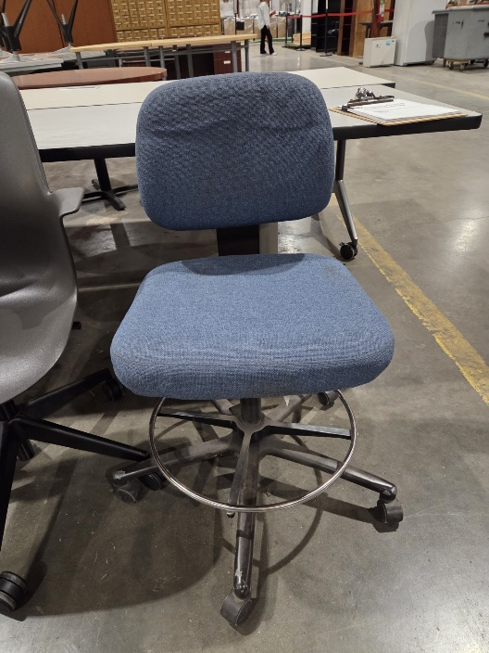

328- 20250630 Two-Seated Green Chair
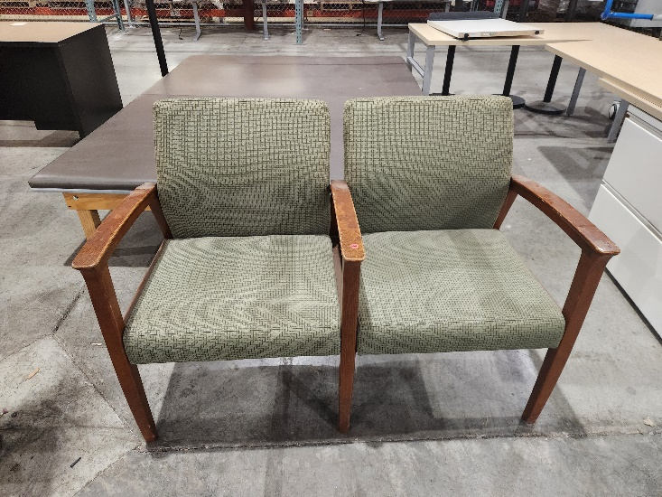

329- 20260605 Wooden Chair w/ Patterned Cushion (QTY 8)
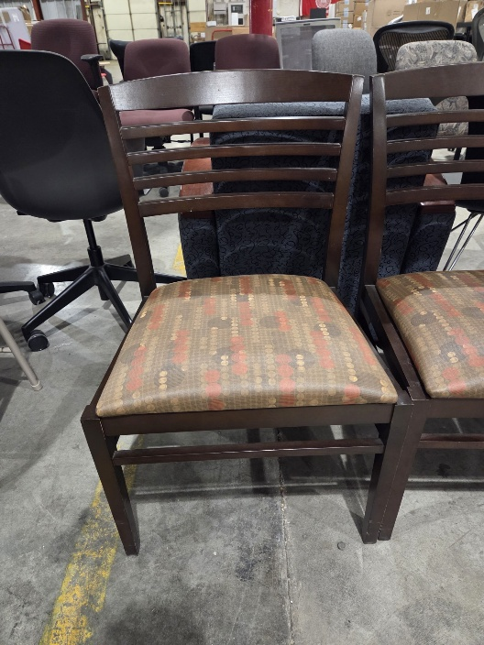

358- 20250616 Wooden Chair (QTY 6)
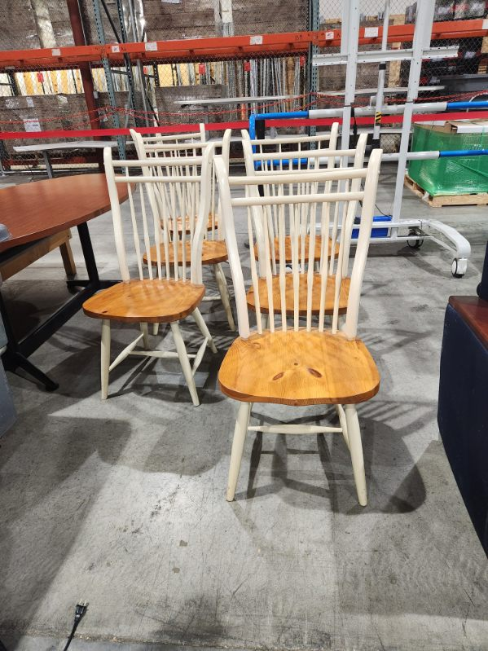

361- 20260724 Blue Chair w/ Wheels
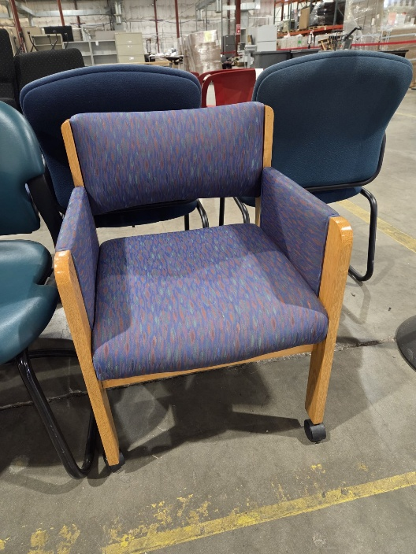
364- 20260724 Black Chair w/ Wheels
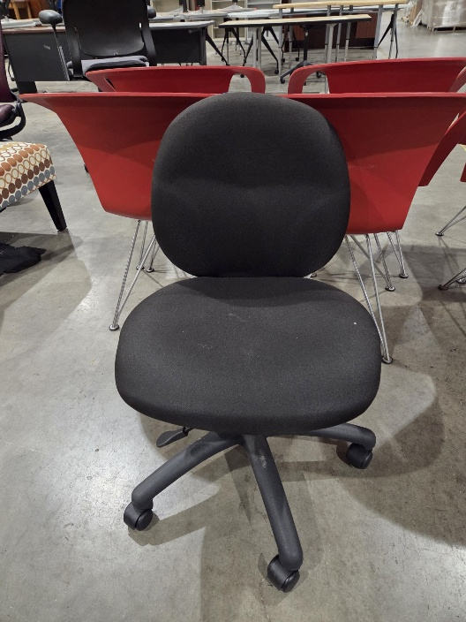

366- 20260807 Red Chair w/ Wheels
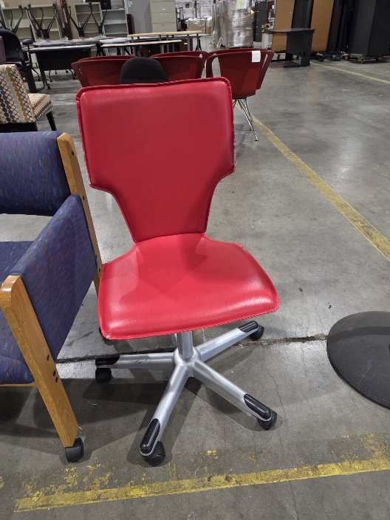

367- 20260807 Green Chair
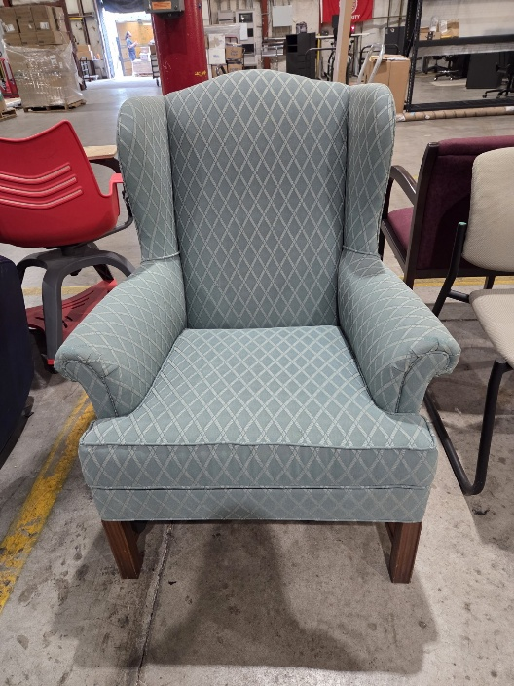

385- 20260227 Red Chair w/ Desk & Wheels (QTY 2)
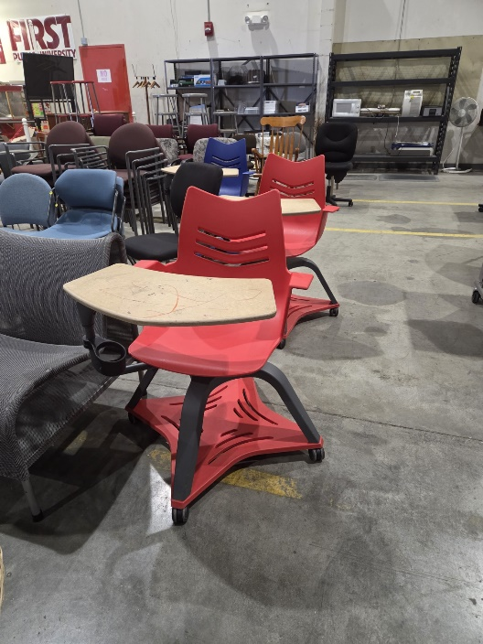

389- 20260227 Blue Chair w/ Desk & Wheels
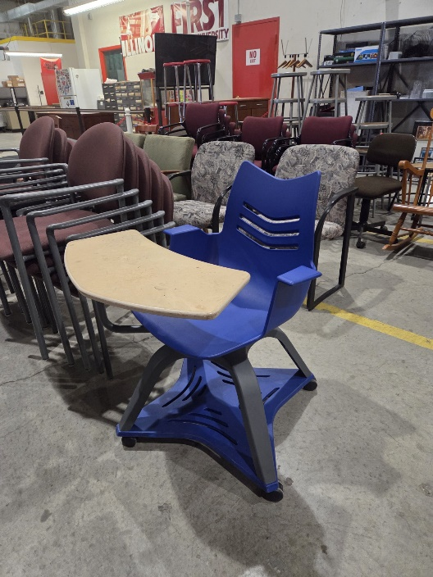

392- 20250815 Red Stool (QTY 8)
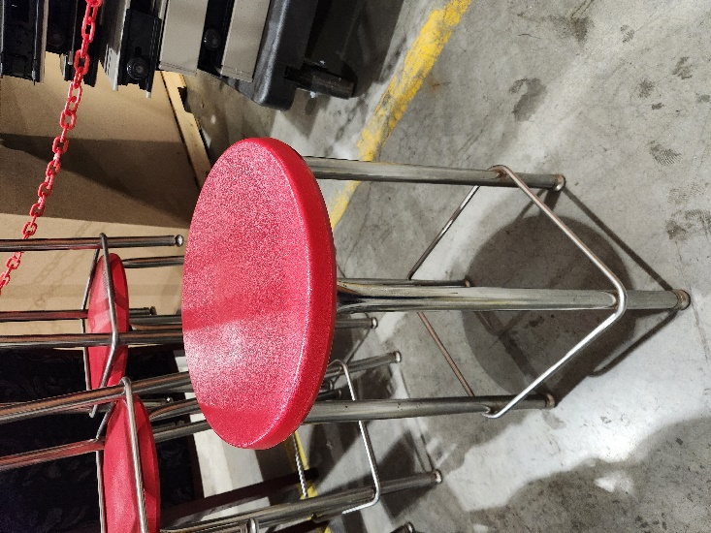

393- Gray Stool (QTY 3)
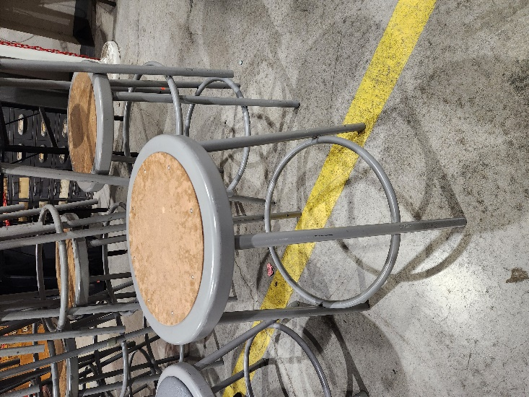

394- 20250815 Black Stool (QTY 2)
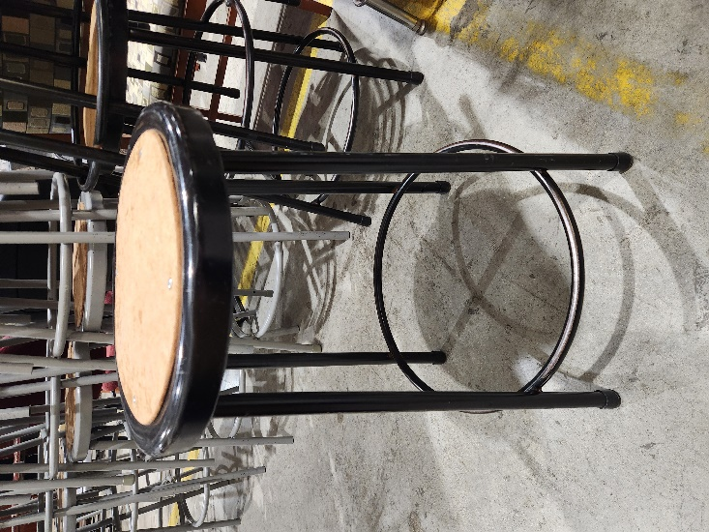

Office Equipment & Miscellaneous Equipment
408 – 20250317 Dual Monitor Stand (QTY 2)
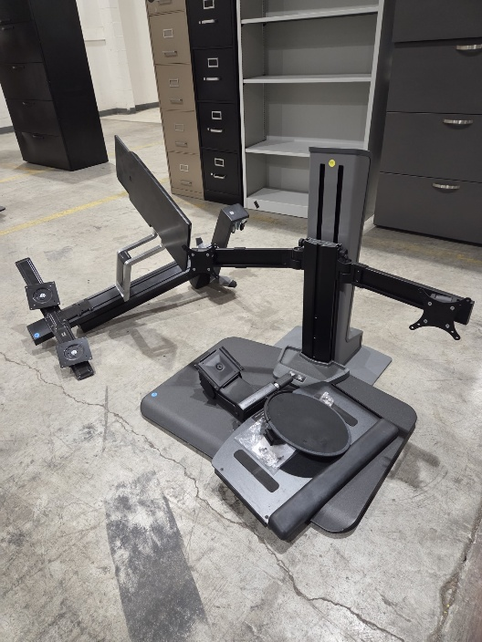
410 – 20250527 Office Supplies/Miscellaneous (3 Pictures)
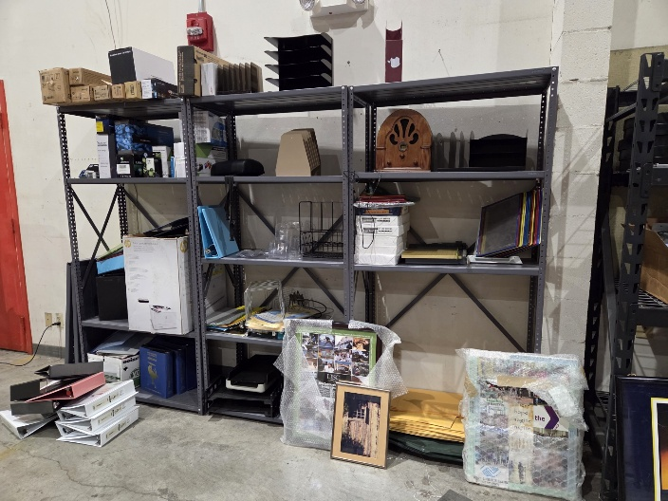
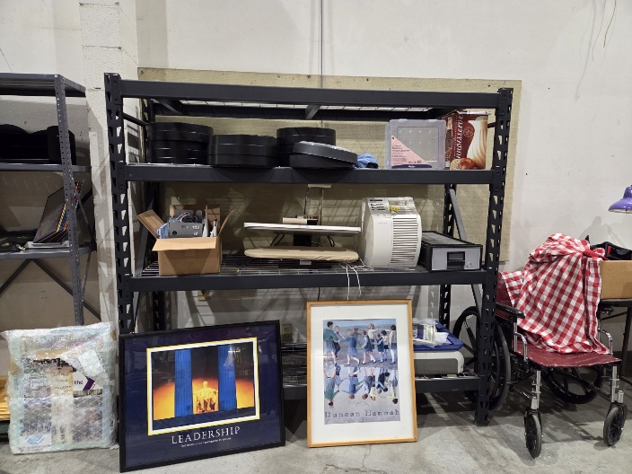
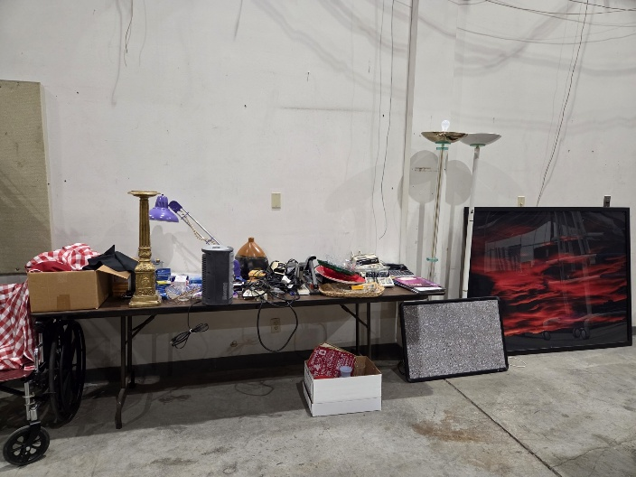

424- 20250829 Tripod Stand (QTY 3)
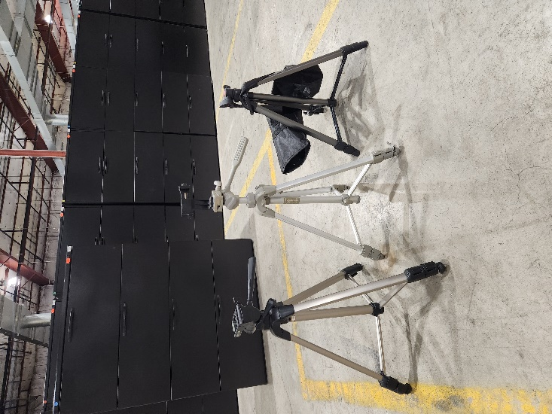

429- 20251107 Cell Phone/Tablet Holder Stand
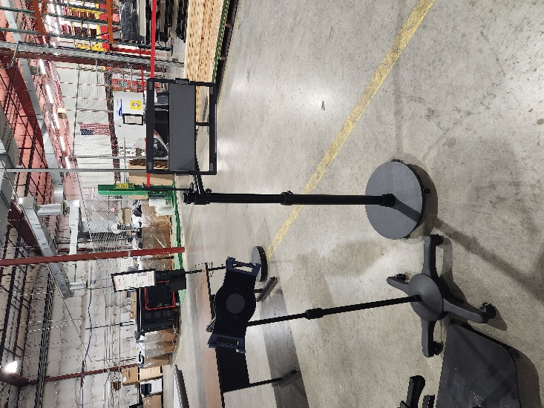

438- 20260327 Large Whiteboard (QTY 2)
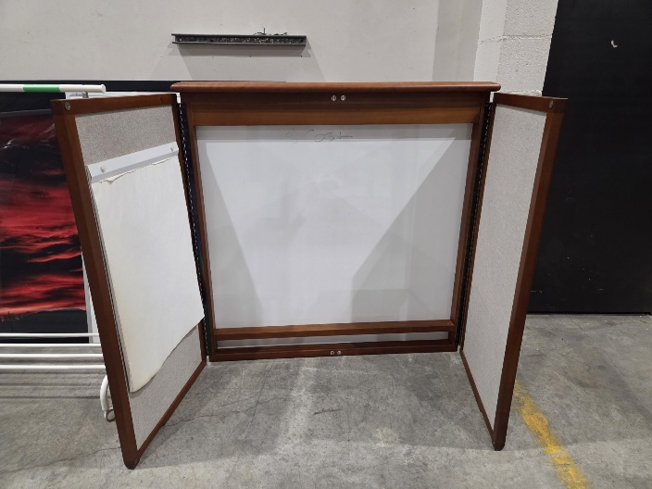

439- 20260720 Wooden Speaking Podium
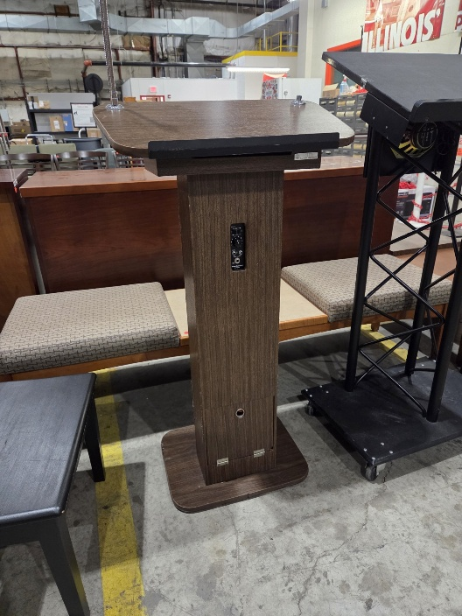

440- 20260720 Black Speaking Podium
