Updated: 20261005

ISU Property Control Surplus Catalog

This surplus catalog is for reference only. To claim an item, you must come to the Warehouse Road complex. This catalog will be updated each Monday.
Table of Contents
Cabinets & Shelving Units 3
Desks & Tables 29
Chairs 41
Office Equipment & Miscellaneous Equipment 47

Cabinets & Shelving Units

101- 20260828 Short Black Filing Cabinet
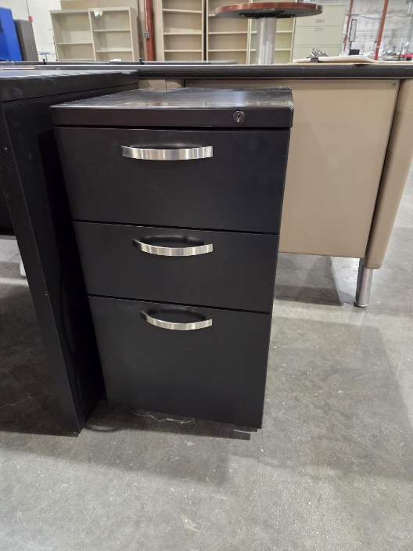
102- 20260918 Small Gray Filing Cabinet
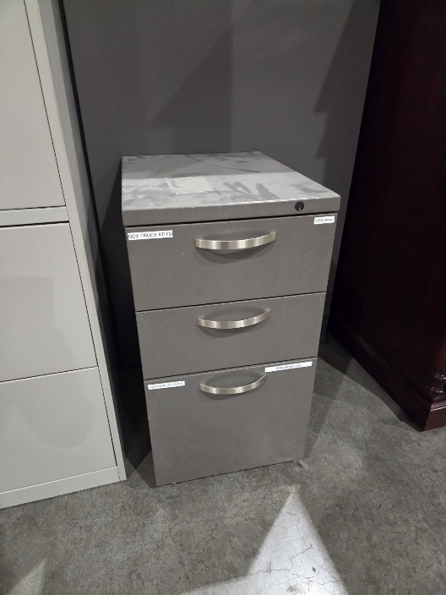

103- 20260403 Wooden Filing Cabinet
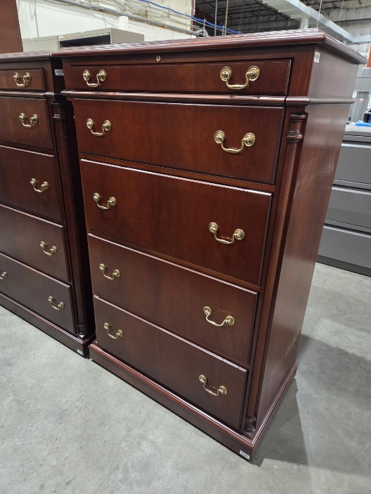
104- 20260904 Short Tan Filing Cabinet
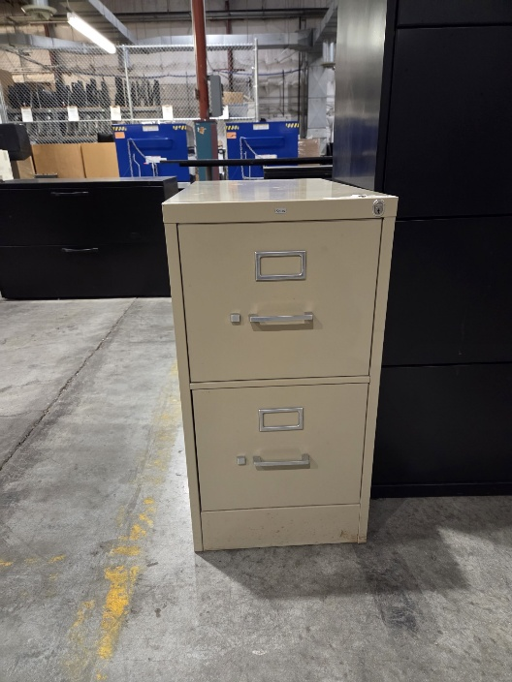

105- 20260904 Gray Filing Cabinet
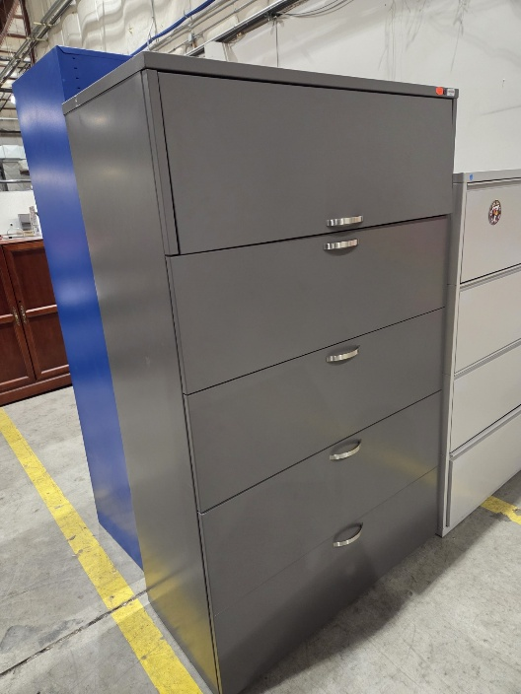

106- 20260706 Wooden Credenza
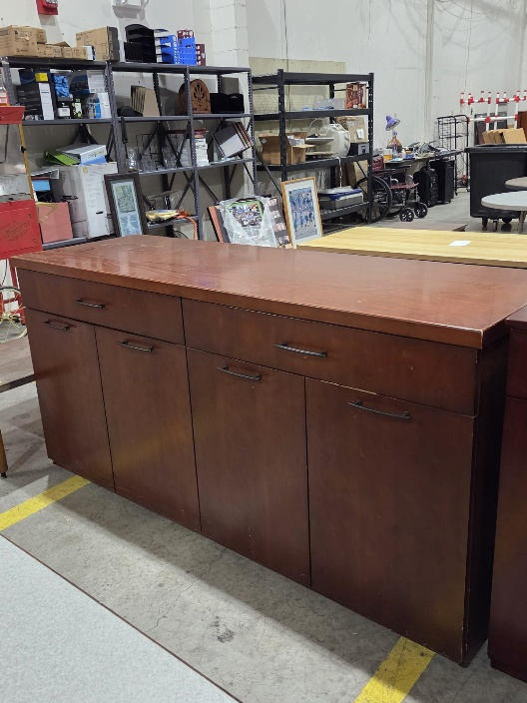
107- 20260904 Black Bookshelf
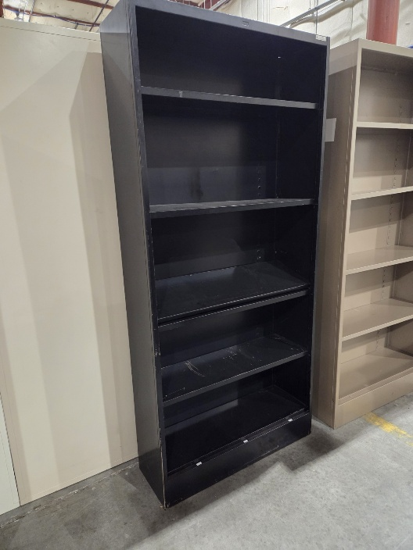

108- 20260526 Tan Bookshelf (QTY 3)
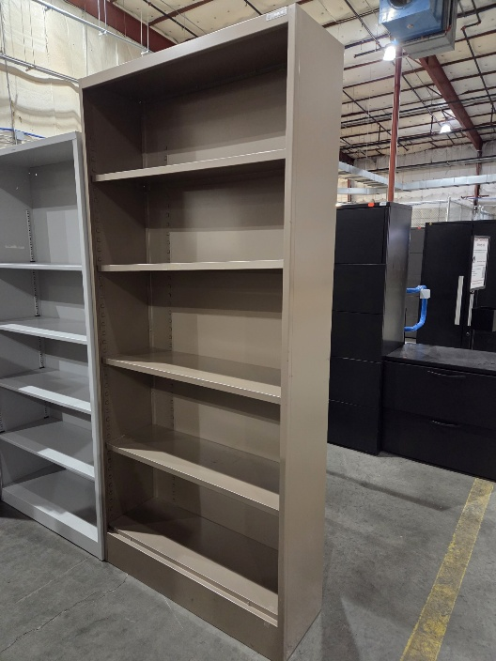
109- 20260629 Wooden Credenza
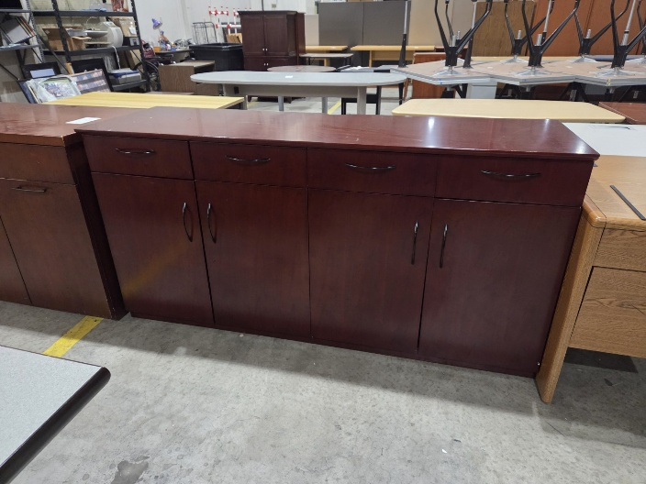

110- 20260904 Gray Bookshelf
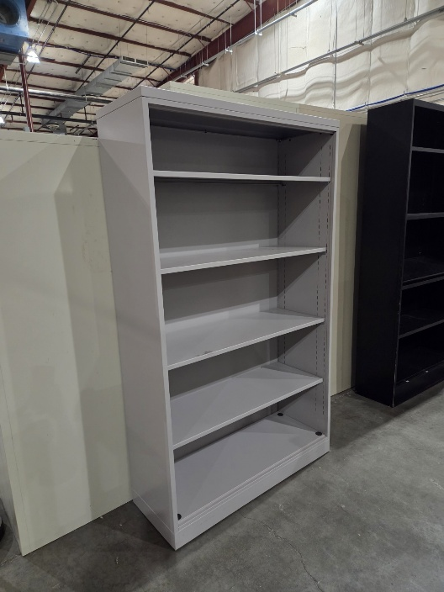

112- 20260918 Gray Filing Cabinet
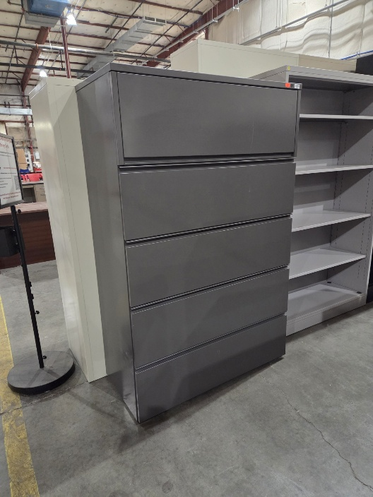

113- 20260612 Black Cabinet
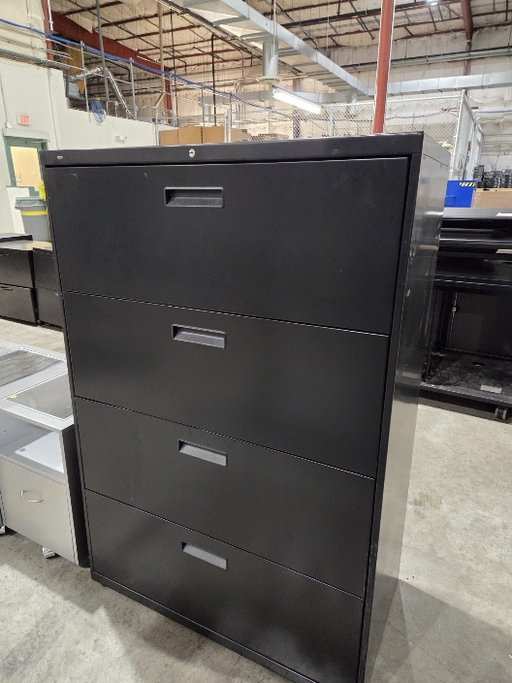

114- 20260828 Short White Filing Cabinet
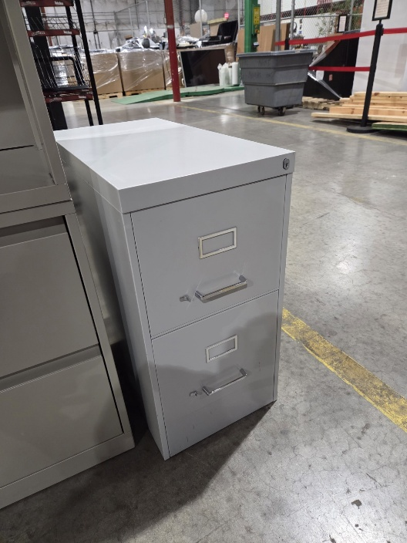

115- 20260828 Metal Racks/Shelves (QTY 3)
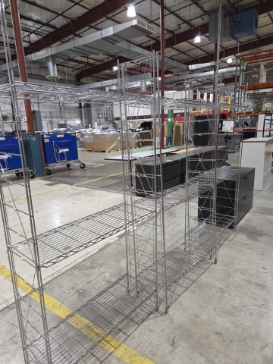

116- 20260828 Black Rack/Shelf
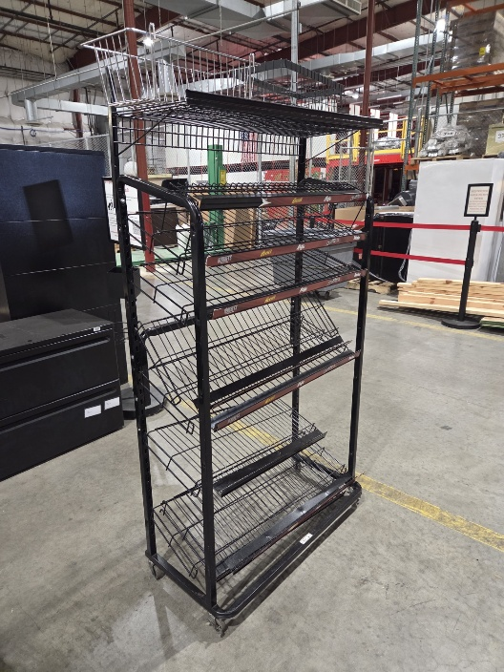

117 – 20250317 Brown Filing Cabinet
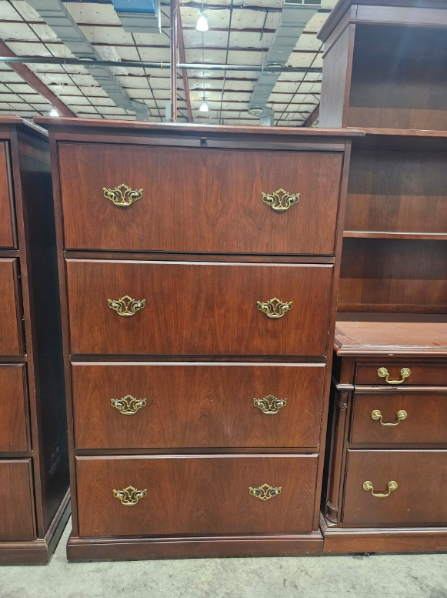
118- 20260918 Short Gray Filing Cabinet
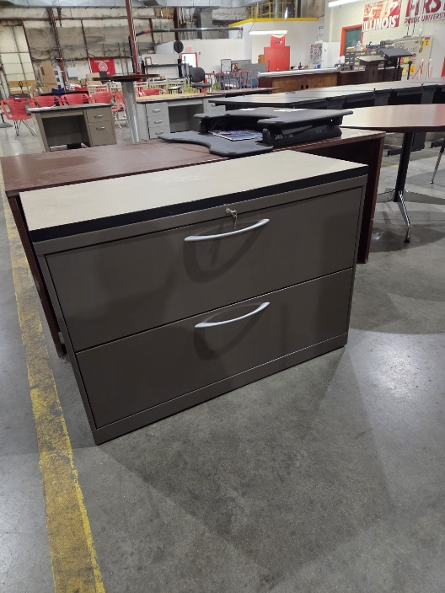

119- 20260918 Gray Filing Cabinet
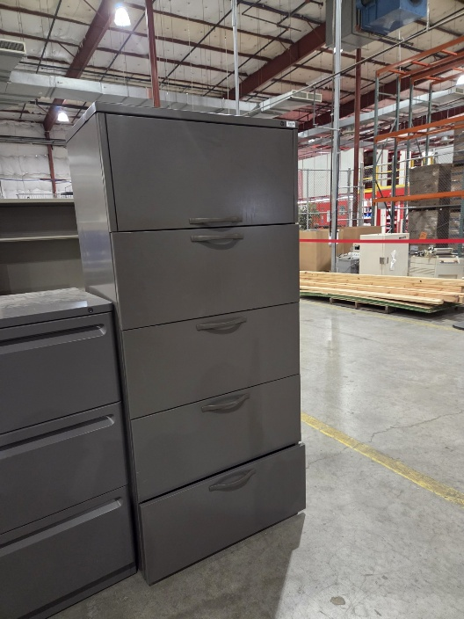

120 – 20250317 Dark Brown Cabinet
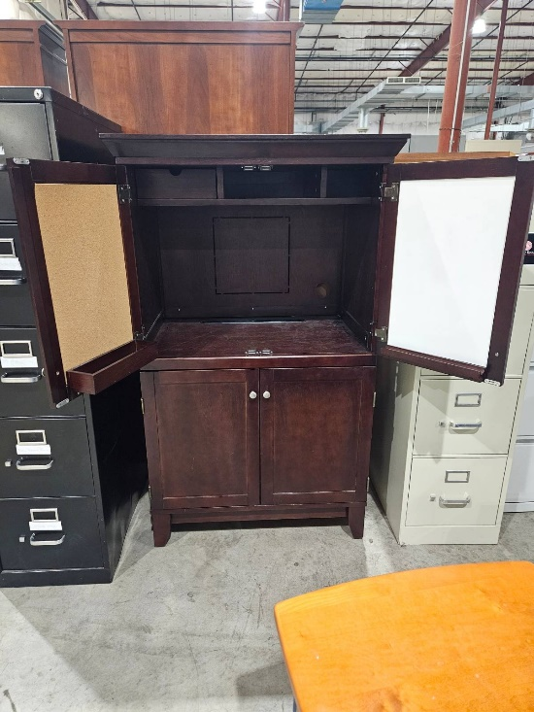

121- 20260918 Short Gray Filing Cabinet
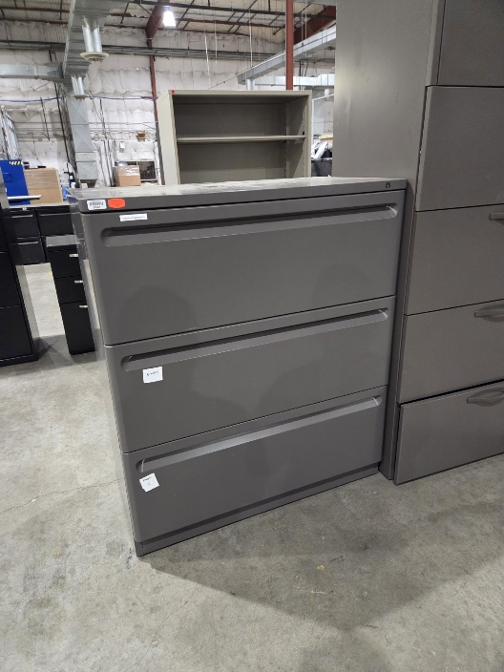

122- 20260925 Gray Bookshelf
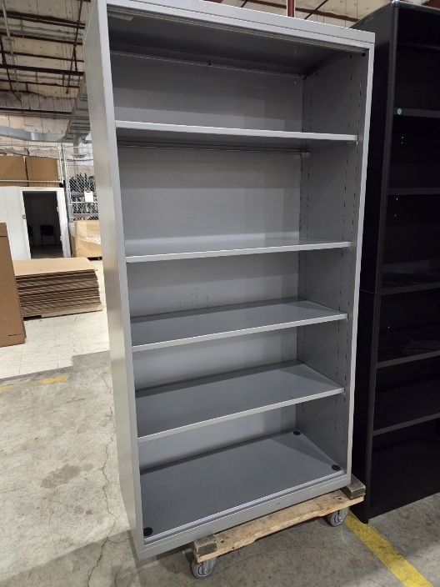
123- 20260925 Gray Filing Cabinet
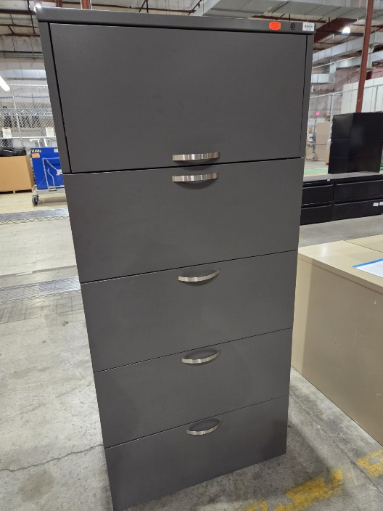

124- 20260925 Short Tan Filing Cabinet
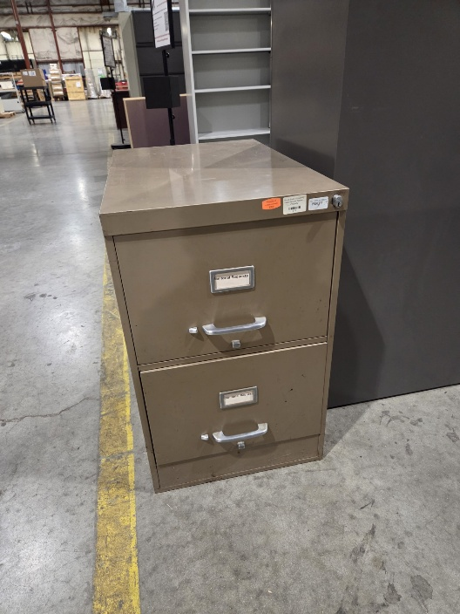
125- 20260925 White Filing Cabinet
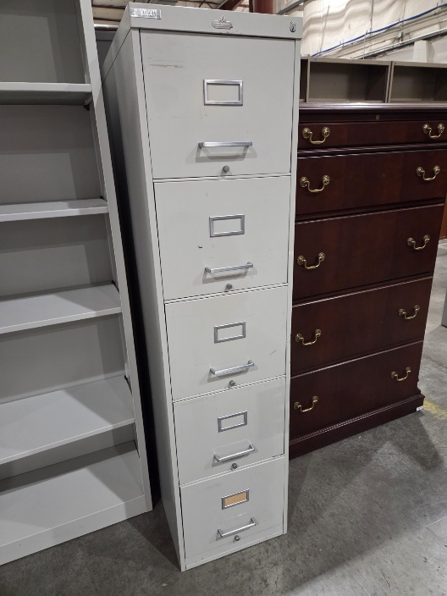

126- 20260925 Gray Bookshelf (QTY 2)
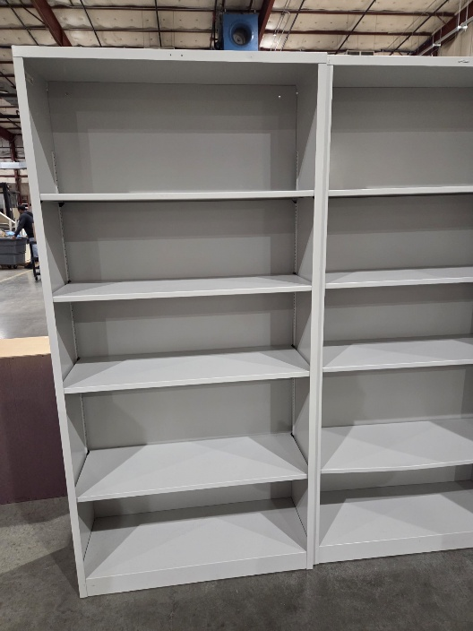

127- 20260313 Gray Filing Cabinet
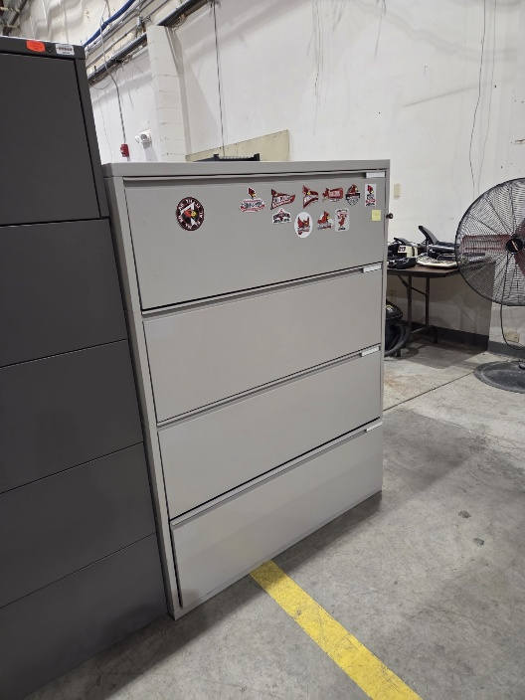

128- 20261002 Wooden Bookshelf
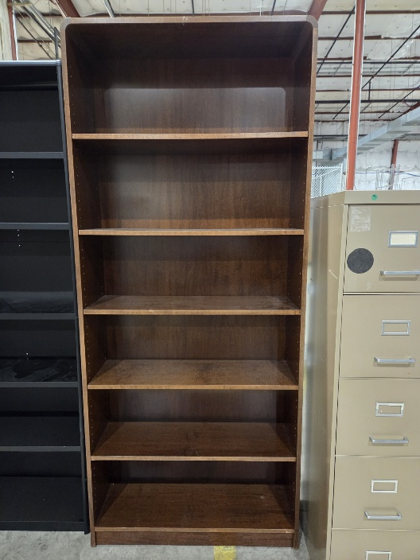

130- 20260720 Tan Filing Cabinet
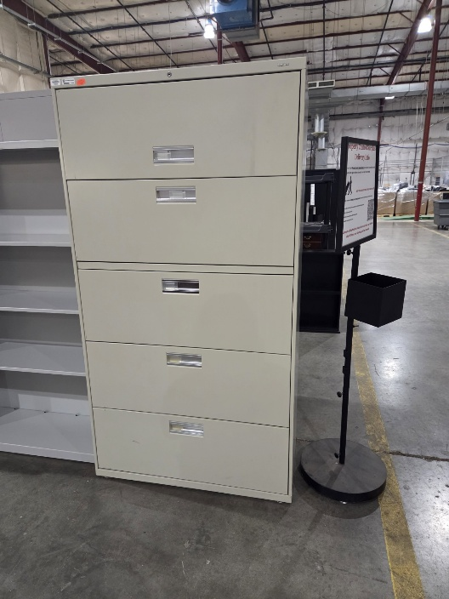

143- 20251121 Black Filing Cabinet
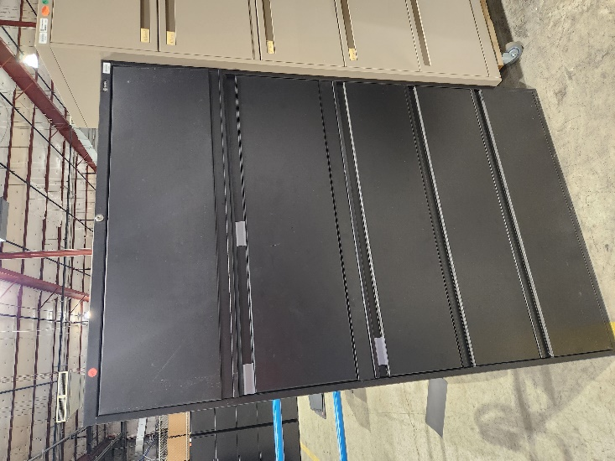

144- 20260904 Small Wooden Bookshelf
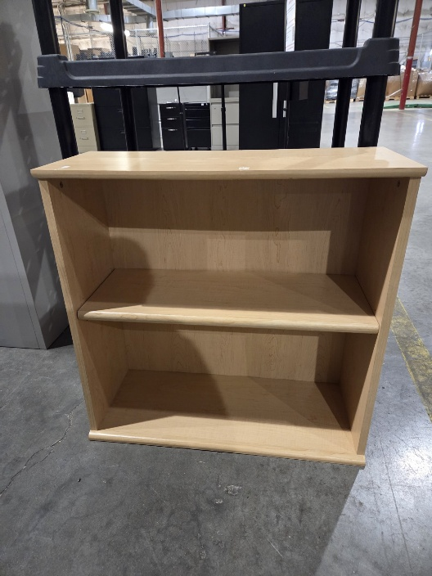

145- 20260928 Wooden Bookshelf
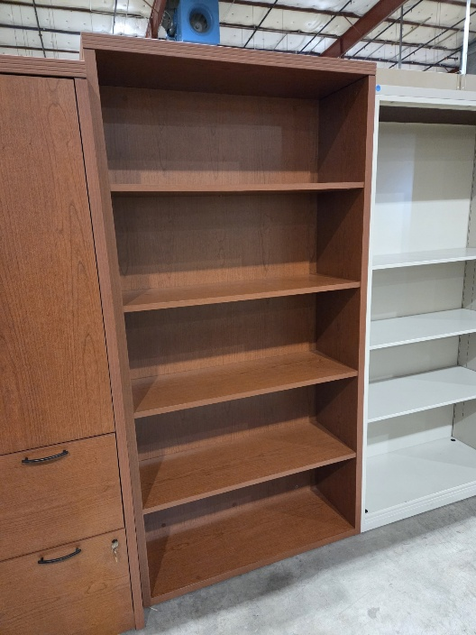

146- 20260928 Wooden Cabinet
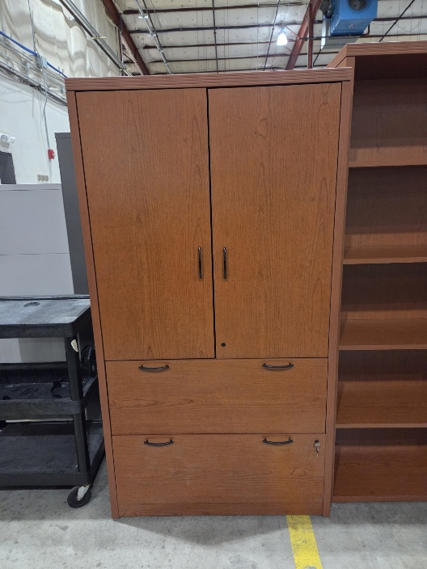

168- 20250822 Tall Gray Filing Cabinet
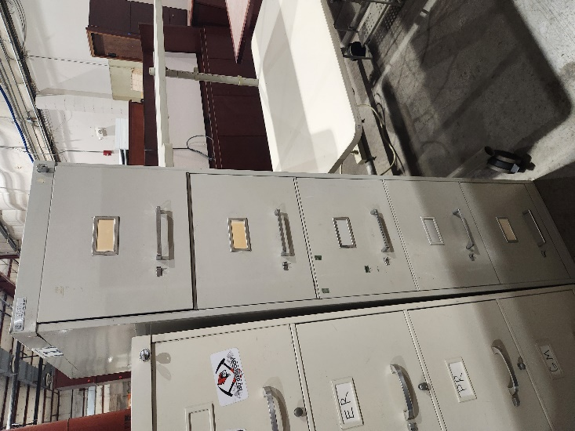

169- 20260424 Black Filing Cabinet
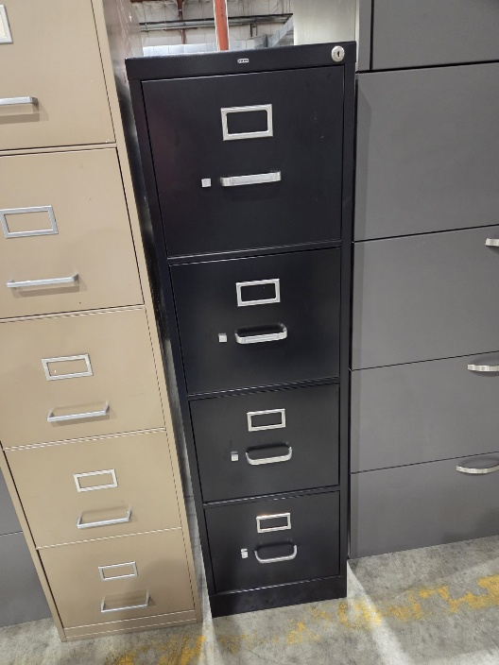

170- 20260914 Gray Filing Cabinet
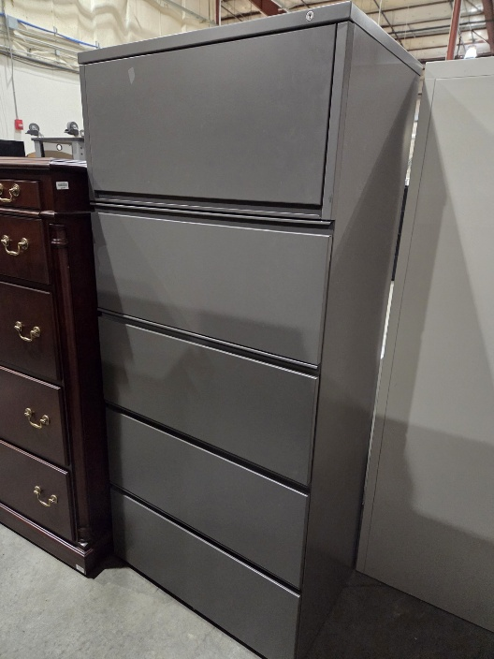

171- 20260914 Black Bookshelf
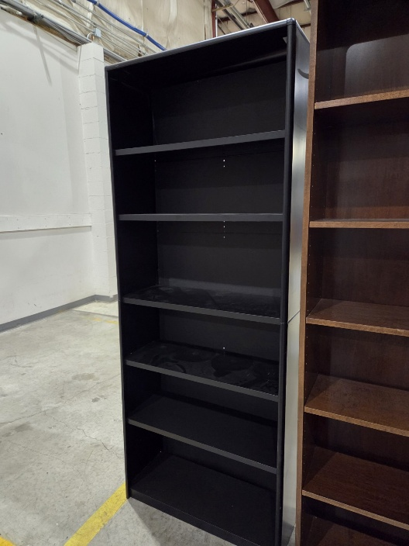
172- 20260914 Tan Bookshelf (QTY 2)
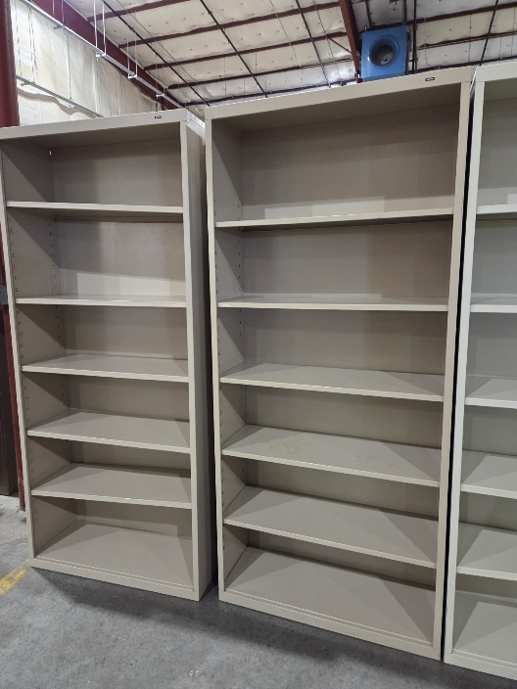

173- 20260914 White Bookshelf
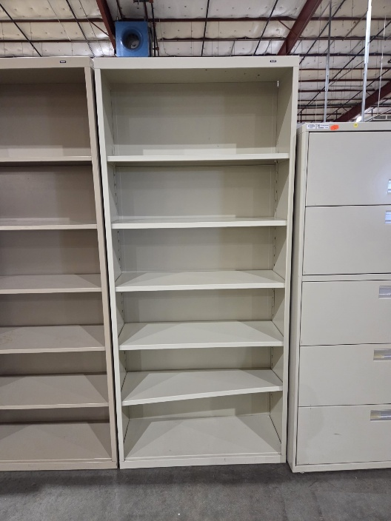

179- 20260622 White Cabinet w/ Shelf
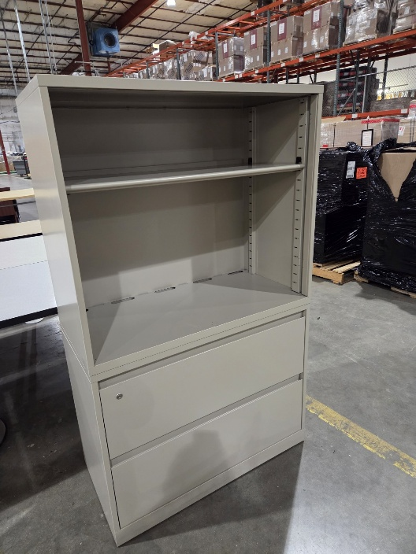

182- 20251010 Gray Filing Cabinet
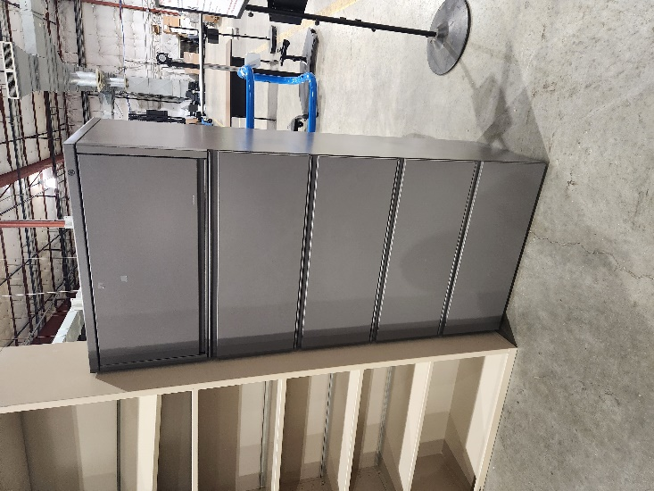

183- 20260227 Short Wooden Cabinet
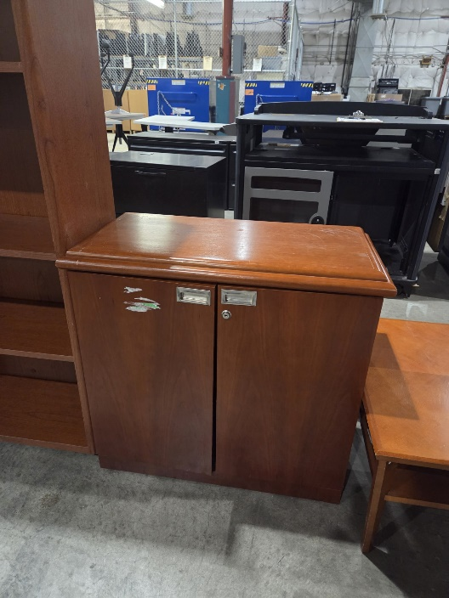

184- 20260622 Black Filing Cabinet
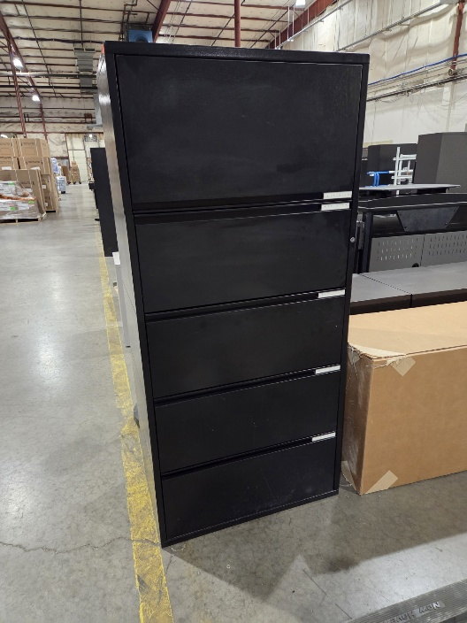

186- 20251107 White Filing Cabinet
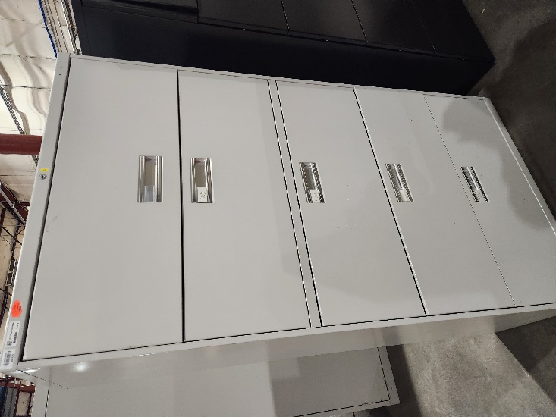

191- 20251114 Short Black Filing Cabinet (QTY 3)
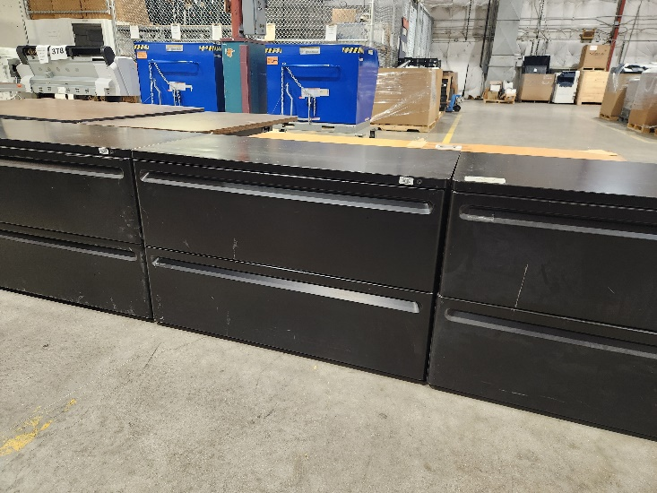

192- 20260807 Wooden Cabinet
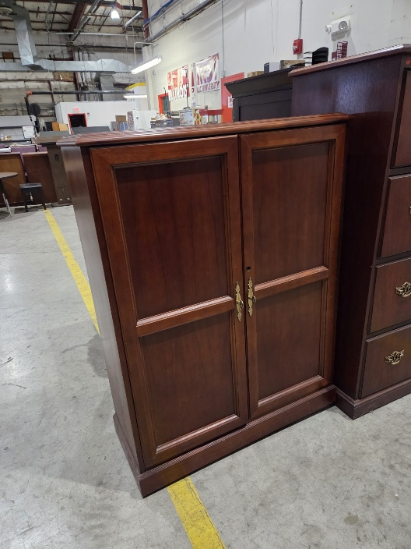

194- 20260105 Gray Filing Cabinet
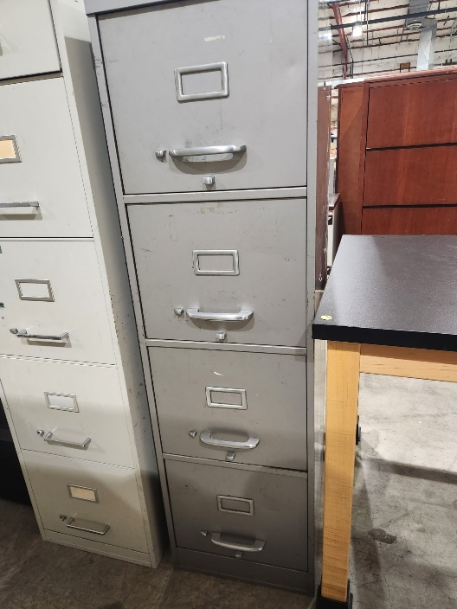

195- 20251114 Short Black Filing Cabinet
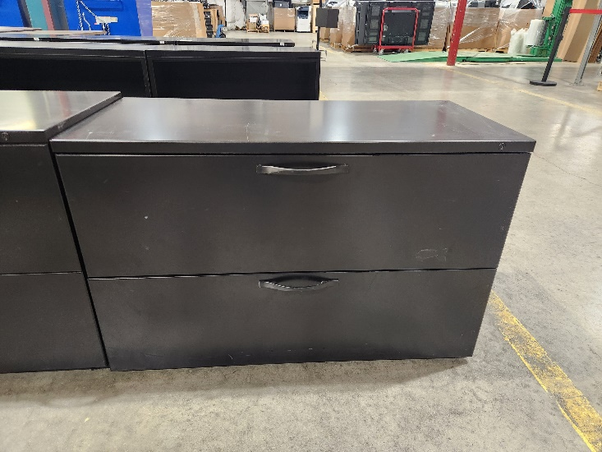

196- 20251114 Large Overhead Cabinet W/ 2 Drawers (2 Pictures)
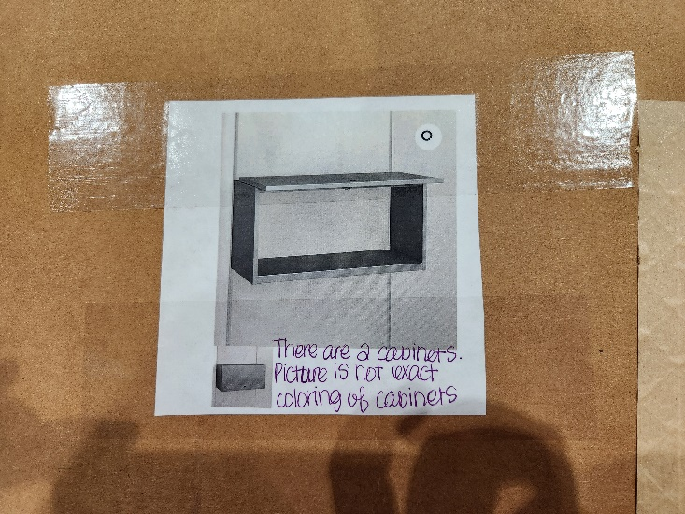
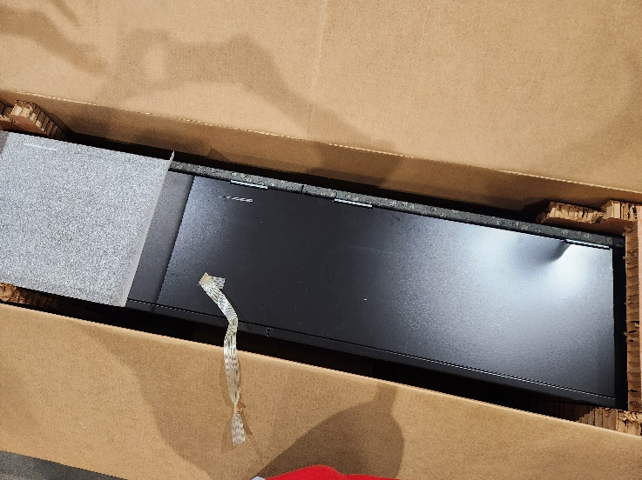

198- 20260720 White Bookshelf
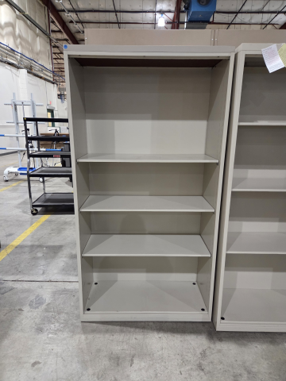

199-20260420 Tan Filing Cabinet
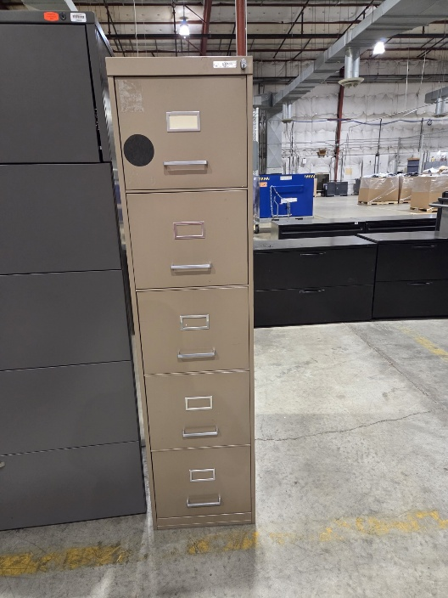

Desks & Tables

201- 20260918 Foldable Round Table
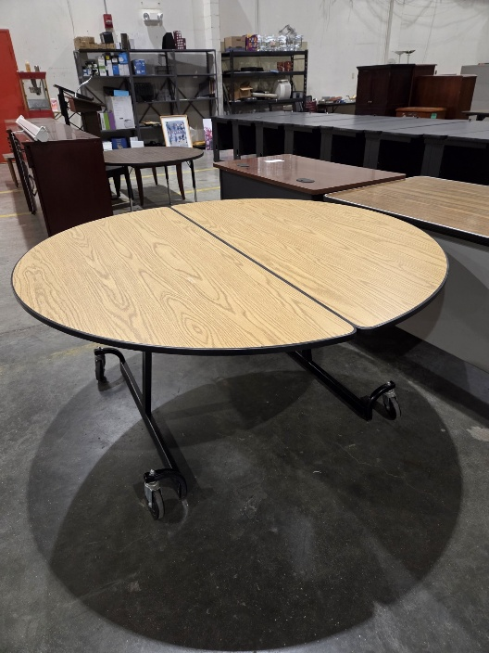
202- 20260925 Brown Metal Desk
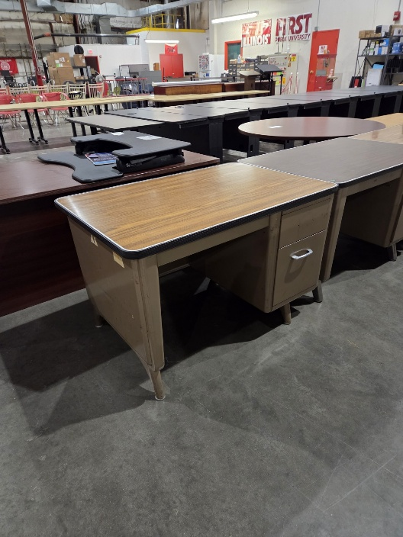

203- 20260925 Tan Table (QTY 10)
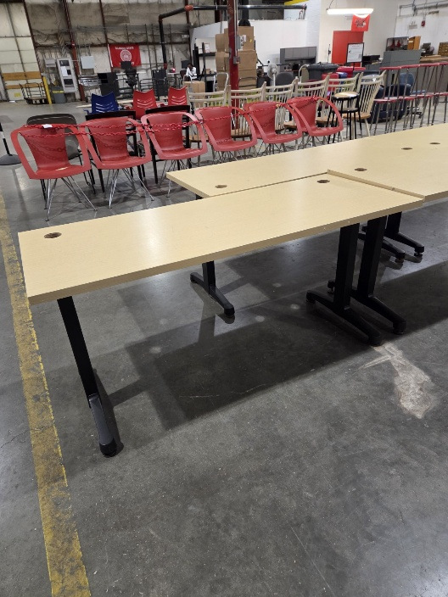
204- 20260925 Tan Table
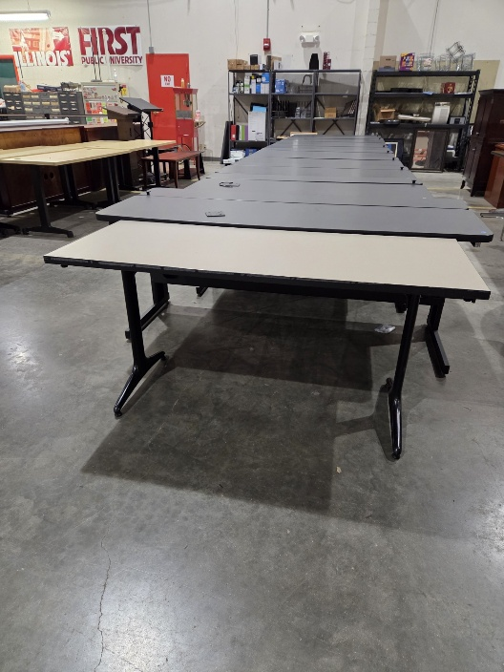

205- 20260925 Gray Table
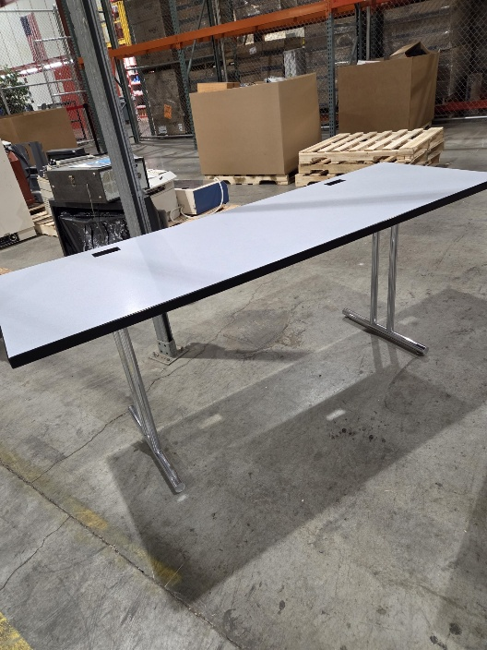
206- 20260925 White Table
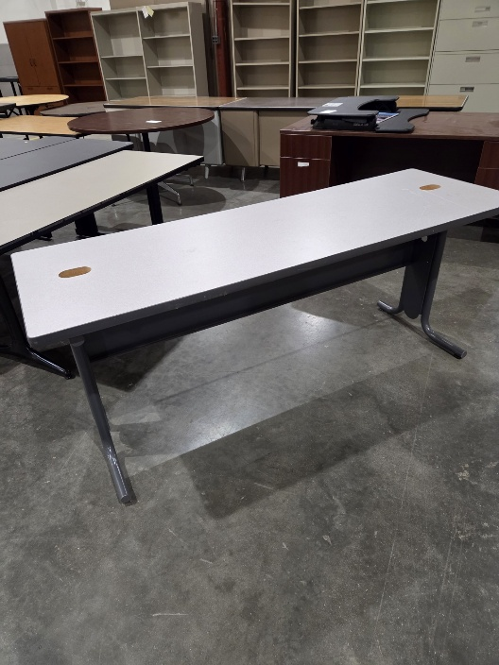

207- 20260925 Tall Wooden Table w/ Wheels
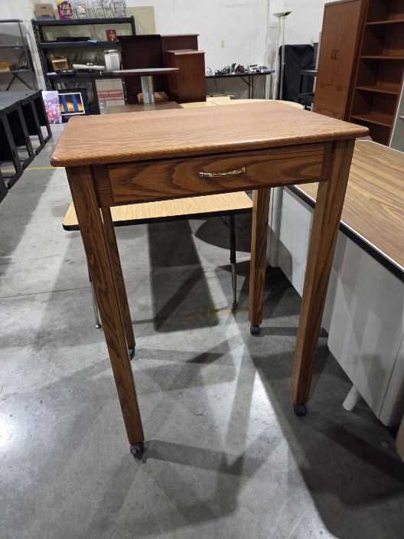

211- 20260612 Round Wooden Table
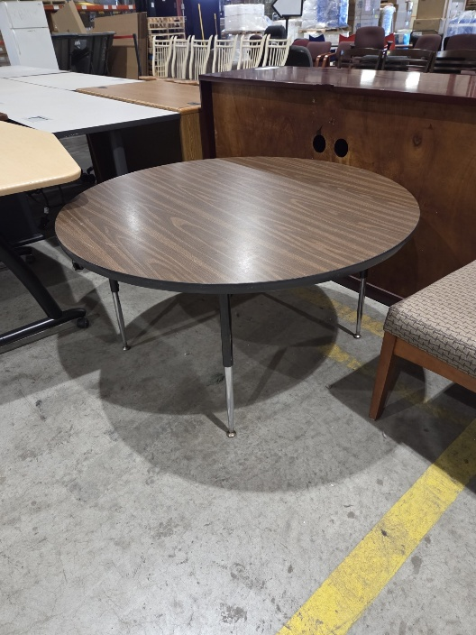

212- 20260526 Small Black Bench
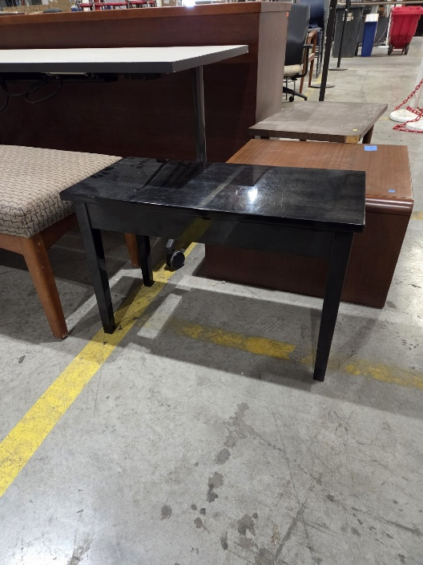

217- 20260720 Rolling Workstation (QTY 3)
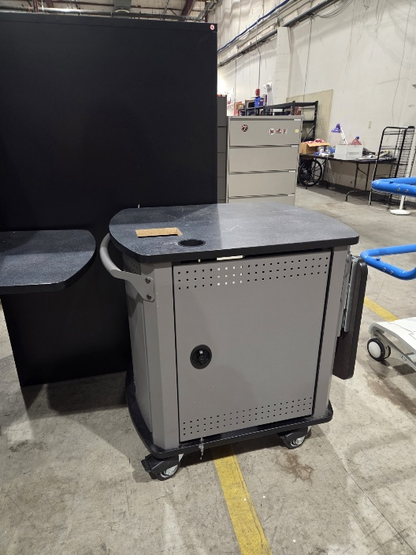

219- 20260706 Small Black Table/Bench
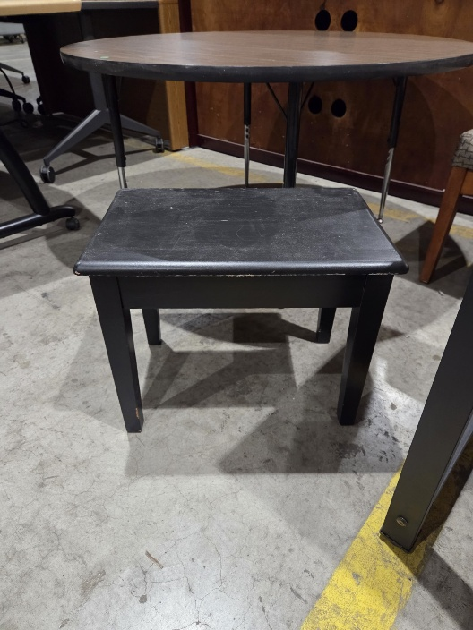

253- 20250829 Wooden Coffee Table
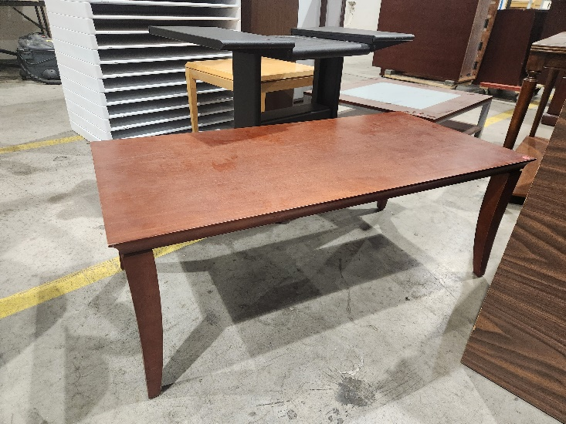

254- 20260814 Black Metal Deak w/ Monitor Stand Compartment (QTY 8)
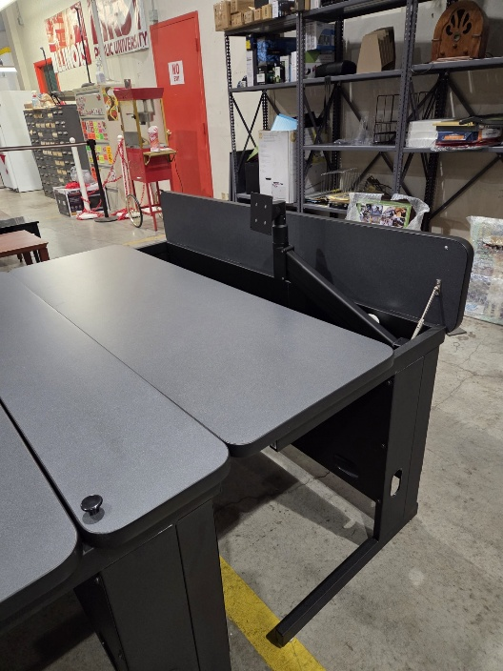

255-20260814 Black Metal Desk w/ Monitor Stand Compartment
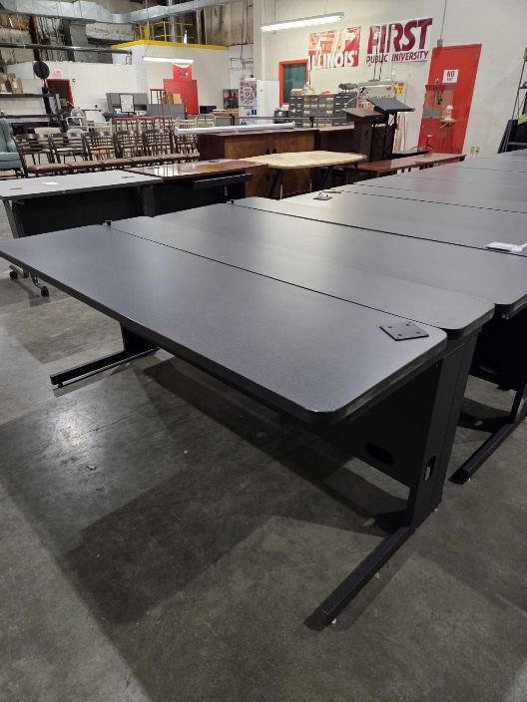

274- 20250815 Wooden Desk
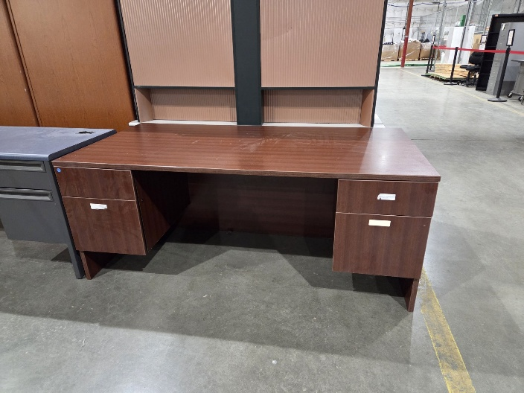

275- 20260904 Black/Wooden Table
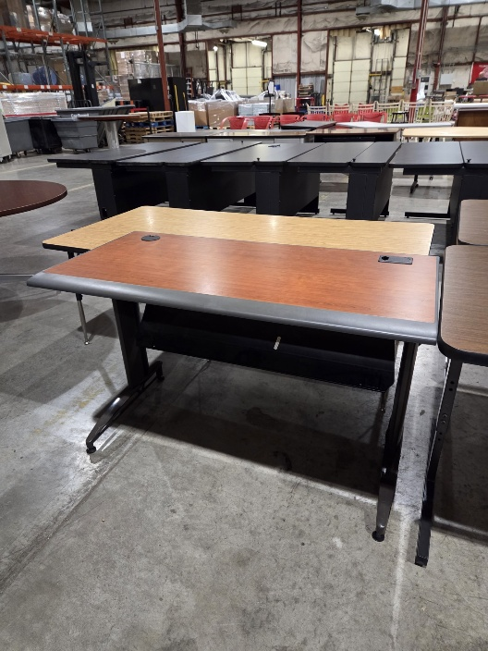

276- 20260904 Long Wood Top Table
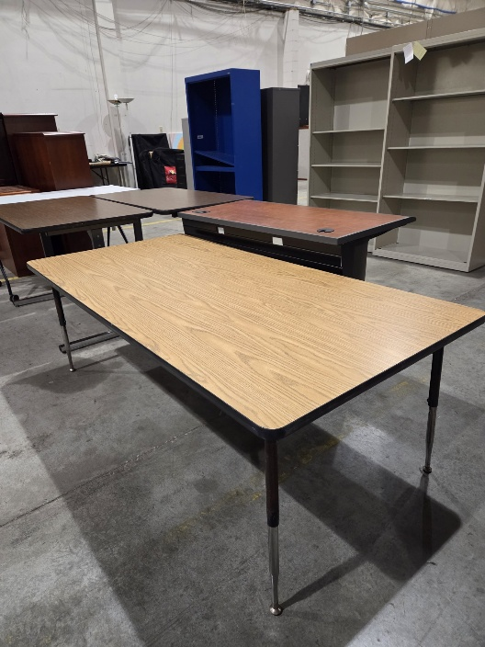
277- 20260904 Wood Top Table (QTY 2)
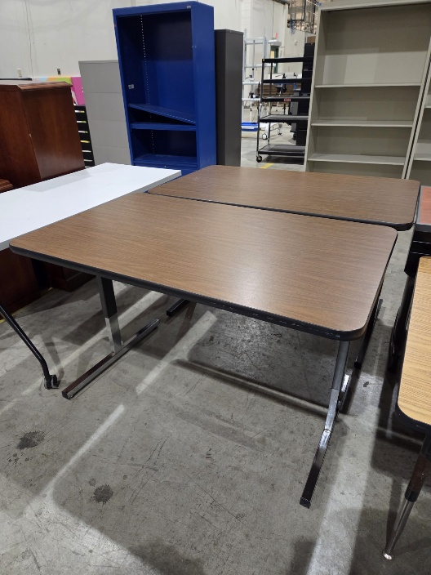

289- 20260828 Tall Round Table
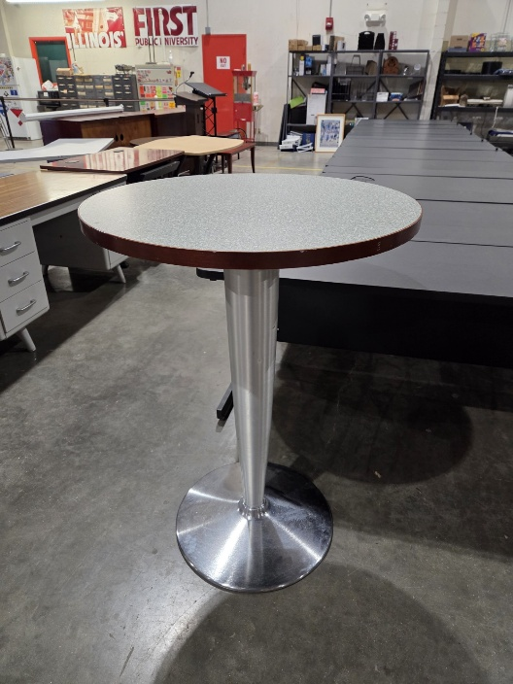

291- 20260914 Metal Desk
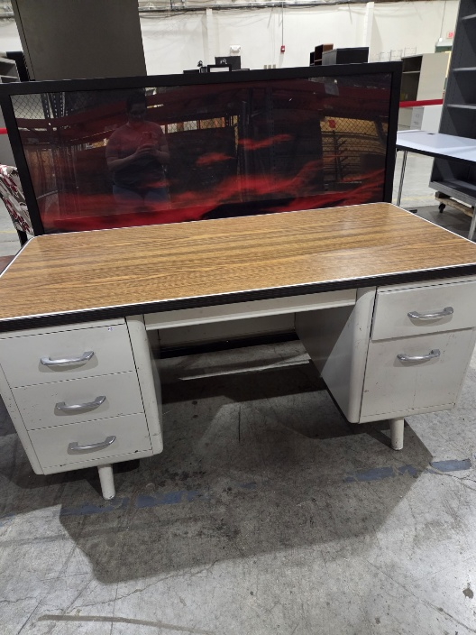

292- 20260828 Brown Metal Desk w/ Wooden Tabletop
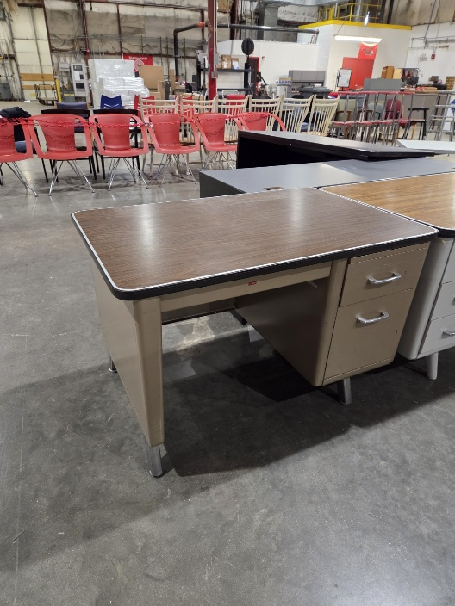
293- 20260828 Black Wooden Coffee Table
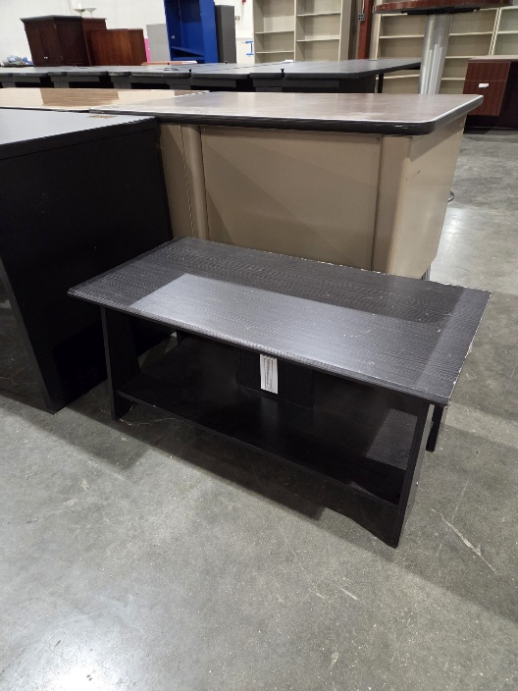

299- 20260420 Small Wooden Table
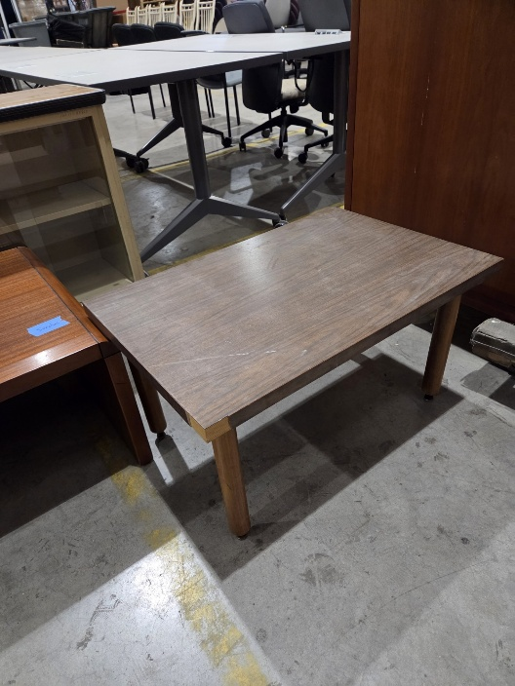

Chairs
301- 20260925 Black Chair
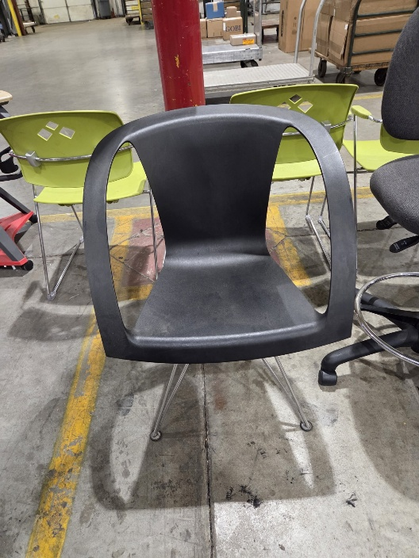

303- 20260925 Maroon Chair w/ Wheels
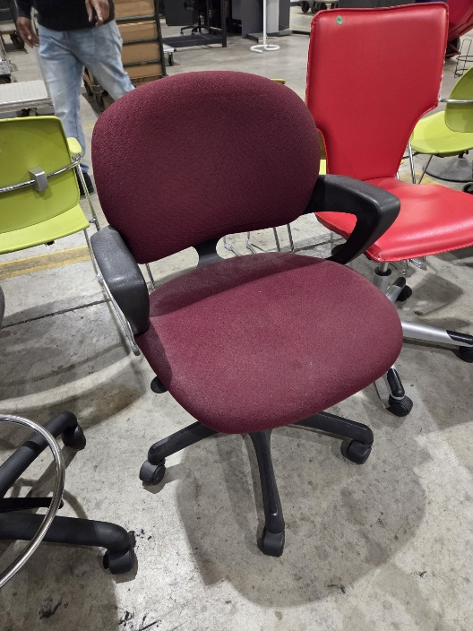

326- 20260515 Blue Chair w/ Wheels
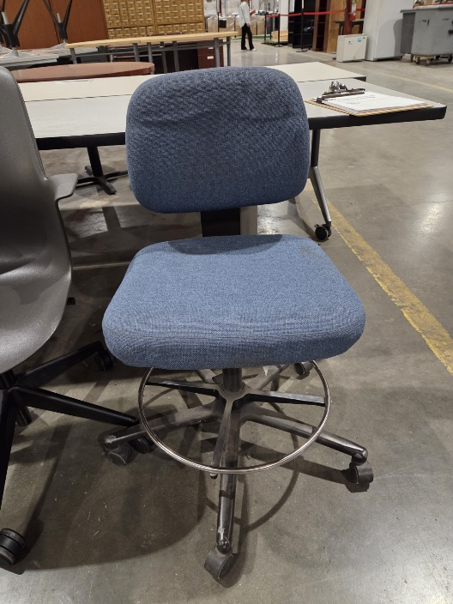

358- 20250616 Wooden Chair (QTY 6)
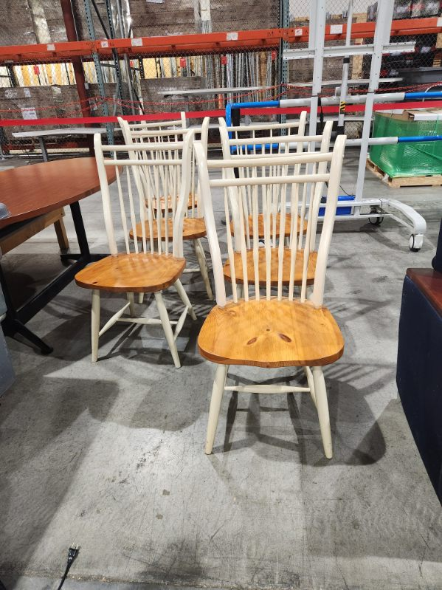

366- 20260807 Red Chair w/ Wheels
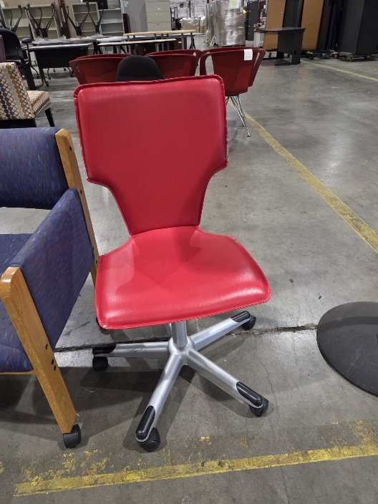

368- 20260904 Green Chair (QTY 6)
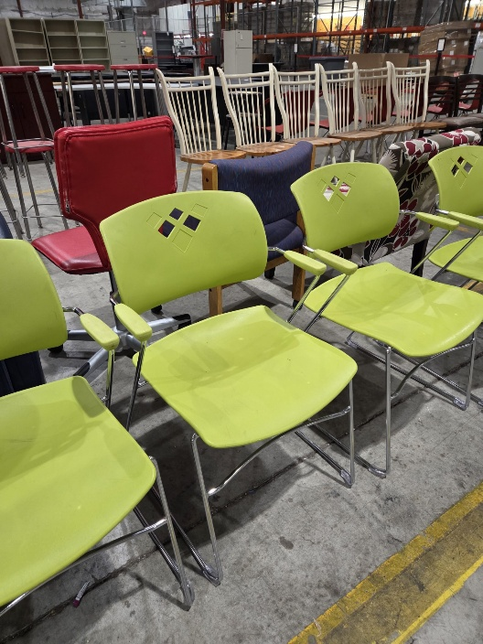

369- 20261002 Black Chair w/ Wheels
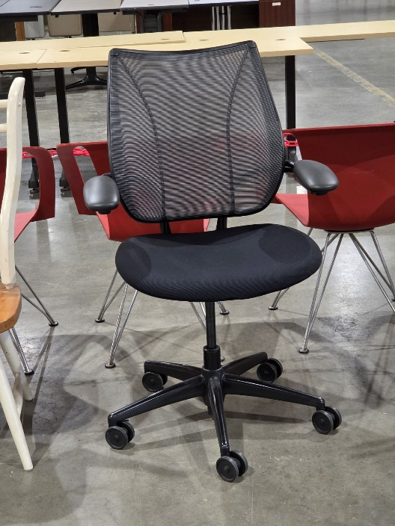

385- 20260227 Red Chair w/ Desk & Wheels (QTY 2)
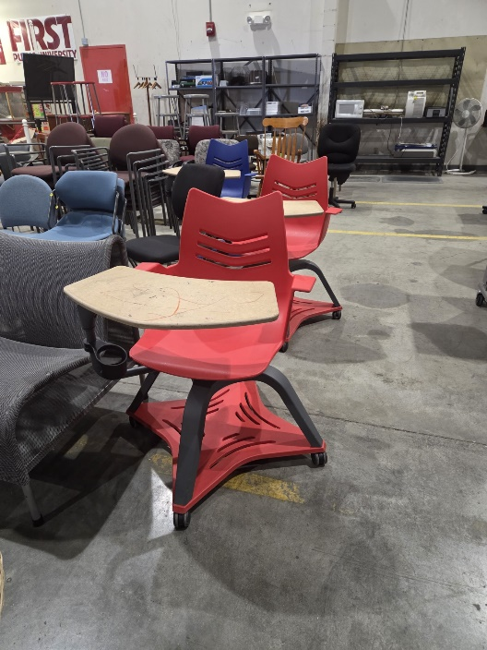

389- 20260227 Blue Chair w/ Desk & Wheels
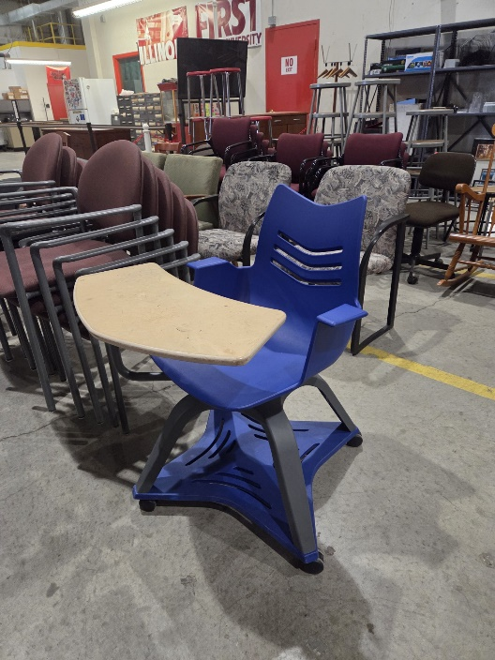

390- 20260914 Gray Chair (QTY 2)
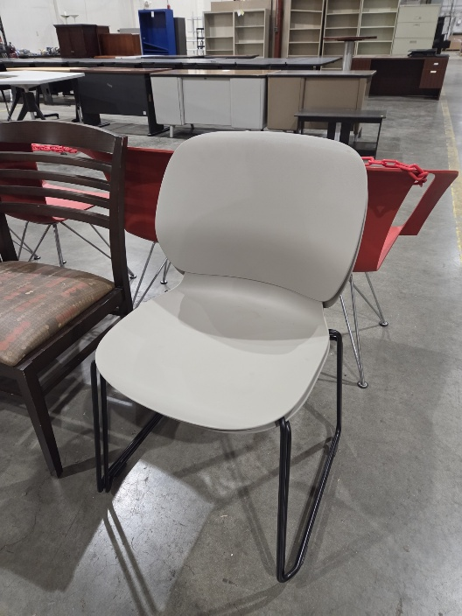

392- 20250815 Red Stool (QTY 8)
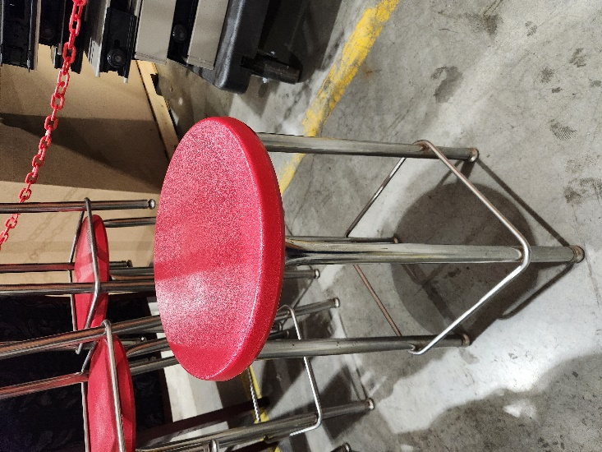

Office Equipment & Miscellaneous Equipment
408 – 20250317 Dual Monitor Stand (QTY 2)
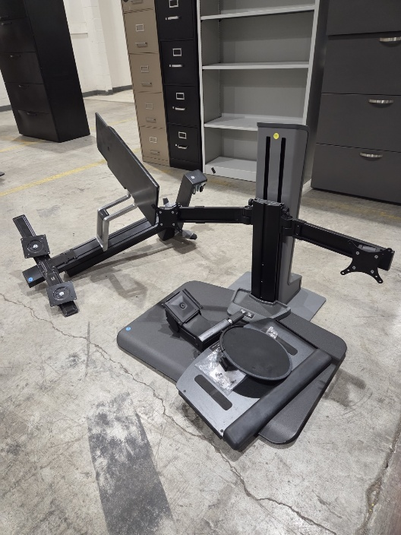
410 – 20250527 Office Supplies/Miscellaneous (4 Pictures)
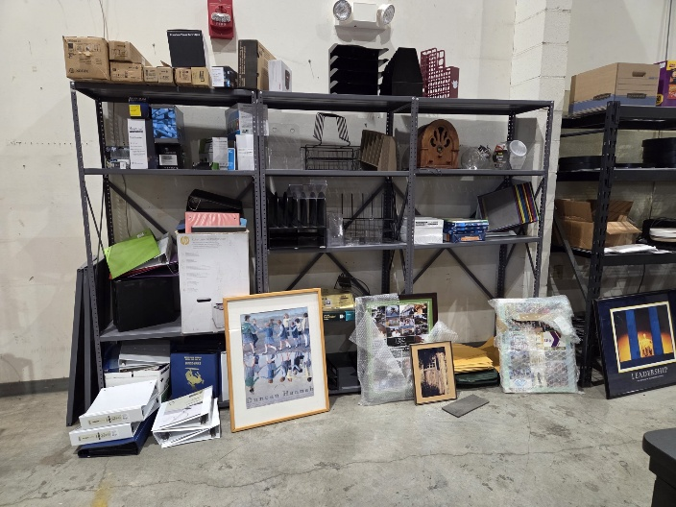
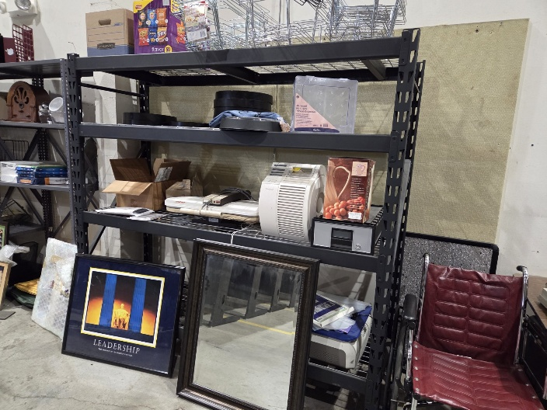
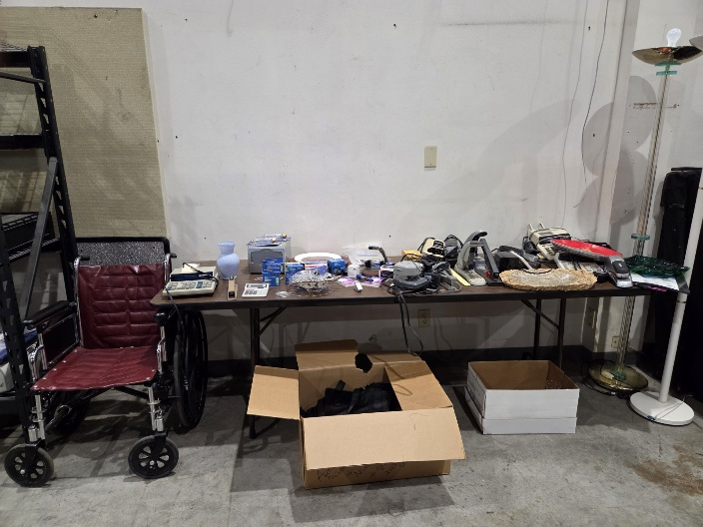
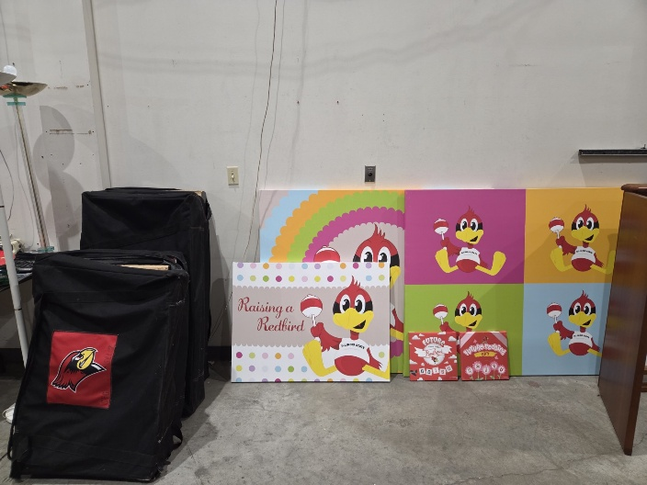

424- 20250829 Tripod Stand (QTY 3)
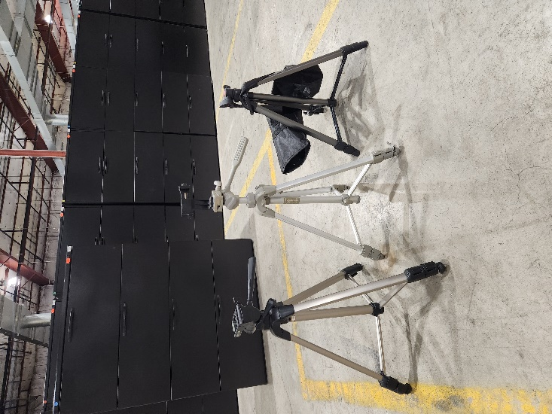

429- 20251107 Cell Phone/Tablet Holder Stand
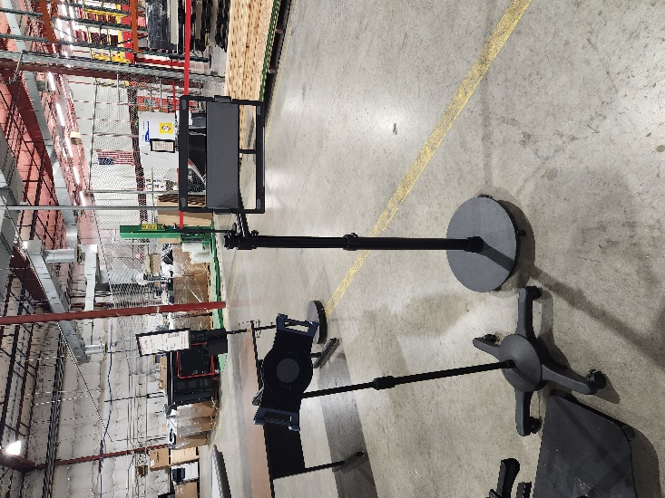

439- 20260720 Wooden Speaking Podium
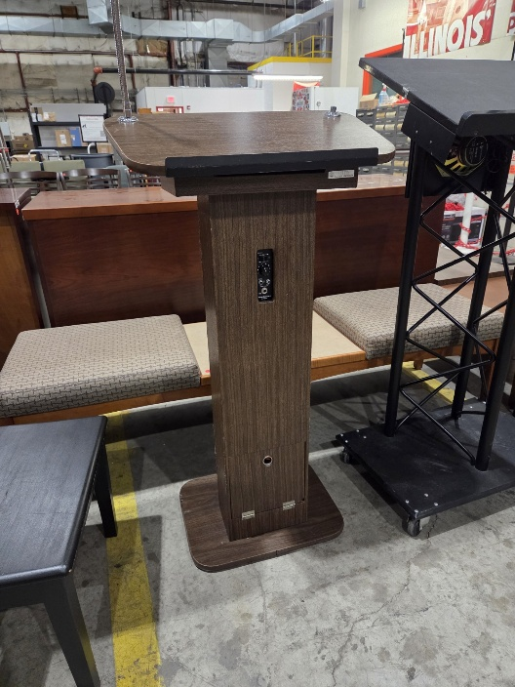

440- 20260720 Black Speaking Podium
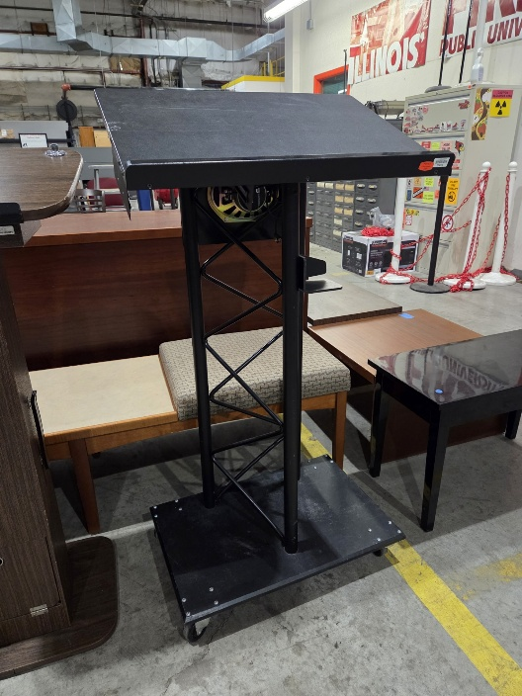

442- 20260904 Mobile Monitor Stand- Black
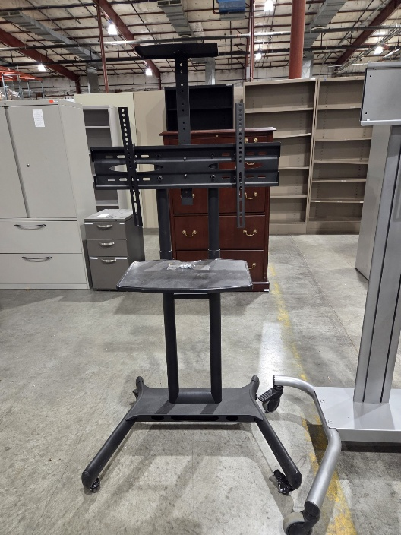
443- 20260904 Mobile Monitor Stand- Silver
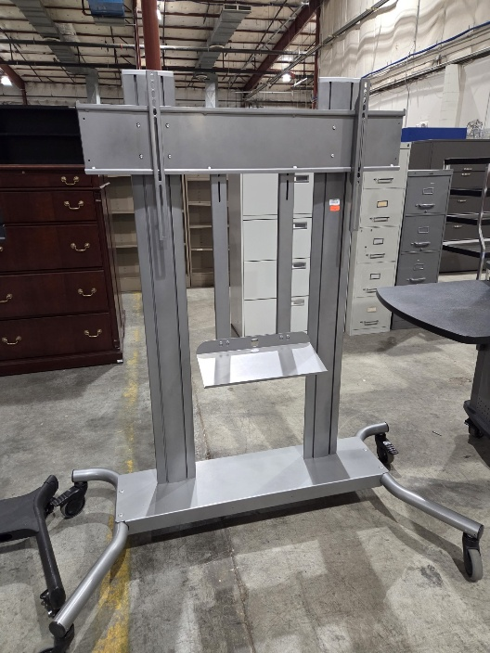

444- 20260918 Black Cart w/ Wheels
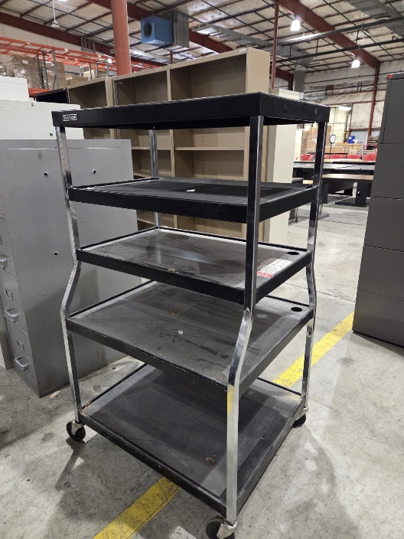
445- 20260918 Black Shelving Rack
