`Updated: 20260914

ISU Property Control Surplus Catalog

This surplus catalog is for reference only. To claim an item, you must come to the Warehouse Road complex. This catalog will be updated each Monday.
Table of Contents
Cabinets & Shelving Units 3
Desks & Tables 23
Chairs 33
Office Equipment & Miscellaneous Equipment 41

Cabinets & Shelving Units

100- 20260320 Black Cabinet
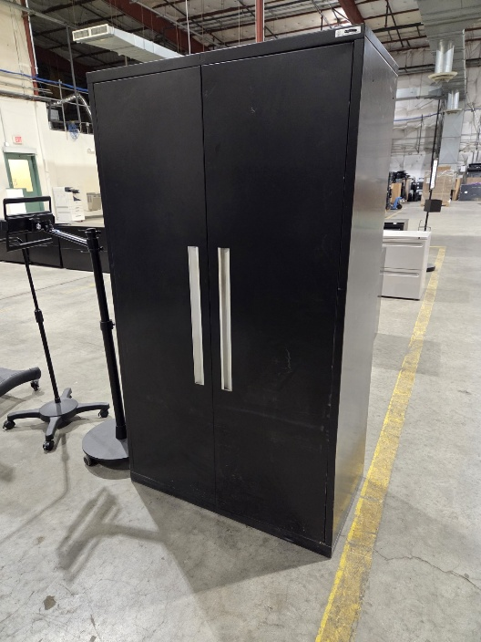
101- 20260828 Short Black Filing Cabinet
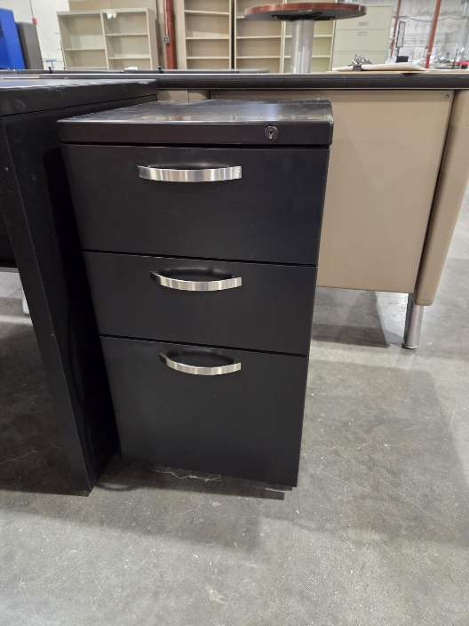

102- 20260828 Short Black Filing Cabinet
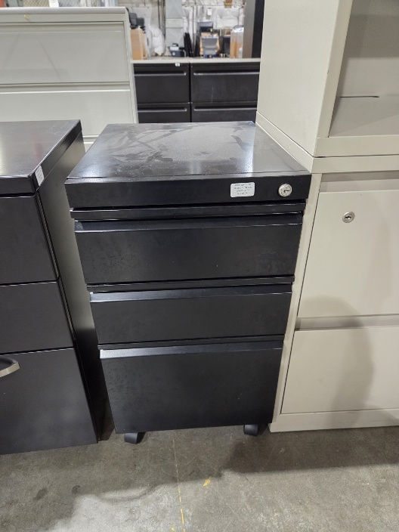

103- 20260403 Wooden Filing Cabinet (QTY 2)
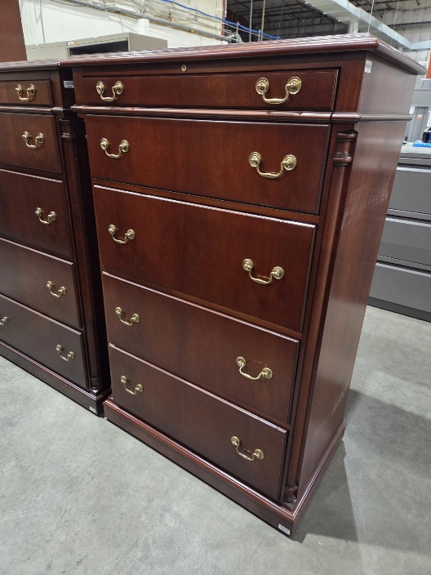
104- 20260904 Short Tan Filing Cabinet
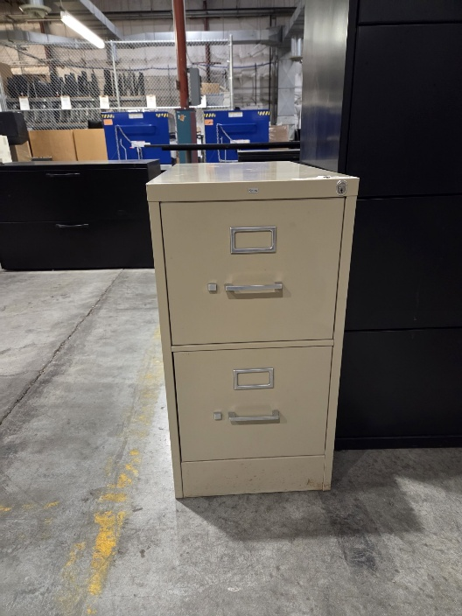
105- 20260904 Gray Filing Cabinet
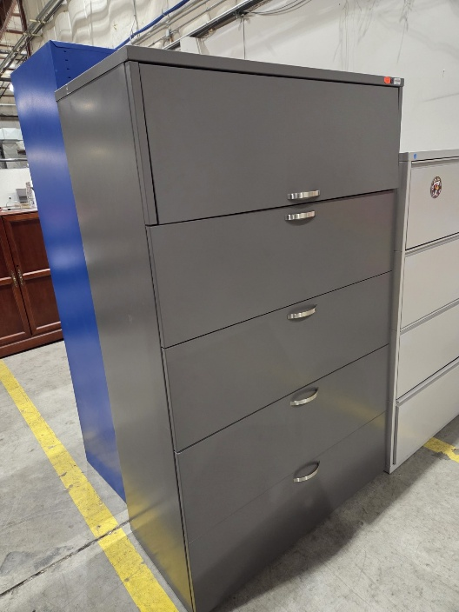

106- 20260706 Wooden Credenza
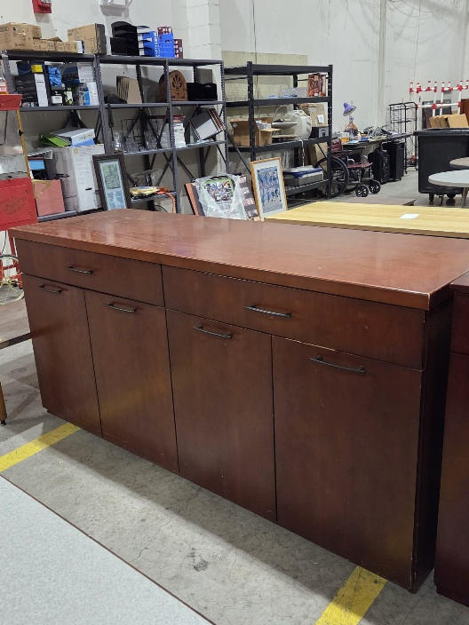
107- 20260904 Black Bookshelf
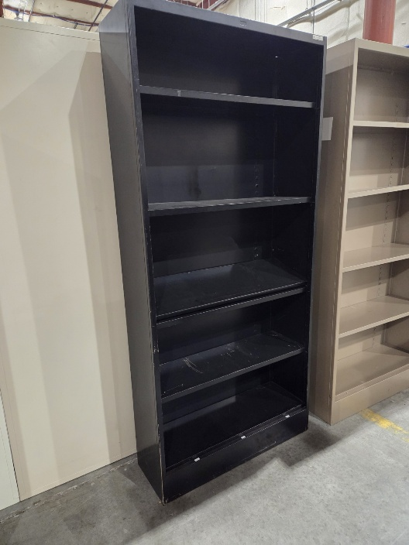

108- 20260526 Tan Bookshelf (QTY 3)
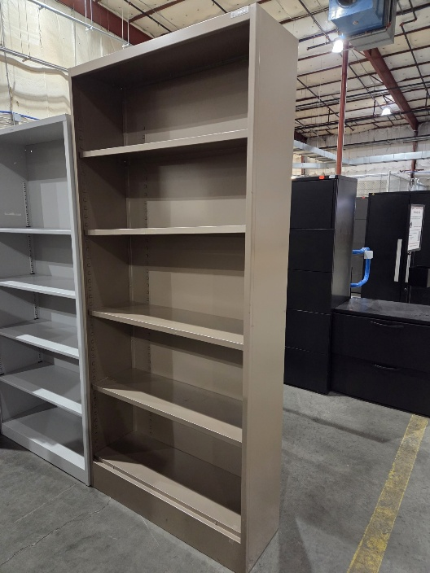
109- 20260629 Wooden Credenza
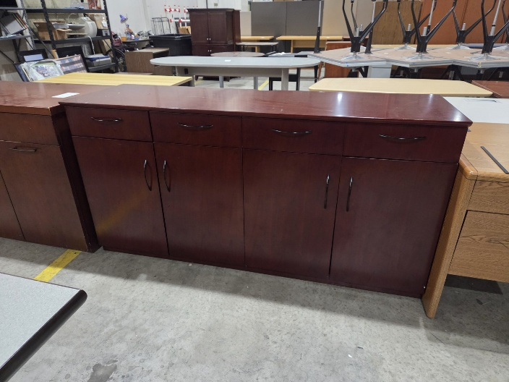

110- 20260904 Gray Bookshelf
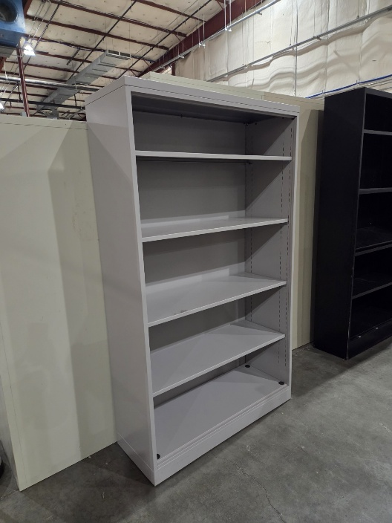

113- 20260612 Black Cabinet
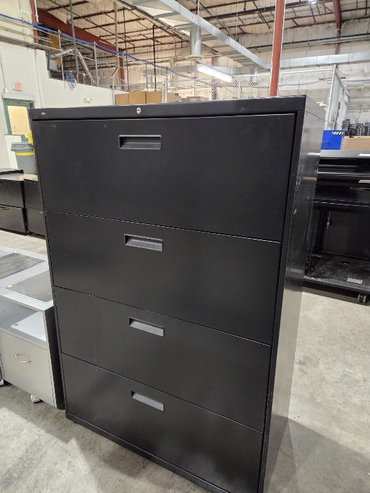

114- 20260828 Short White Filing Cabinet
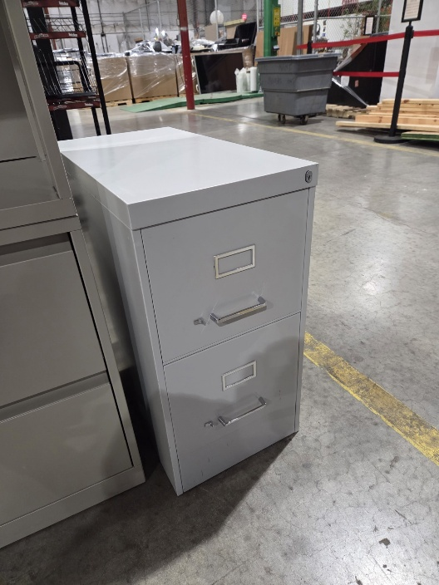
115- 20260828 Metal Racks/Shelves (QTY 3)
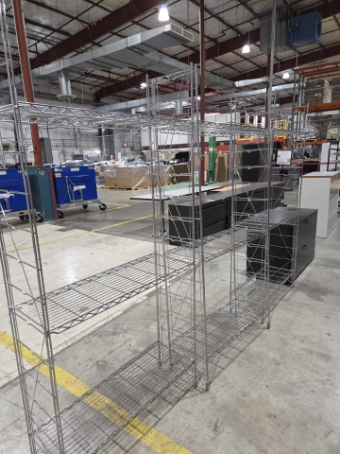

116- 20260828 Black Rack/Shelf
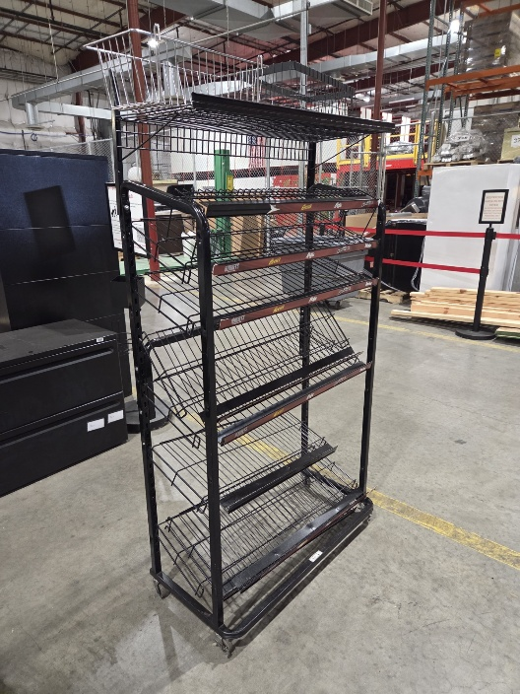

117 – 20250317 Brown Filing Cabinet
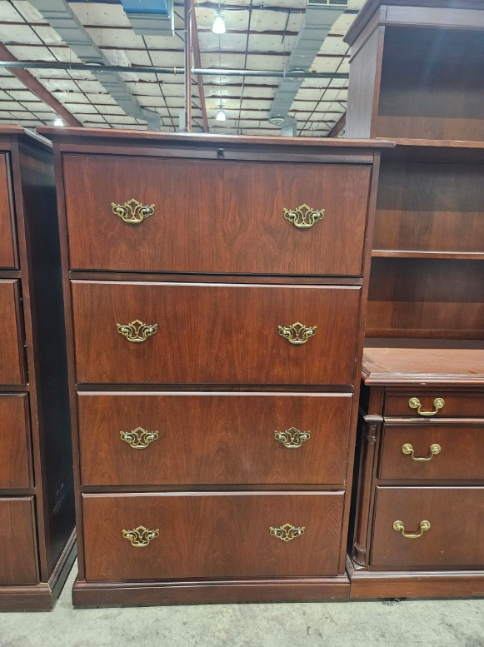

120 – 20250317 Dark Brown Cabinet
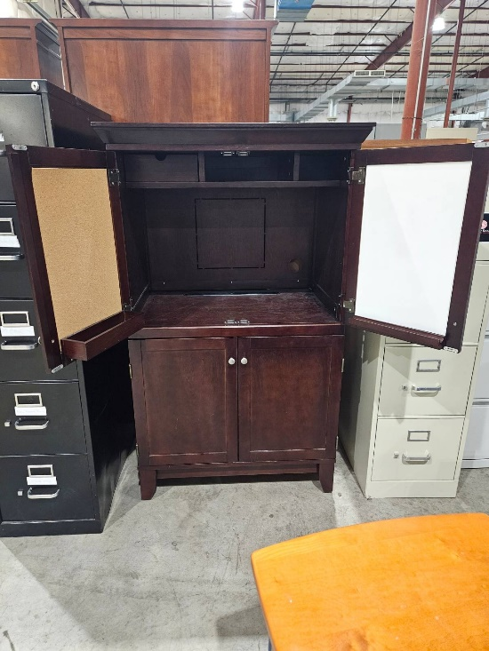

127- 20260313 Gray Filing Cabinet
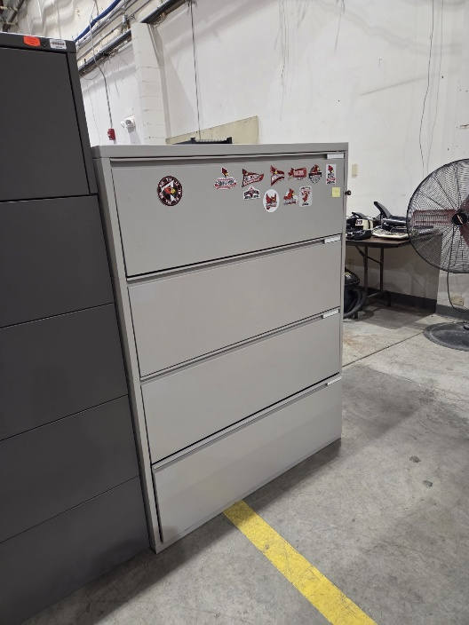

130- 20260720 Tan Filing Cabinet
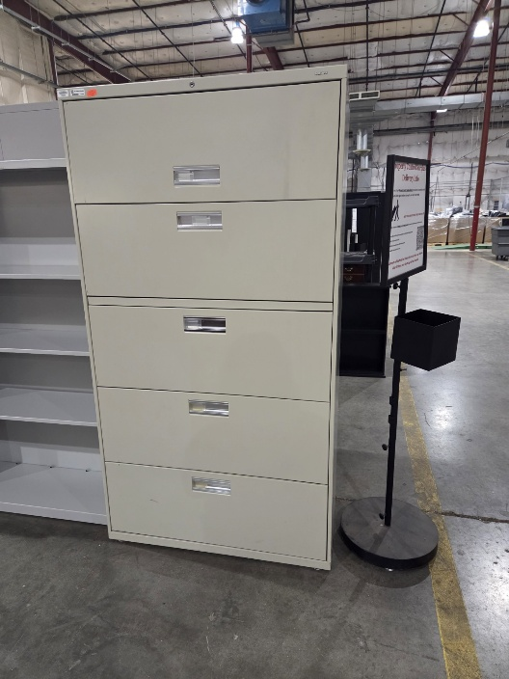

143- 20251121 Black Filing Cabinet
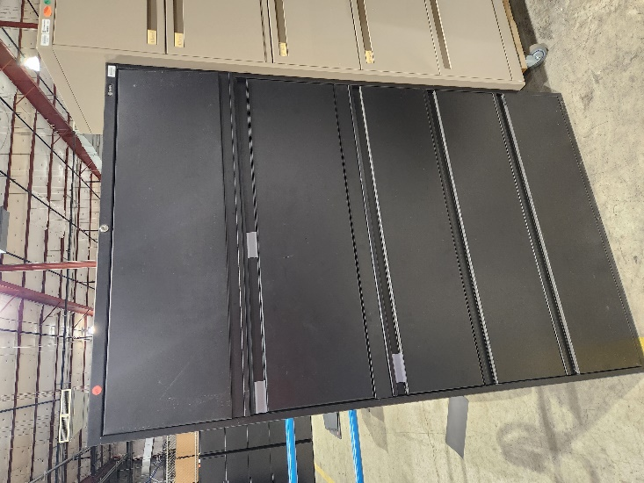
144- 20260904 Small Wooden Bookshelf
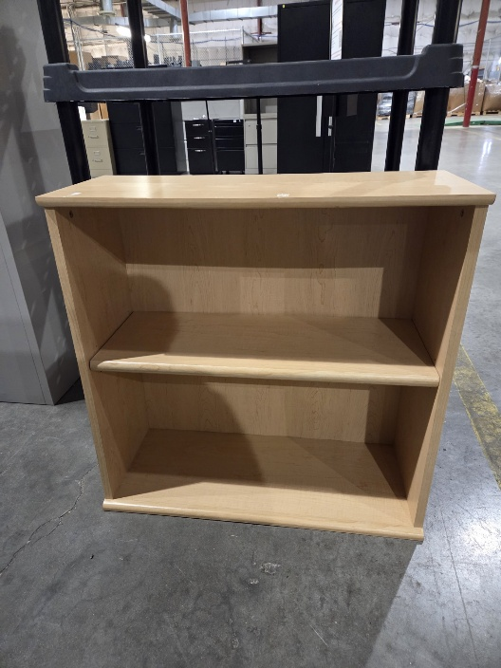

168- 20250822 Tall Gray Filing Cabinet
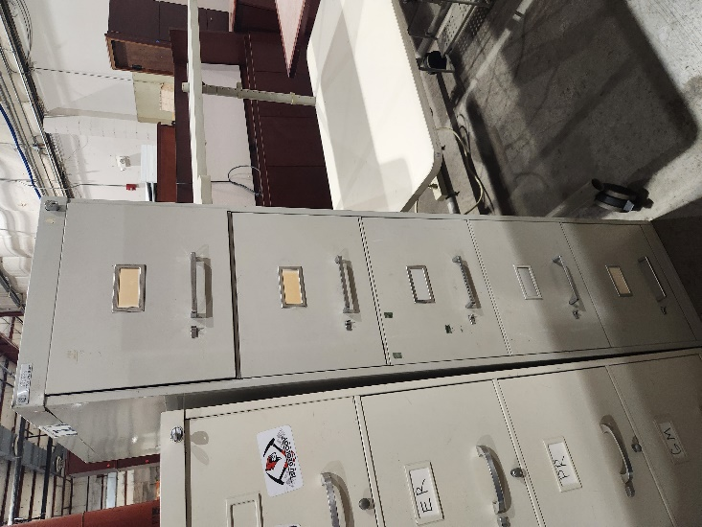

169- 20260424 Black Filing Cabinet
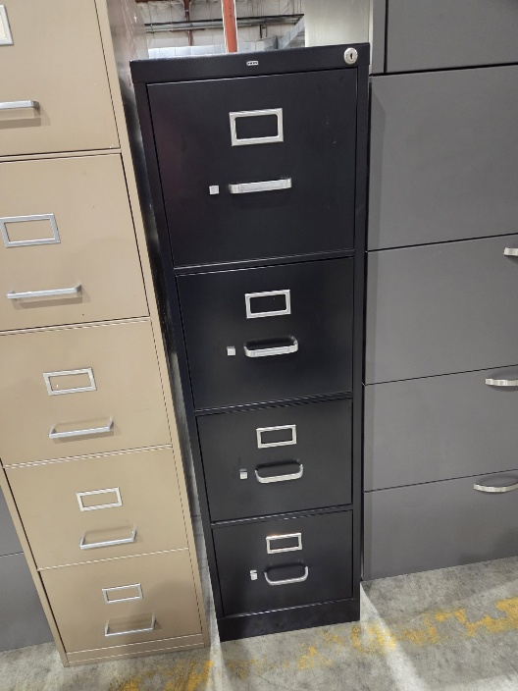
170- 20260914 Gray Filing Cabinet
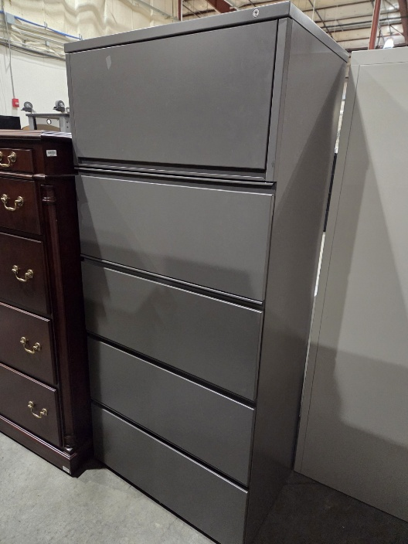

171- 20260914 Black Bookshelf
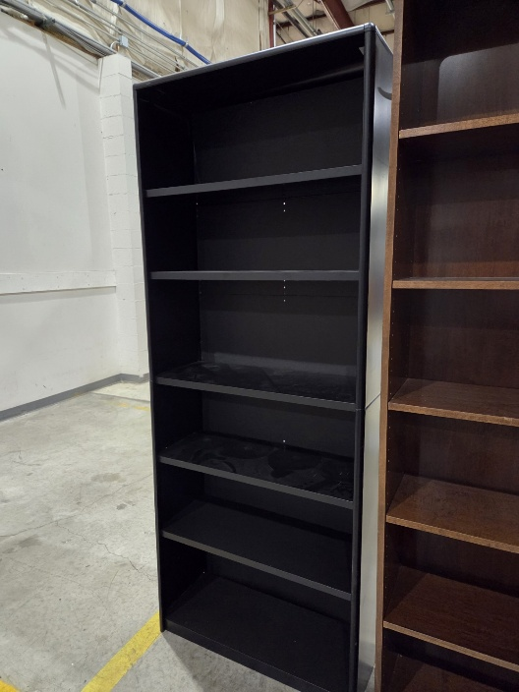
172- 20260914 Tan Bookshelf (QTY 2)
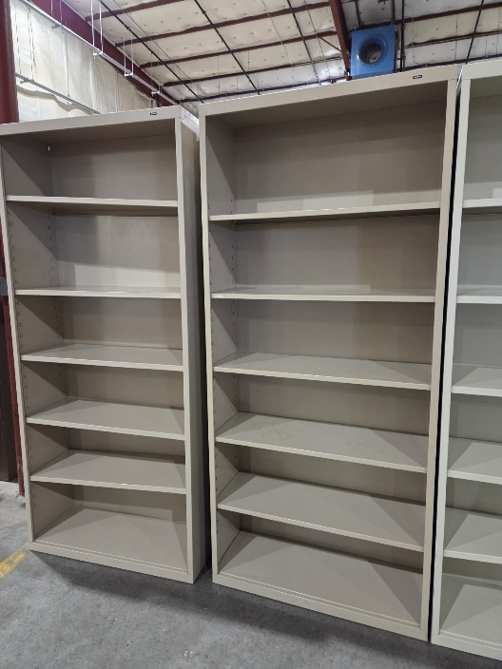

173- 20260914 White Bookshelf
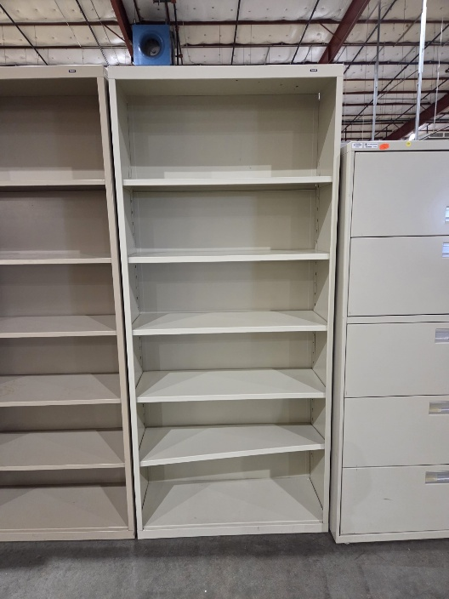

179- 20260622 White Cabinet w/ Shelf
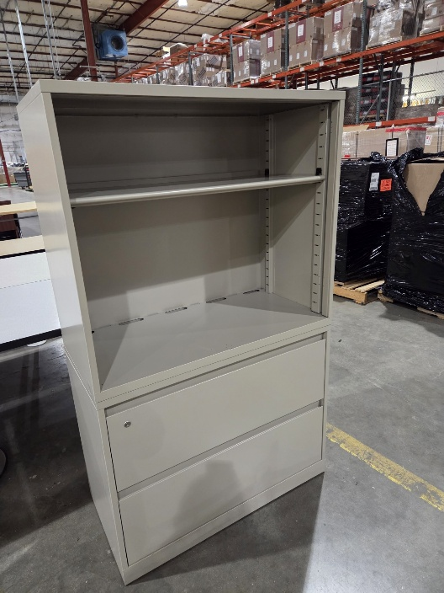

182- 20251010 Gray Filing Cabinet
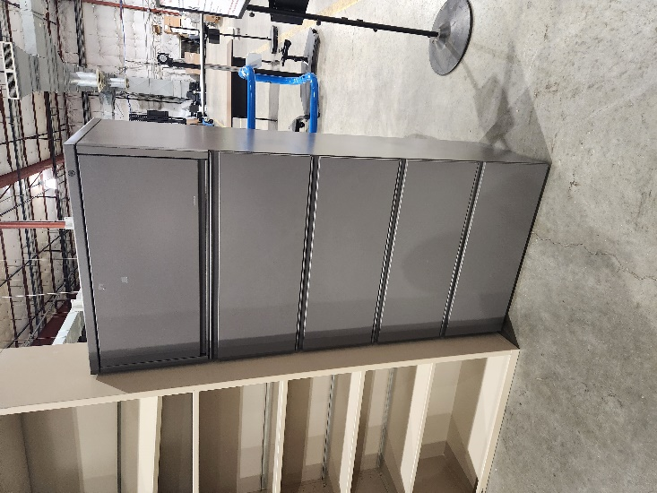

183- 20260227 Short Wooden Cabinet
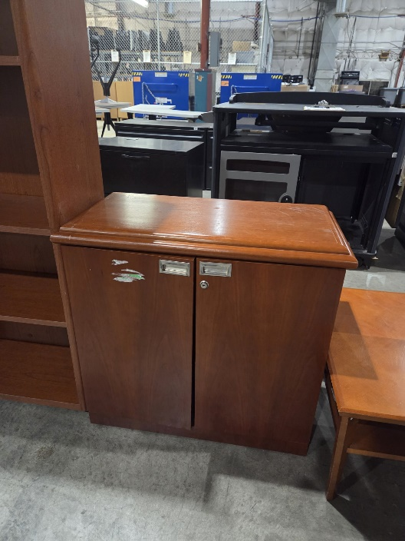

184- 20260622 Black Filing Cabinet
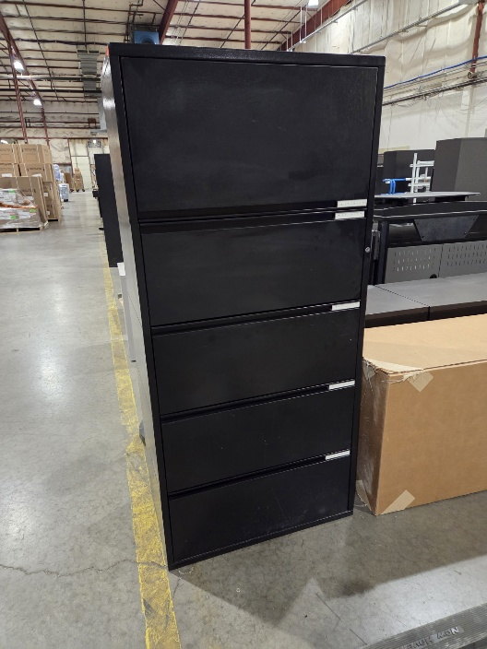

186- 20251107 White Filing Cabinet
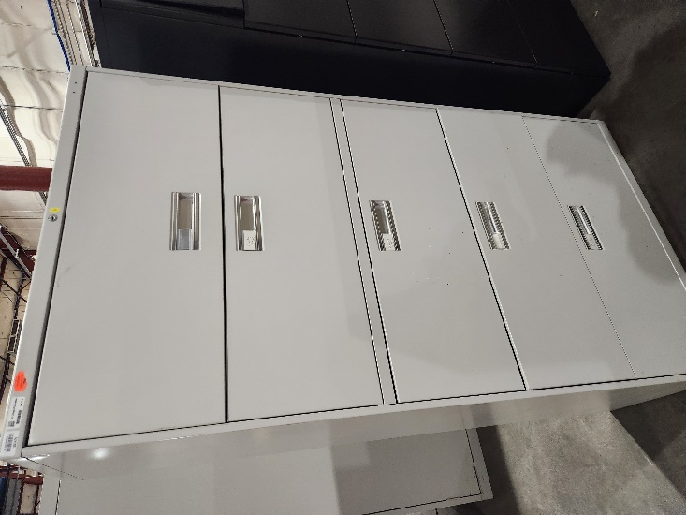

191- 20251114 Short Black Filing Cabinet (QTY 3)
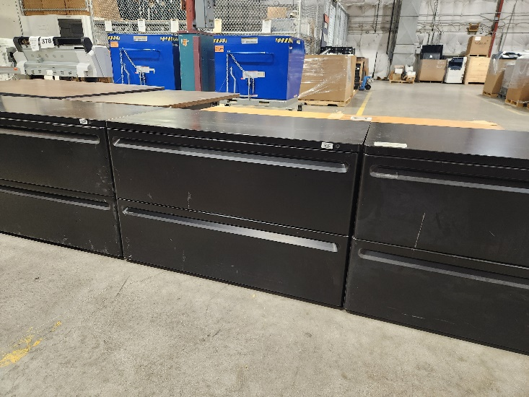

192- 20260807 Wooden Cabinet
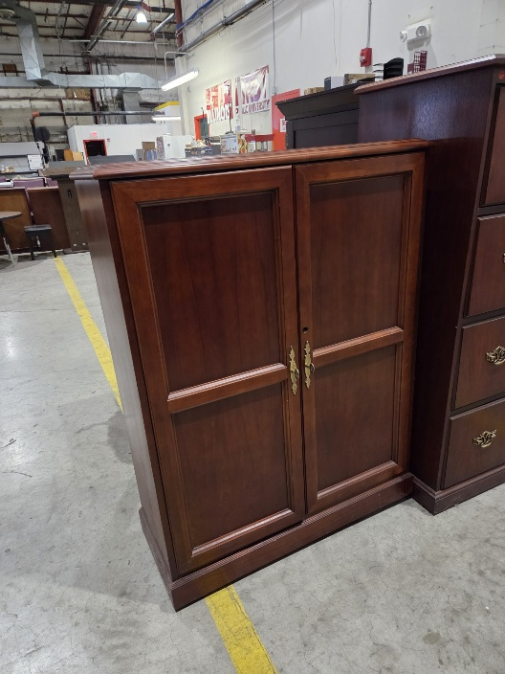

194- 20260105 Gray Filing Cabinet
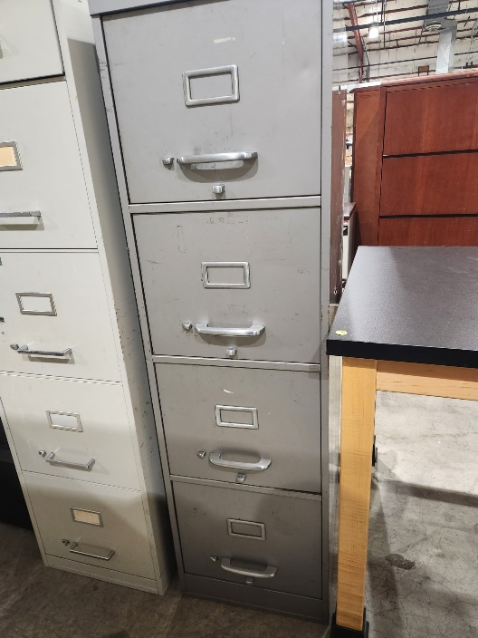

195- 20251114 Short Black Filing Cabinet
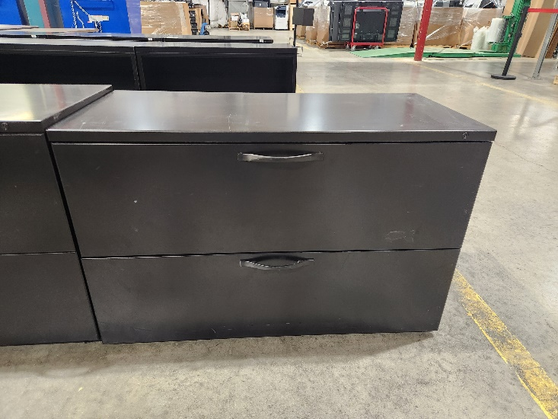

196- 20251114 Large Overhead Cabinet W/ 2 Drawers (2 Pictures)
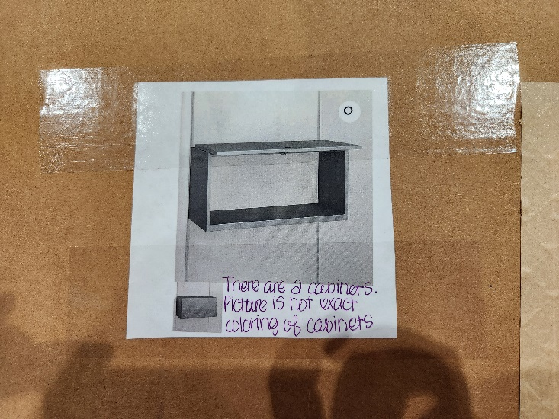
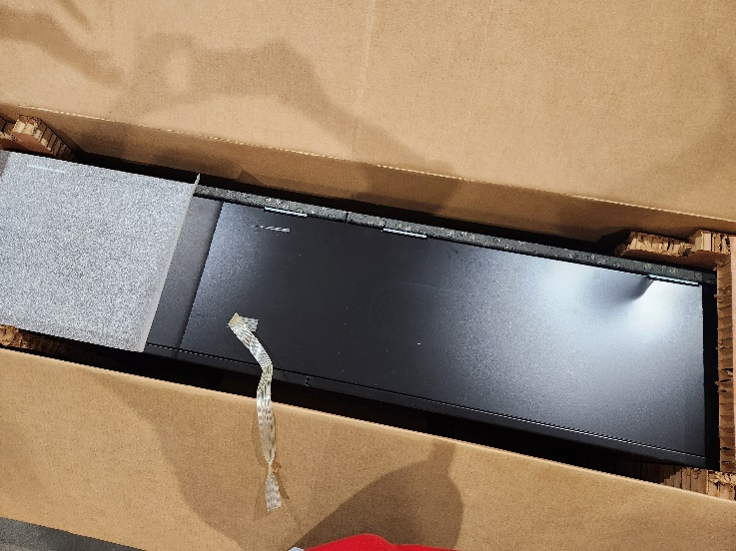

198- 20260720 White Bookshelf
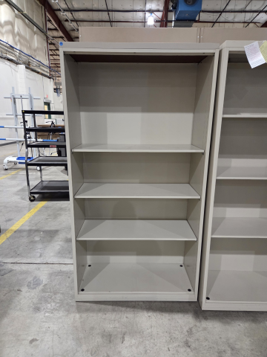

199-20260420 Tan Filing Cabinet
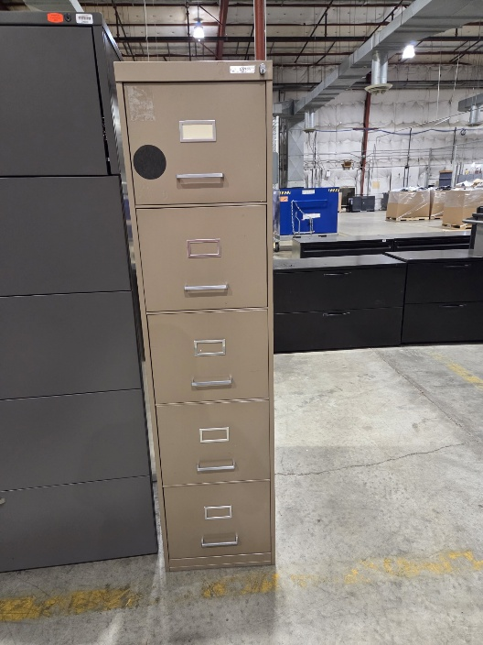

Desks & Tables

204- 20260605 Black Desk w/ Wooden Top
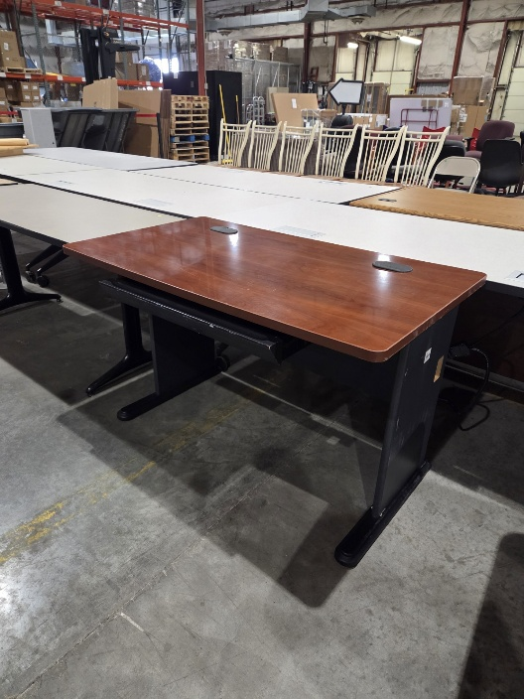

211- 20260612 Round Wooden Table
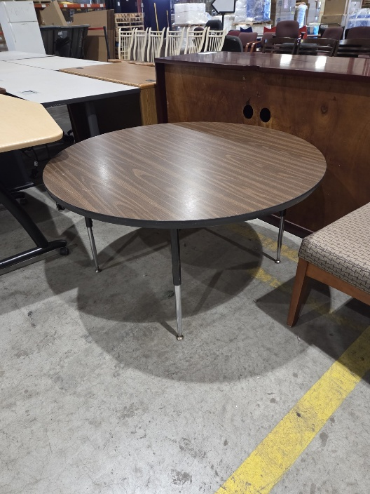

212- 20260526 Small Black Bench
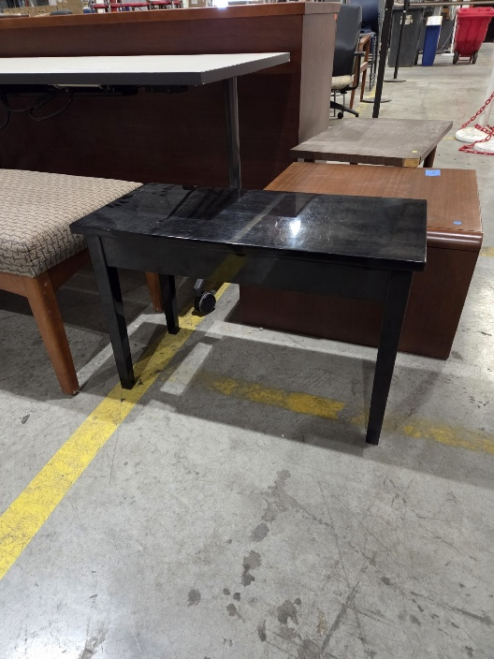

217- 20260720 Rolling Workstation (QTY 3)
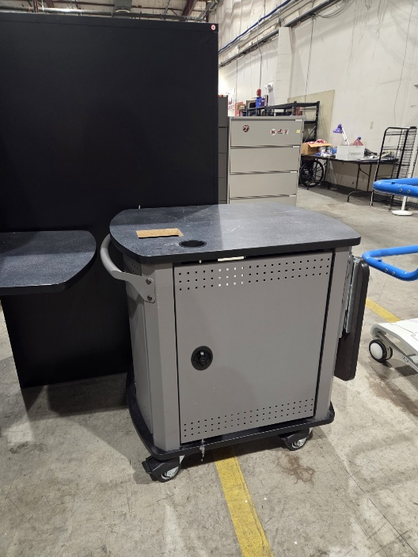

219- 20260706 Small Black Table/Bench
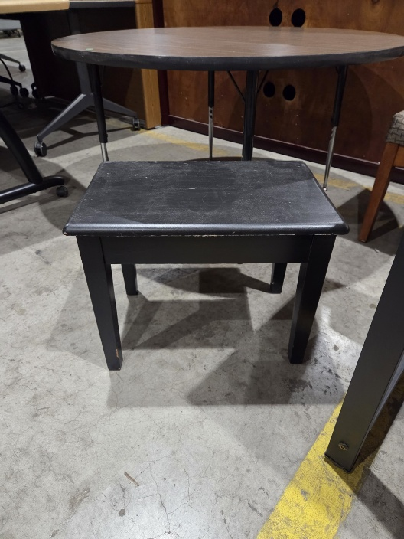

253- 20250829 Wooden Coffee Table
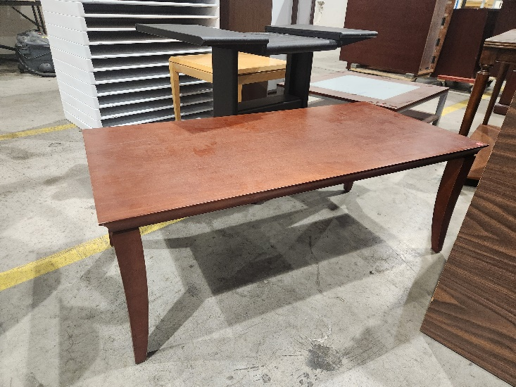
254- 20260814 Black Metal Deak w/ Monitor Stand Compartment (QTY 8)
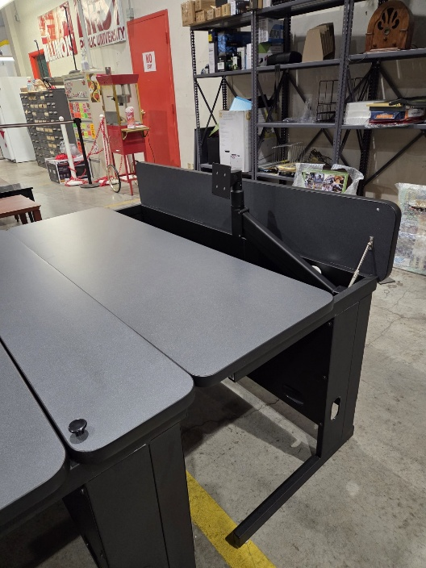
255-20260814 Black Metal Desk w/ Monitor Stand Compartment (QTY 2)
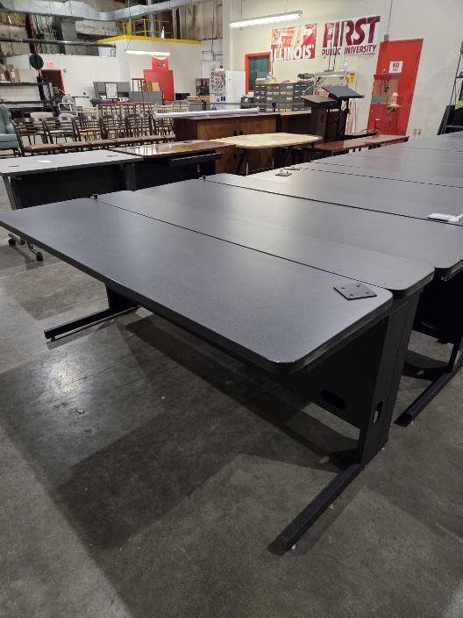

274- 20250815 Wooden Desk
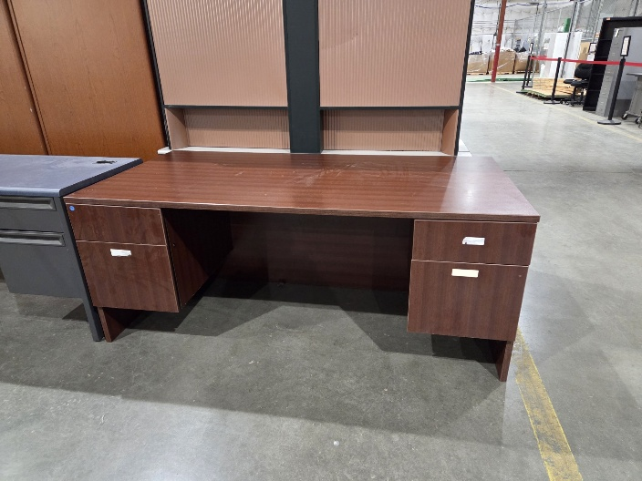
275- 20260904 Black/Wooden Table
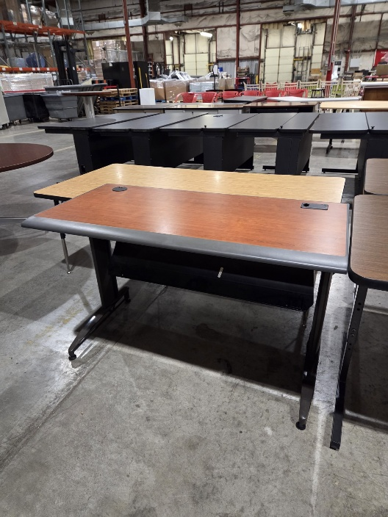

276- 20260904 Long Wood Top Table
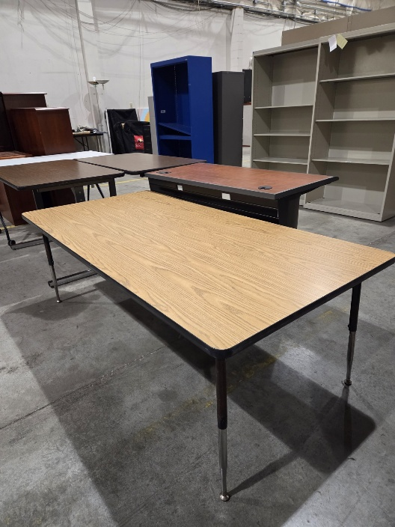
277- 20260904 Wood Top Table (QTY 2)
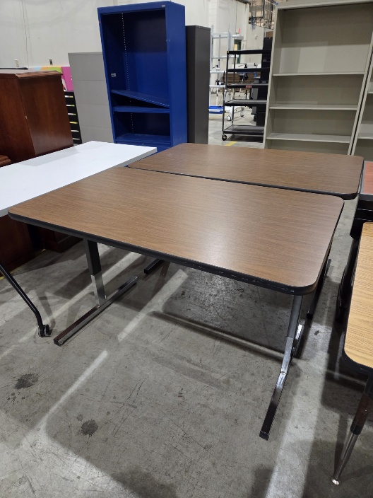

278- 20260904 White Table w/ Wheels
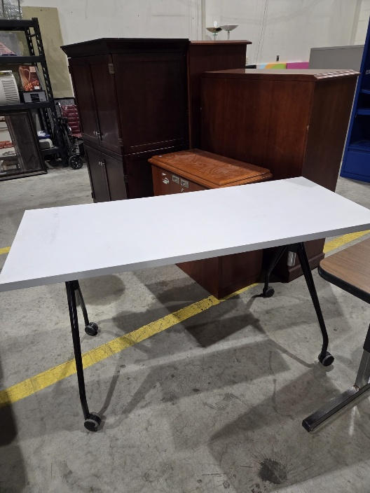

288- 20260828 White Boomerang Shaped Table w/ Wheels
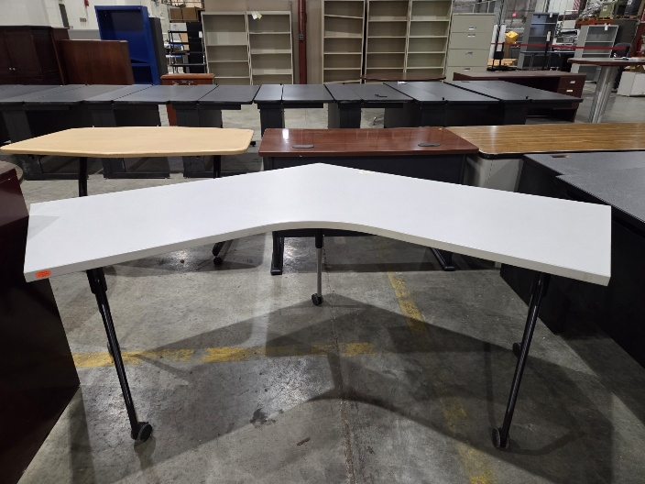
289- 20260828 Tall Round Table
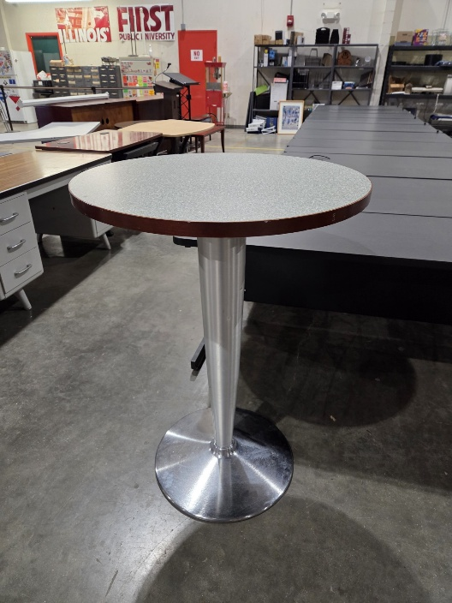
290- 20260914 Round Table
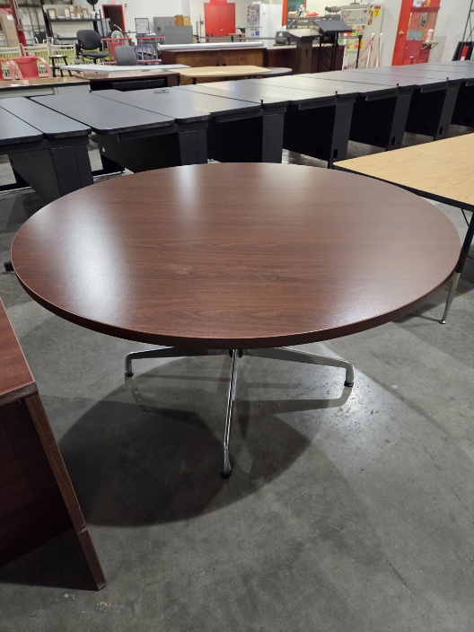

291- 20260914 Metal Desk
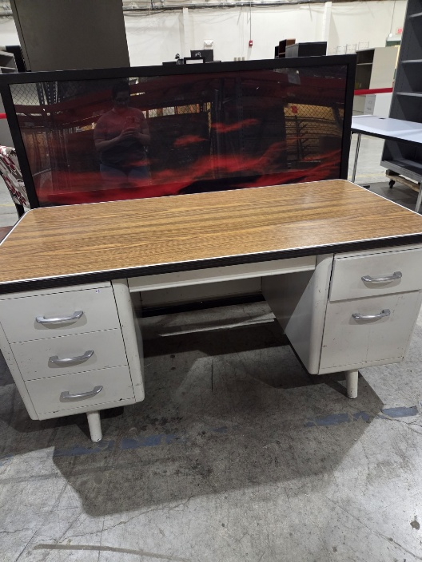

292- 20260828 Brown Metal Desk w/ Wooden Tabletop
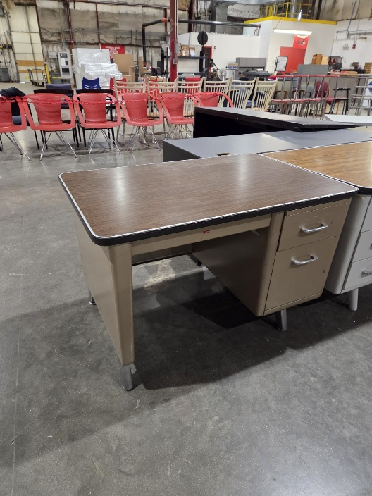
293- 20260828 Black Wooden Coffee Table
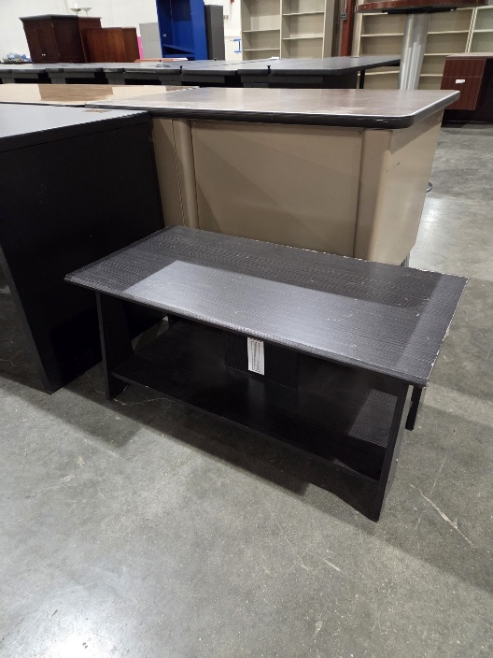

299- 20260420 Small Wooden Table
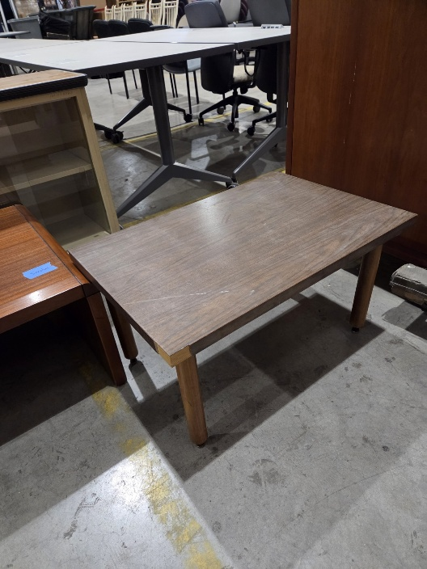

Chairs

307- 20260130 Red Chair
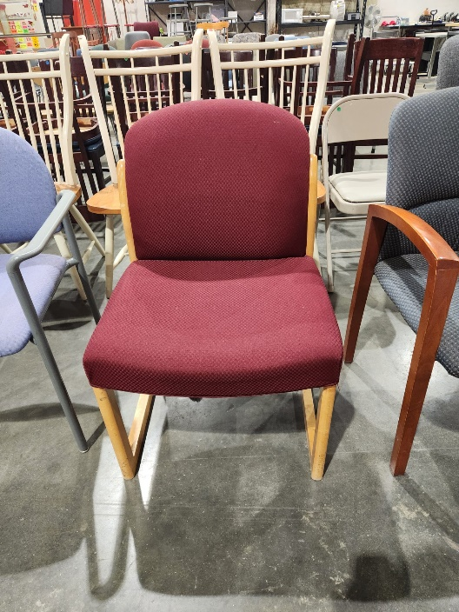

309- 20260529 Gray Chair
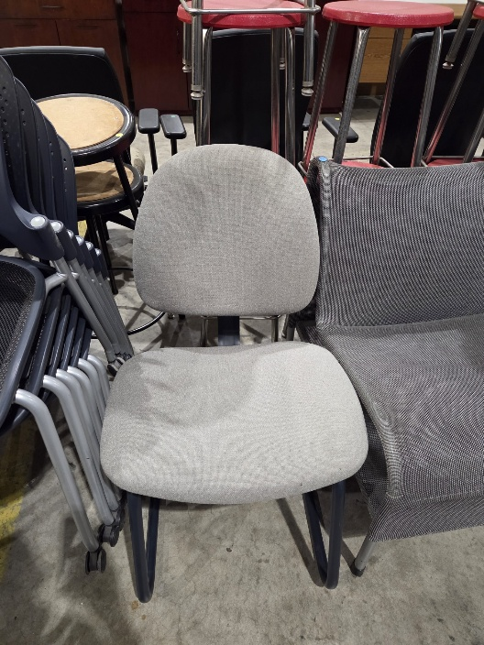

312- 20260720 Blue Chair w/ Desk
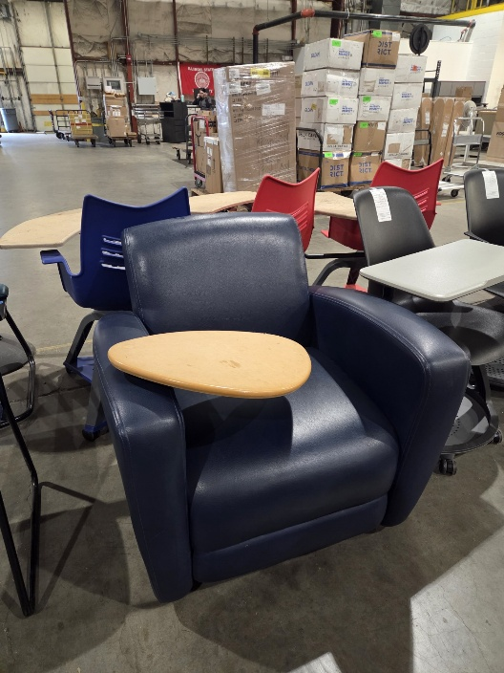

314- 20250829 Cream Colored Chair
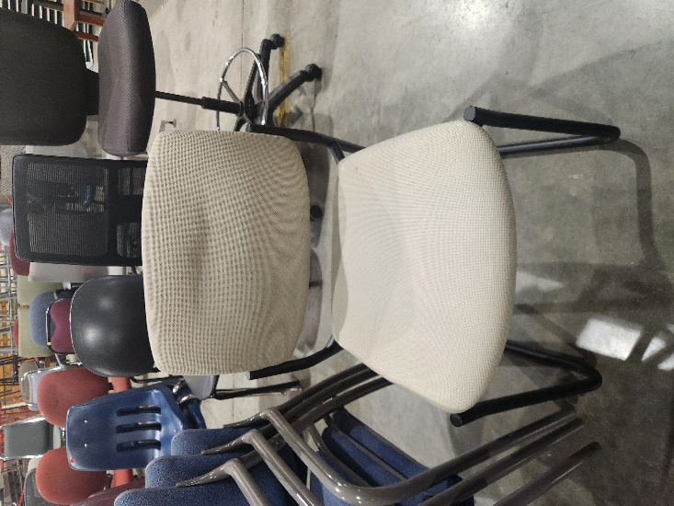

326- 20260515 Blue Chair w/ Wheels
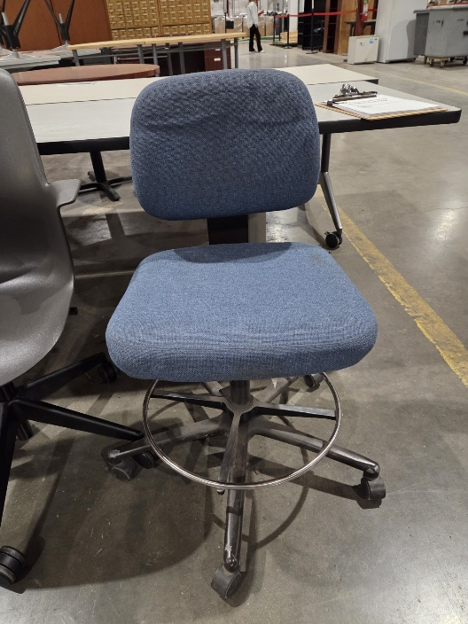
329- 20260605 Wooden Chair w/ Patterned Cushion (QTY 2)
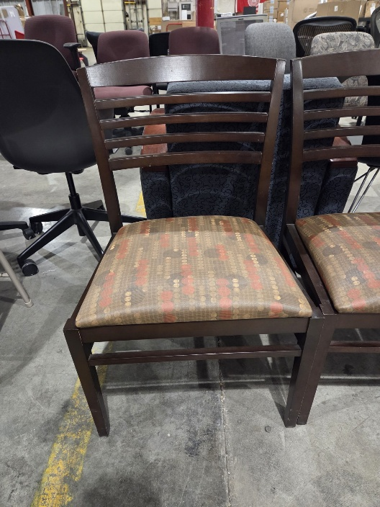

358- 20250616 Wooden Chair (QTY 6)
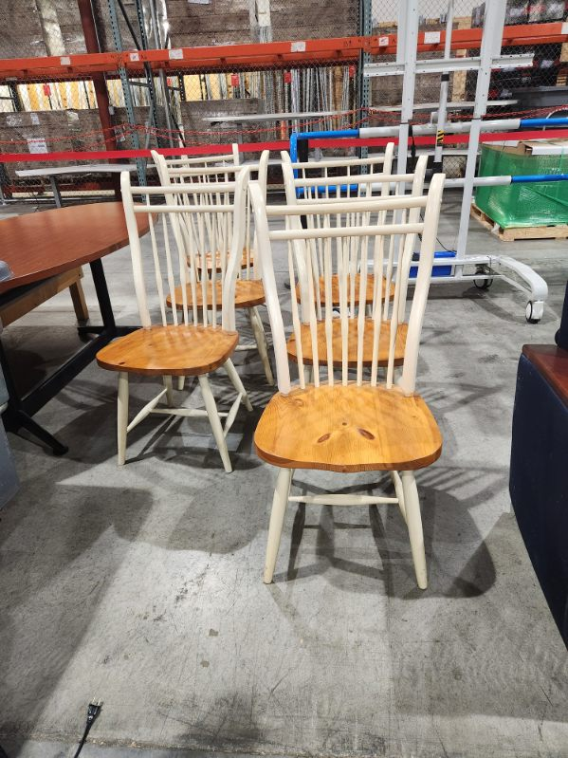

366- 20260807 Red Chair w/ Wheels
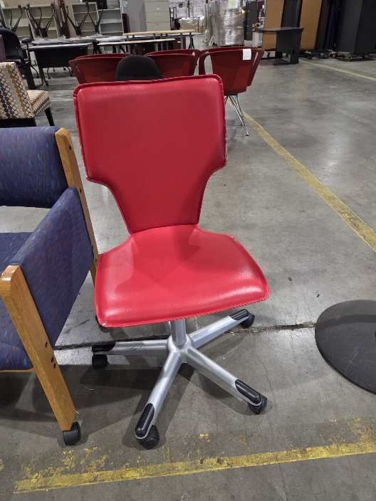

368- 20260904 Green Chair (QTY 6)
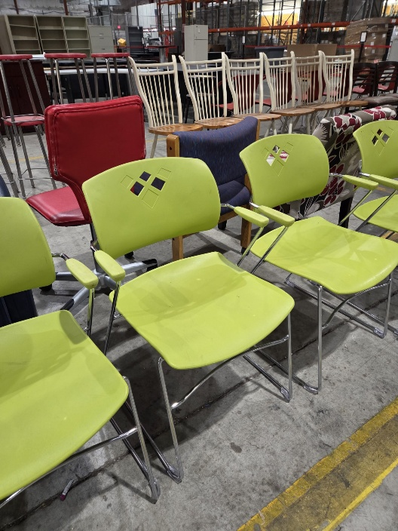

385- 20260227 Red Chair w/ Desk & Wheels (QTY 2)
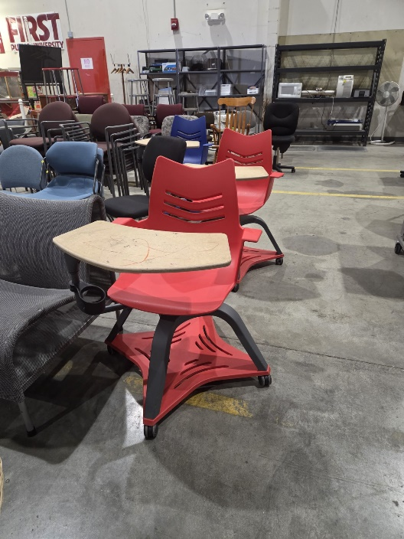

389- 20260227 Blue Chair w/ Desk & Wheels
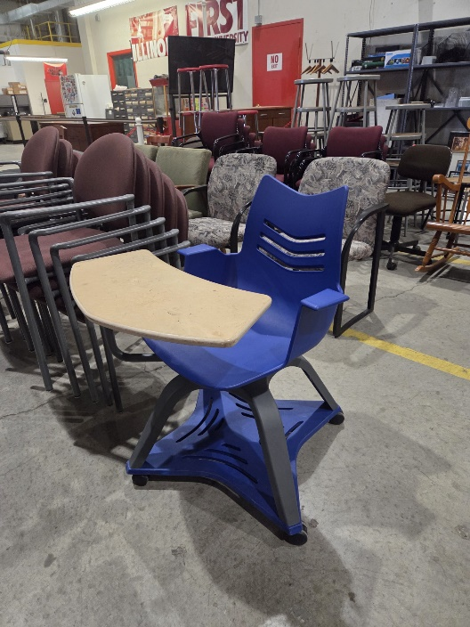
390- 20260914 Gray Chair (QTY 2)
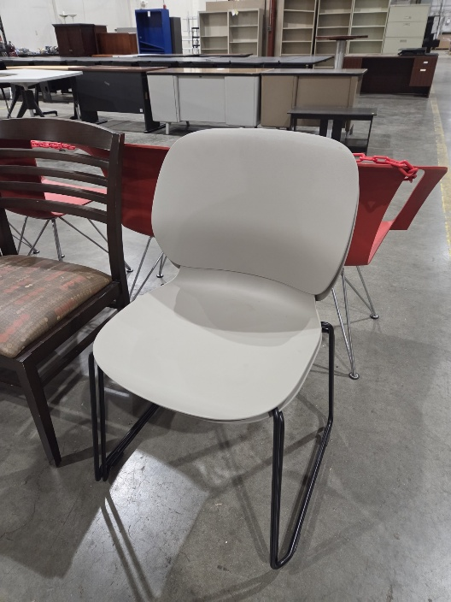

391- 20260914 Black Chair w/ Wheels
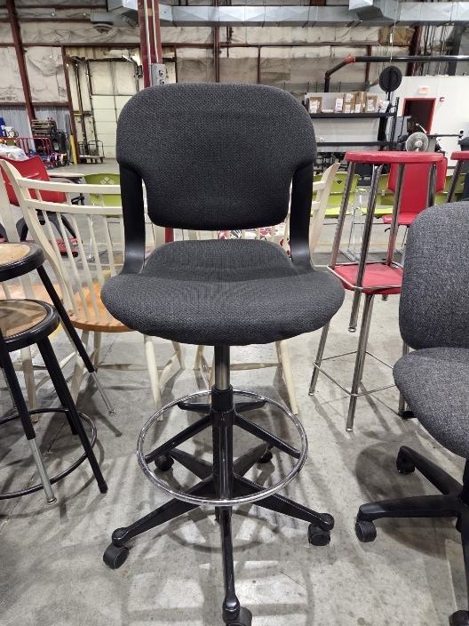

392- 20250815 Red Stool (QTY 8)
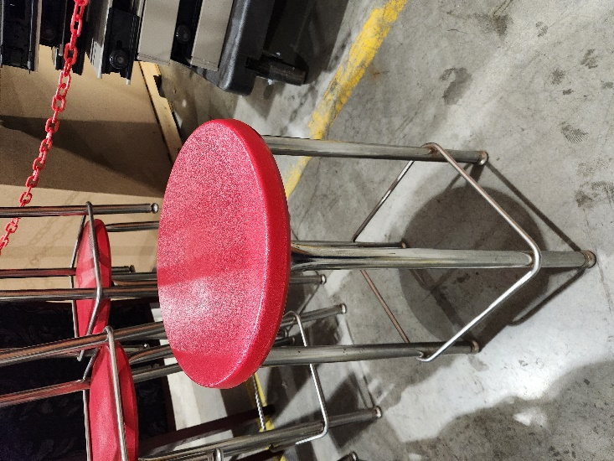

393- 20260914 Gray Chair w/ Wheels
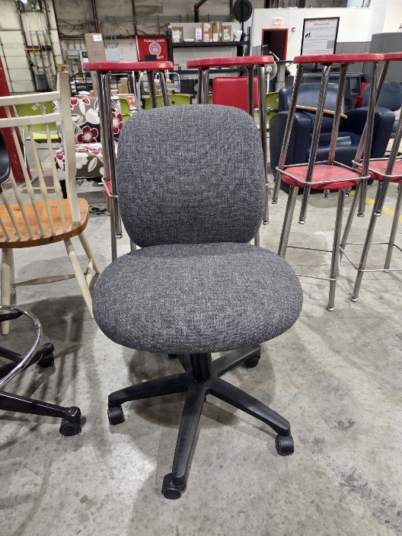

Office Equipment & Miscellaneous Equipment
408 – 20250317 Dual Monitor Stand (QTY 2)
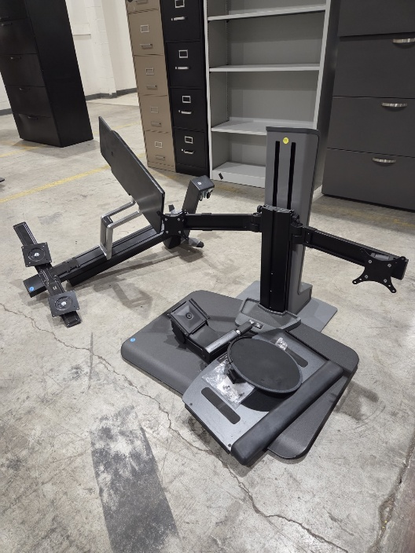
410 – 20250527 Office Supplies/Miscellaneous (4 Pictures)
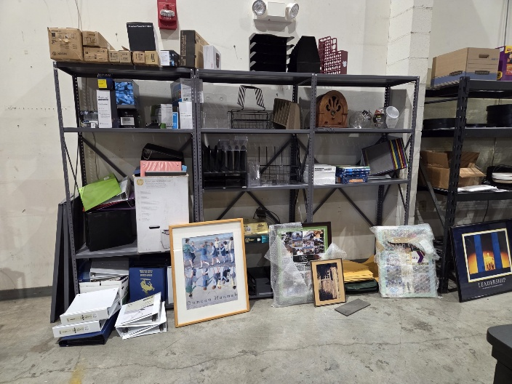
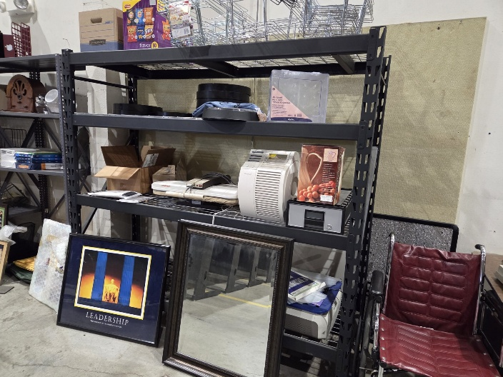
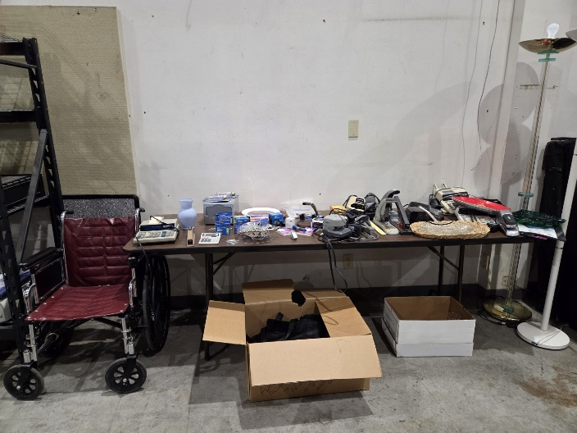
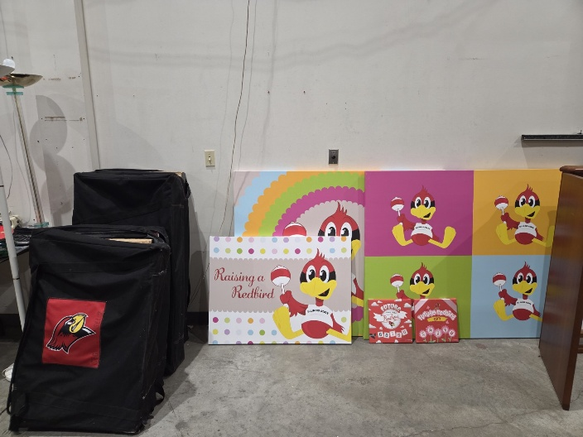

424- 20250829 Tripod Stand (QTY 3)
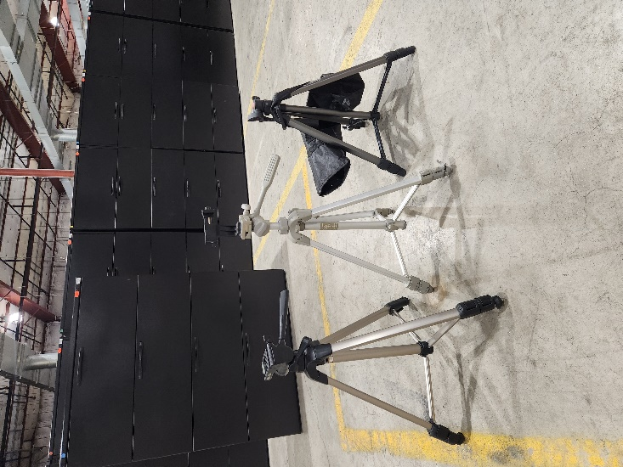

429- 20251107 Cell Phone/Tablet Holder Stand
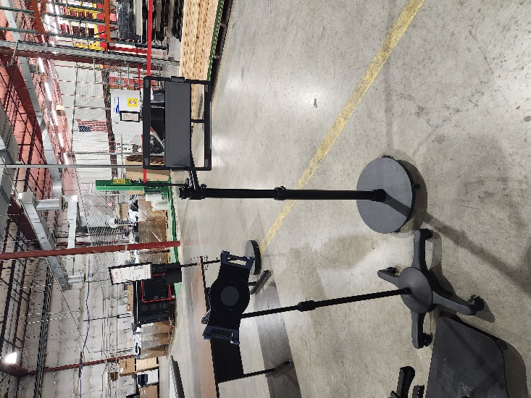

438- 20260327 Large Whiteboard (QTY 2)
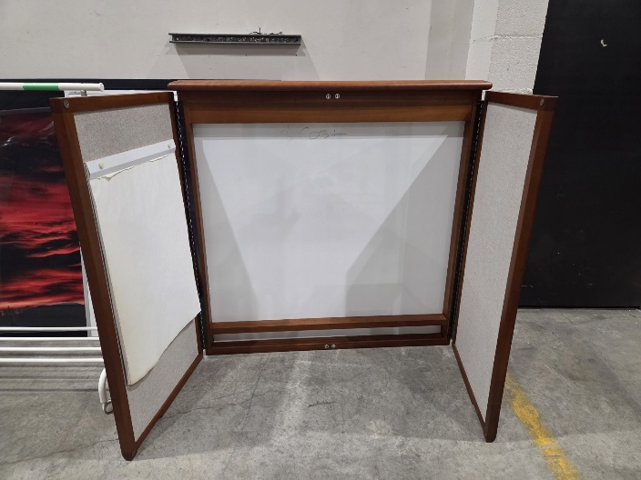

439- 20260720 Wooden Speaking Podium
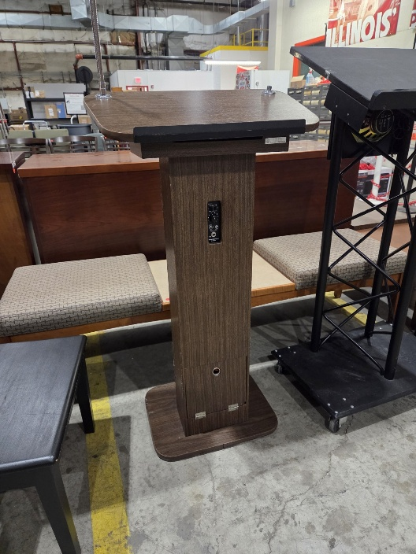

440- 20260720 Black Speaking Podium
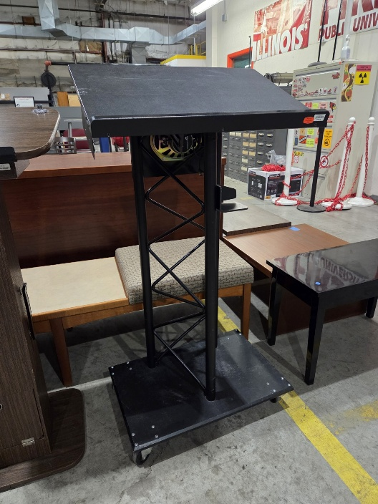

441- 20260828 Black Varidesk
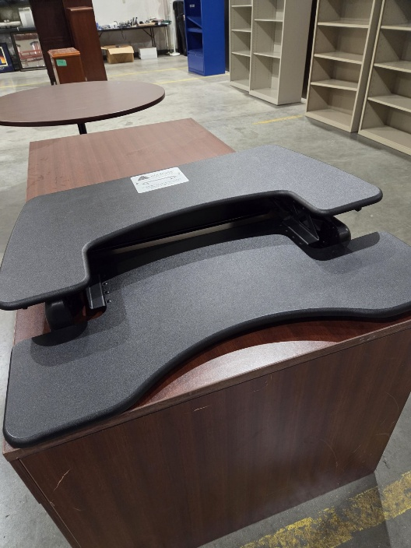

442- 20260904 Mobile Monitor Stand- Black
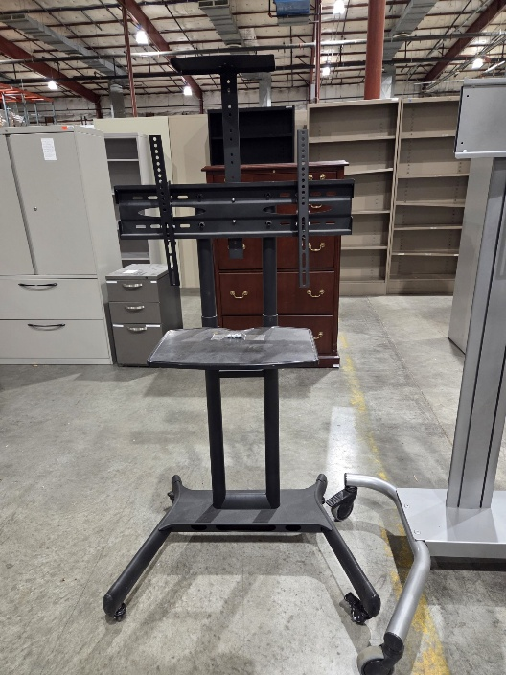
443- 20260904 Mobile Monitor Stand- Silver
